

**All we need here is a little bit of info about the Landlord**

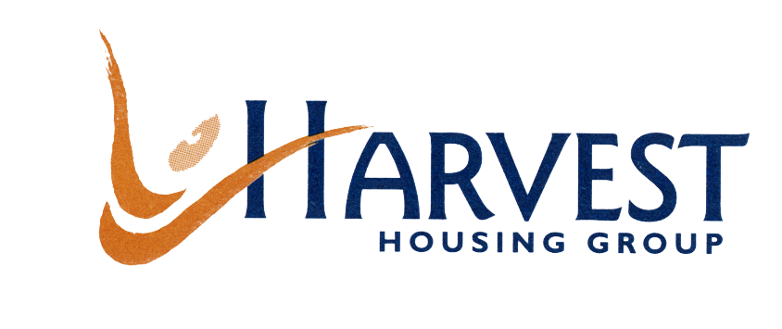

Harvest Housing Group, Apex House, 266 Moseley Road, Manchester M19 2LH.

Head office tel number: 0161 248 2300.

Harvest Housing Group manages over 18,000 homes throughout the North West of England and alongside a full range of mainstream housing association activity - general needs, sheltered housing, single people, supported housing, residential care and low-cost home ownership schemes, Harvest works in the housing property and regeneration markets in addition to meeting a large variety of specialist housing and related services needs. The Group is made up of Industrial and Provident Societies. Most of the members are registered providers (RPs) and all are charitable:

**Harvest Housing Group** is the parent body and service provider – strategic direction, corporate services, finance, business and service development and Harvest Response, our shared service centre.

**Frontis** is responsible for the housing and neighbourhood services in Warrington and also developing key worker, affordable and other new housing products across the country

**Outlook Homes Limited** is the one-stop-shop for the house building industry. Working with house builders across the country developing affordable new homes for sale and rent. Providing a sales service for all home ownership products and agency services for property management companies.

Housing and neighbourhood services are delivered by locally based housing associations:

**Derwent & Solway Housing Association** - Delivering affordable housing and neighbourhood services in Cumbria

**Eaves Brook Housing Association -** Delivering affordable housing, neighbourhood services and housing market renewal services in Lancashire

**Manchester & District Housing Association** - Delivering affordable housing and neighbourhood services and Private Finance Initiatives in Manchester, Greater Manchester and Cheshire.

**Moorlands Housing** - Delivering afforable housing and neighbourhood services in Leek, Cheadle, Biddulph, High Peak and Cheshire.

**Partington Housing Association** - Delivering affordable housing and neighbourhood services in Partington.

**Grove Village –** Management of Council homes as part of a 30 year Private Finance Initiative agreement with Manchester City Council, which commenced in2003.

Our Corporate Vision is:

**“Turning homes and neighbourhoods into places where people want to live and choose to stay”**