Life Boat College, Poole

How to find us
By Road
Travelling west on the M27 the road becomes the A31 to bypass Ringwood, Ferndown and Wimborne Minster. Remain on the bypass until reaching the roundabout junction signposted the A349 Poole town centre and ferry port.
Follow the A349 and ferry signs until reaching the roundabout signposted the A350 Poole town centre. This roundabout has the Poole Fairway marker buoy in the centre of it. Turn left here onto the A350 (Holes Bay Road).
Follow the dual carriage way which skirts the bay. You should be able to see The Lifeboat College and the lifeboats moored to the front right. At the next roundabout at the end of Holes Bay Rd, take the last exit on the left. This is West Quay Road. The RNLI Headquarters is 200 metres on the left, the Slip Way to The Lifeboat College is just after this on the right.
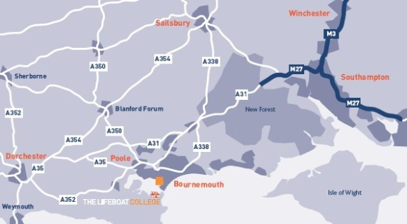
Poole Bus/Coach Station
Exit the bus station passing KFC, follow the pavement all the way around the perimeter of the shopping centre, stay on the left walk,underneath the flyover. When you come to the end of the pavement you will see the train station on your right. From this point please refer to Poole Train Station.
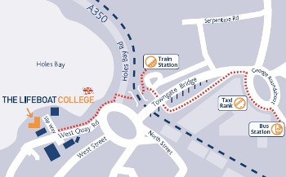
Poole train station
On arrival at Poole Train Station exit the station onto Holes Bay road via the station platform or the underground subway. Crossing the dual carriageway, turn left and walk onto West Quay Road.
Parking at The Lifeboat College
Parking at The Lifeboat College is limited. Please ask for further details.
Download the directions.
Every £1 you spend at the Lifeboat College helps the RNLI save lives at sea.
Contact details:
The Lifeboat College
West Quay Road
Poole
Dorset BH15 1HZ
Tel: 0870 833 2000

