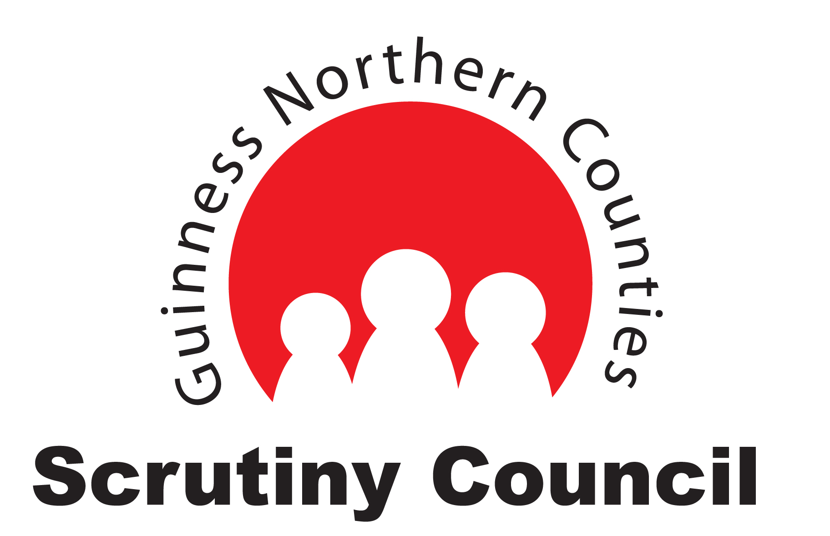

Code of Conduct for Scrutiny Council Members
A code of conduct outlines the responsibilities and behaviours that are expected of a Scrutiny Council Member so you are able to achieve your full potential.

- Courteous and professional in all your contact with residents and staff, dealing with people sensitively, fairly and with respect.
- Be objective, impartial, accurate and reasonable in your work.
- Professional and efficient, acting in the best interests of Guinness Northern Counties and its residents.
- To use your ID Badge only for the purpose of Scrutiny Council business.
- Open, consistent and honest in communicating judgements and assessments.
- Attend at least 12 meetings a year to complete your full scrutiny duties. If you cannot attend a meeting, to send in apologies in advance of the meeting.
- If ill health prevents you from completing your scrutiny duties, please let us know as soon as possible for us to review your position.
- If you miss more than 3 consecutive meetings without apologies, we will contact you to discuss your situation and review your membership of the Council.
- To attend an annual appraisal and to under go any training required.
- Comply with the Confidentiality and Equality and Diversity statement contained in the Terms of Reference for the Scrutiny Council.
- Present yourself in a clean, tidy and appropriate manner.
- Not to make financial or any other gain or advantage through your work.
- To consult with the Customer Engagement and Support Team prior to communicating with any external agencies such as the press.
- Claim expenses in accordance with our Customer Expenses Policy.

This Code of Conduct covers behaviours both inside and outside of the meeting room. This includes all communication (verbally and written) between Council Members and all other parties. Breaches of this Code of Conduct will then be addressed by our Grievance Procedure.

