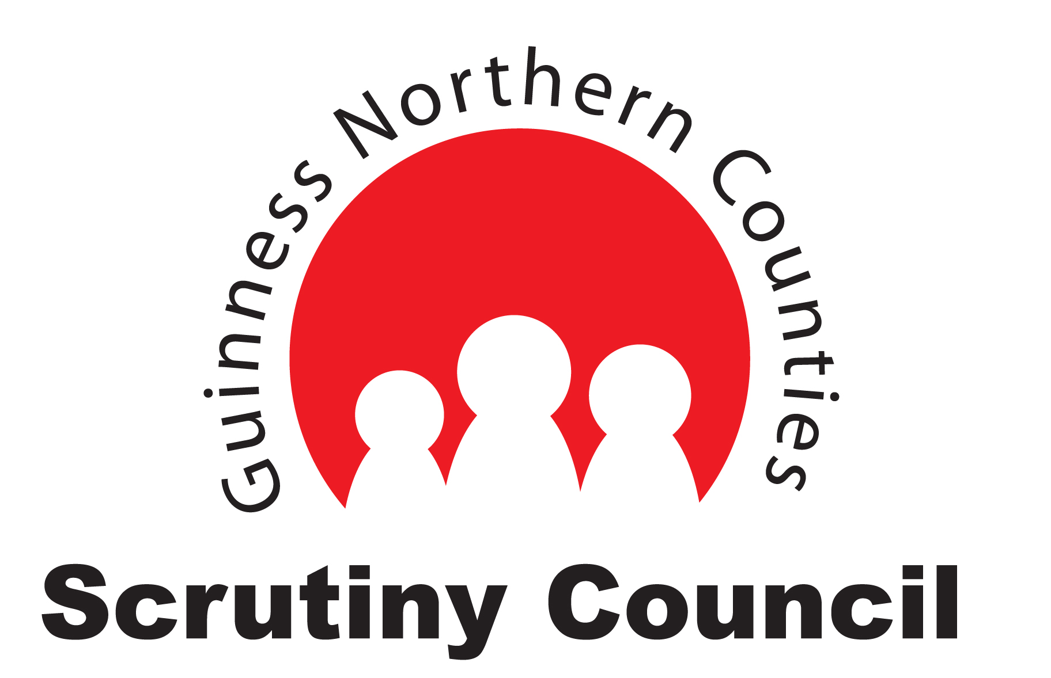

Scrutiny Council
Guinness Northern Counties

Referral Process

Stage 1- Identify Service Area

Area Forums
And
Service Area Forums

Scrutiny Council

Wider Customer
Body
CMT
And
Board

Scrutiny Council
Dashboard

Call for action
Referral Form

Performance
Referral Form

Q. How will Scrutiny Council identify the service area in need of scrutiny?

A. This will be achieved by monitoring performance on our Dash board and customer and company referrals. We will use 4 key elements to help us spot weaknesses in a service area.

Q. What key elements will help Scrutiny Council identify the service area?

A. These elements are

- Customer Complaints
- Customer Satisfaction
- Key Performance Indicators
- Value for Money
- Corporate Targets and Standards

Stage 2 - Diagnosis

Service Area
Head of Service provides presentation
Diagnostic

Failed
Kog
Identified
Prioritise
Programme

Q. How does Scrutiny Council run the diagnostic to identify the key kog to scrutinise?

A. We will ask the Head of Service to attend our meeting. They will provide us with a presentation of strengths and weaknesses of their service area based on these 5 key elements.

These elements are

- Customer Complaints
- Customer Satisfaction
- Key Performance Indicators
- Value for Money
- Corporate Targets and Standards

Stage 3 – Prioritising Programme

Failed
Kog
Identified
Identify and
Prioritise
Programme
Scrutiny Council scores each failed kog

Q. How does Scrutiny Council know which kog to scrutinise first?

A. When we have identified the failed kog, we will then score it against the 5 key elements. The kog with the highest score will have priority on our scrutiny programme.

Q. How will this scoring system work?

The scoring system will work on the following format

- Customer Complaints – number of customer effected – Changes in level as % of increase of number of complaints..

- Customer Satisfaction - % from target - % of decrease

- Key Performance Indicators - % from target - % of decrease

- Value for Money - % of change – Benchmarking, less than top quartile

- Corporate Targets and Standards - % of target – 1 to 5 score if they are being met.

Stage 4 – Communicate Programme and referral responses

Prioritise
programme
on an ongoing basis
Scrutiny Council scores each failed Kog
CMT and Board
Area Forums
And
Service Area Forums
Wider Customer Body
Referral
Feedback
Referral
Feedback
Referral
Feedback
Newsletter
Internet
Etc

Q. How will we know and when, if our referral has been accepted by Scrutiny Council?

A. Scrutiny Council will consider and score your referral as per stage 3. We will then provide you feedback of that score and any further actions you may be able to do to help make improvements to the situation. We will let you know if we have prioritised the referral for scrutiny, but we do score on an on-going basis as referrals come in and priorities are subject to change.

We acknowledge that some customer groups meet less frequently than ourselves. We will make sure the result of your referral will get to you quickly, so you don’t need to wait till your next meeting for an update.

Stage 5 – Scrutiny Process

Once the failed kog has been identified and prioritised, then we will embark on the Scrutiny Project.

The process is as follows with a bottom up approach.

- Plan and prep overall Project Plan – pencil in deadlines and meetings.

- Set Challenges – these challenges will be framed around the 12 Lines of Investigation.

- Request Information – using Notice for Information and set deadline.

- Desk Top Review – review the Notice for Information to identify Tasks and Stakeholders.

- Set Tasks – agree and set up task groups and set their actions around the agreed Lines of Investigation,

- Agree Methods and Stakeholders – interviews, focus groups, InCheckers, observation, survey etc and who and where.

- Reality Checking – Under take investigation and gather evidence.

- Reporting Back - review the Project Plan Actions and the information gathered.

- Finding and Recommendations – review evidence and start building recommendations on the investigation findings.

- Joint Negotiation – Work with GNC to turn the recommendations into agreed deliverable actions.

- Present Report – report sent to Board and CMT

- Monitoring – continuous monitoring of the delivery of the Actions

