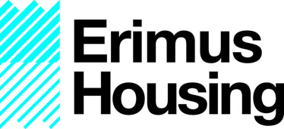

ERIMUS HOUSING

Internal Scrutiny Co-ordinator

The position of co-ordinator will be elected annually by a ballot, following a request for Panel members to nominate themselves for the positions available. Those interested will be required to fill in an expression of interest form explaining why they are suitable for the post and outlining their skills and what they can bring to the Panel.

They will then be asked to make a short presentation to the Panel and the Resident Engagement manager or their deputy, outlining why they feel they are suitable for the role, how they will approach the role and how they will act in the interests of the Panel.

Panel will elect by secret ballot on the day.

Role Profile

Title: Internal Scrutiny Co-ordinator of Erimus Housing

Responsible to: Scrutiny panel

Key Skills:
- Active member of Scrutiny Panel

- Excellent organisational Skills

- Understand the Scrutiny process

- Ensure all panel members are contributing to the agreed targets.

- Oversee Scrutiny projects.

- Positive attitude

- Excellent Communicator

- Ability to work in a team.

- Ability to make balanced and informed decisions

Term: 12 Months

Time Commitment: 2 days per month in addition to Scrutiny Panel work.

Key expectations for a Scrutiny Co-ordinator:

- Develop and maintain a good working relationship with other Panel Members.
- Thoroughly prepare for Panel meetings by ensuring all agreed tasks are complete and in an agreed format to share with other members.
- Participate in discussions and decision-making, bringing your skills and experience to help form a consensus, and share responsibility for and upholding Panel decisions.
- Prepare for and attend training and development sessions that are appropriate for Panel Members.
- Deputise for the external co-ordinator where necessary and ensure the smooth running of meetings.

Equality and Diversity

All Panel Members will be expected to recognise the importance of promoting and encouraging tolerance, fairness and equality and in positively influencing other colleagues to achieve the aims associated with equality and diversity.

Health and Safety

Panel Members will be expected to contribute to maintaining health and safety standards to ensure compliance with all appropriate legislation and health and safety responsibilities.

