

Service Design Newsletter
January 2013Issue 1

Welcome to Issue 1 of the new Future of Council Housing Service Design Newsletter!

This is the first in a series of updates that will help to keep you in touch with progress for all of the Service Design project groups. This first edition is quite a read as we wanted to include the Terms of Reference and membership for all the groups so you know who’s who and what sort of areas they’ll be looking at.

What are the Service Design groups all about?

The Service Design Project Groups will provide customers and staff from Sheffield Homes and the Council with the chance to get involved in shaping the vision for our future housing services.
There are 8 project groups established to reflect the feedback from both staff and tenants that we gathered through the ‘It’s your shout’ campaign over the summer. These are:

- The opportunity to have my say
- Well maintained homes and neighbourhoods
- Clean, attractive neighbourhoods
- A quick and effective response to Anti-Social Behaviour
- Easy access to services
- A home to suit my needs
- Making the most of our available income
- Joined up services that better support me

Half of the project groups are being led by Sheffield Homes staff and half by Sheffield City Council. Each of the steering groups includes both Sheffield Homes and Sheffield City Council staff and crucially customer representatives are also key members.

What’s happened so far?

All 8 groups held their first meetings in December to agree their terms of reference. These are the outcomes that each of the groups would like to achieve through the future design of the service. The groups also talked a bit about the timeline for undertaking this work and started to identify who else would be interested in that area of work. We are just compiling all this information and will share this as soon as we can.

All the groups have a standard set of principles which help ensure that important issues are picked up and the way the projects are governed happens in a standard way. However, aside from that each group has developed its own scope primarily based on the feedback received through ‘It’s your shout’. The following sections show the key areas that each of the project groups will focus on.

The opportunity to have my say

At their January meeting the group will consider the Tenant Advisory Group terms of reference and will discuss engagement and governance with Cllr Damms.

The membership of the steering group is:

Catherine Hill – Sheffield Homes
Mark Cowley – Sheffield Homes
Ann Lodge – Tenant
Don Whitehead – Leaseholder
The scope of this group is:

An approach to Community Engagement which
- is based on openness, honesty, inclusion and listening
- puts meaningful grassroots-level consultation and involvement at the heart of housing services
- uses new ways of engaging tenants and leaseholders and so increases the numbers of people actively involved
- ensures feedback is given to those involved
- enables and encourages tenants to be actively-involved citizens within a Council-wide community engagement framework

A governance structure which
- is clear, easily understandable and accessible
- devolves more influence on decision-making to tenants and leaseholders
- is transparent
- operates effectively at both a local and city-wide level
- involves tenants in the governance of the Housing Revenue Account
- enables and encourages tenants to be actively-involved citizens within a Council- wide governance framework

Tenants and Residents Associations (TARAs) which
- are effective and sustainable
- are representative
- are effectively supported
- represent good value-for-money

Tracey Kerrigan – Tenant
Linda Daniels – Tenant
Simon Richards – Sheffield City Council (Lead)
Michael Bowles – Sheffield City Council

Well maintained homes and neighbourhoods

Future meetings of the ‘Well maintained homes and neighbourhoods’ group will include meeting staff and seeing how the service works.

The membership of the steering group is:

Janet Sharpe – Sheffield Homes (Lead)
Mark Whitworth – Sheffield City Council
Jason Siddall – Sheffield Homes
Darren Whittaker – Leaseholder
Simon Holmesmith – Sheffield City Council Lizzie Tasaranarwo – Tenant
Peter Westwood – Tenant
Margaret Williams – Tenant

2
The scope of this group is:

A contribution to investment plans which
- will support priorities in the Asset Management
Strategy
- help reduce fuel poverty and increase affordable
warmth
- help tenants to feel safer in their homes
- contribute to well-maintained neighbourhoods

A contribution to a repairs service
- which has high standards of customer care
- that represents good value-for-money
- that ensures responsive repairs are dealt with within appropriate timescales

Management of vacant properties in a way which
- ensures a quick turn-around of properties
- ensures properties are secure and well-maintained whilst they are empty

Gardens
- that are well-kept
- that are safe areas for children to play

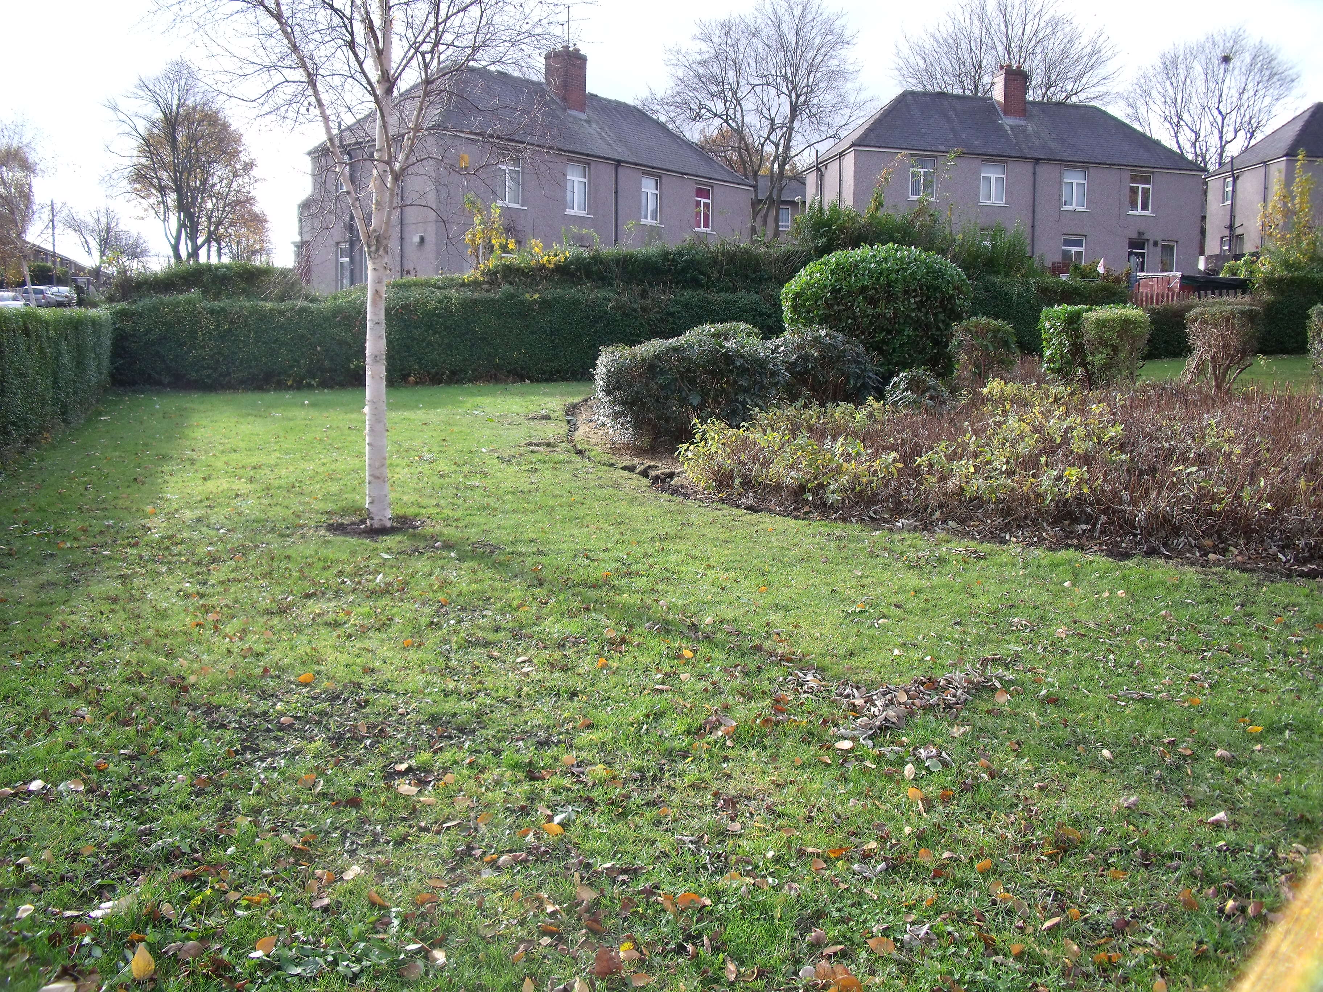

A quick and effective response to Anti-Social Behaviour

The January meeting will hear more about the current ASB service and explore the customer experience of reporting anti-social behaviour.

The membership of the steering group is:

Simon Mitchell – Sheffield City Council (Lead)
Dean Butterworth – Sheffield Homes
Lorraine Greeves – Sheffield Homes
Winnie Smith – Resident
Hazel Lowe – Tenant
The scope of this group is:

Support the creation of safer neighbourhoods
- by taking preventative action on nuisance and ASB
- through effective letting policies
- by encouraging tenants to respect the community where they live

Effective enforcement of tenancy conditions
- by making it easy and safe to report ASB
- by dealing with breaches in tenancy conditions quickly and effectively
- by tackling the perpetrators of ASB

Working better together to tackle Anti-Social Behaviour
- through a co-ordinated partnership approach to tackling ASB and related problems
David Hoad – Tenant
Josephine Hughes – Tenant
Gail Gibbons – Sheffield City Council

3

Clean, attractive neighbourhoods

The group’s January meeting will focus on understanding the current service, developing a vision for the future and analysing the gap between the two.

The membership of the steering group is:

Dean Fearon – Sheffield City Council
Steve Wellings – Tenant
Ron Roe – Tenant
Dawn Shaw – Sheffield Homes (Lead)
The scope of this group is:

Open Spaces
- that are clean and well kept
- that reflect the needs of local people
- that are clean, safe areas for children to play

Waste
- Speedy clearance of fly tipping and litter
- Effective collection of household waste

Education and Enforcement
- Swift action against people causing environmental nuisance
- Dog fouling is not tolerated

Shared areas
- Staircase and landings clean and in good repair
- External shared spaces such as paths and drying areas that are safe and well kept
- Customers encouraged to keep their neighbourhood clean and attractive


Jayne Foulds – Sheffield Homes
Michael Williamson – Tenant
Mick Daniels – Tenant
David Hargate – Sheffield City Council

A home to suit my needs

The January meeting of the group will explore the customer pathway and the route that people can take to access rehousing services.

The membership of the steering group is:

Jasper South – Sheffield Homes
Rosie Sheldon – Sheffield Homes
Richard Palmer – Sheffield City Council (Lead)
Sharon Schonborn – Sheffield City Council
John Kite – Tenant
Ann Bentley – Tenant
Ted Payne – Tenant
Paula McCartney – Tenant

4
The scope of this group is:

Maximising access to suitable housing
- by ensuring that people with the most need can access appropriate housing when they need it
- by letting the homes that are available in a fair and transparent way
- by making better use of empty properties in both council housing and the private rented sector

Better communication to support customer choice
- by improving understanding about the way that council housing is allocated
- by developing good quality information and advice to enable customers to understand their options

Working better together to enable independent living
- by making it easier to access regular tenancy support
- by developing early interventions for new tenants
- by supporting older or disabled tenants to live in a suitable home

Easy access to services

The January meeting of the group will consider information on how customers currently access services as well as more detail from the ‘It’s your shout’ consultation.

The membership of the steering group is:

Iain Allott – Sheffield Homes
Lynne Butler – Tenant
Eric Colley – Tenant
Margaret Hill – Tenant
Claire Lane – Sheffield Homes
Zoe Young – Sheffield City Council (Lead)
Fayzeh Mohamed – Sheffield City Council

The scope of this group is:

Easy access to information
- through a range of printed and digital media, and from council officers in person
- to help customers find answers to their questions quickly without unnecessary waiting or steps in the process

Easy access to services
- that provide a ‘one-stop’ solution wherever possible
- that meet customers’ needs
- that understand not everyone can go ‘digital’, and that digital services must be easy to use

Easy access when things go wrong
- by sorting out problems quickly and effectively

Easy access for all
- by treating people fairly according to their needs
- by recognising different customer groups have different needs

5

Making the most of our available income

The group’s work in the coming months will include a trip to the credit union, and making links with the Income Management Partnership Group.

The membership of the steering group is:

Maxine Stavrianakos – Sheffield Homes (Lead)
Doreen Mukasa – Tenant
Steve Pendlebury – Tenant
Liz Orme – Sheffield City Council
Jon West/John Squire – Sheffield City Council
Yvonne Collins – Tenant
Sandra Wright – Tenant
Frances Potter – Community Legal Advice Service South Yorkshire

The scope of this group is:

Well-informed and effectively-supported tenants and leaseholders
- who are aware of what welfare benefit reform means for them
- who receive good quality debt advice if and when they need it
- who are aware of what support is available, and can access that support, to manage their household budgets and bills
- who are aware of their responsibility in respect of paying rents and services charges

Maximising the money available to invest in homes and front-line services
- by taking a firm but fair approach to the collection of rent and other charges
- by effective management of the impact of welfare benefit reform
- through effective recovery of rent arrears, other HRA-related debts and other Council debts owed by tenants / leaseholders

Help tenants to make the most of their income
- by supporting tenants and leaseholders to maximise their income
- by better joining-up of services across the Council - including Public Health, Community Care and Revenues and Benefits

Joined up services that better support me

The steering group for the ‘Joined up services that better support me’ has a bigger membership than the other seven. This is to help them manage a wide ranging remit with several different strands.

The membership of the steering group is:

Dean Butterworth – Sheffield Homes
Bev Mullooly – Sheffield Homes (Lead)
Jasper South – Sheffield Homes
Julie Knight – Sheffield City Council
Lorraine Jubb – Sheffield City Council
Hazel Dobson/Sam Martin – Sheffield City Council

David Bernard – Tenant
Ken Turton – Tenant
Tony Merrygold – Tenant
Anthony Watson – Tenant
Eric Staniland – Tenant
Christine Scarborough – Tenant

6

The scope of this group is:

Supportive and joined-up services
- Easy access to more than just housing
- Closer working with health and social care
- Better understanding of individual and family needs

Tenants who achieve more
- By maintaining a successful tenancy
- Through support for their health and wellbeing

Better value for money (VFM)
- Less duplication
- More co-ordination
- Getting things right first time


What comes next?

Other news

This newsletter will be produced on a monthly basis. We’re really keen to hear your views and feedback so if you have anything to feed in to any of the groups contact the Project Team at planningthefuture@sheffield.gov.uk or telephone 0114 205 3908.

