

**Magenta Living Scrutiny Group**

**Scrutiny Report**

**Review of Estate Walkabouts**

**Review Date: January – June 2014**

Contents

**Appendices 3**

**Acknowledgements 4**

**Introduction 5**

**Purpose of the Report 5**

**Scope of the Review 6**

**1. Estate Walkabouts** 7

**2.** **Participation in walkabouts** 8

2.1 Observations 9

**3.** **Review of the current process of walkabouts** 10

3.1 Process 10

3.2 Advertising 10

3.3 Participation 10

3.4 Spread Sheets 10

3.5 Action taken after walkabouts 11

3.6 TP Tracker 11

**4.** **Supported Housing** 11

4.1 Our Findings 11

4.2 Observations with Supported walkabouts 12

**5.** **Block Champion Model** 12

**6.** **Northwest and Cheshire Peer Review Group** 13

6.1 Housing Quality Network Toolkit 14

**7.** **Health and Safety** 14

7.1 Findings 14

**8.** **Results from Staff Survey** 16

**9.** **Resident Survey** 17

**10.** **Good practice from other Housing Associations** 17

**11.** **Overall Comments and Recommendations** 19

**12. Appendices** 24

# Appendices

Appendix 1 – What is an estate walkabout.....................................................................................28

Appendix 2 – Current standard form used for walkabouts.........................................................29/30

Appendix 3 – Block Champion Score Card................................................................................

Appendix 4 – Peer Review Score Card

Appendix 5 – Officer Survey Responses

Appendix 6 – Resident Survey Responses

Appendix 7 – Job Description of Tenant Services Officer

Appendix 8 – Sample form including scoring system – Calico Housing

# Acknowledgements

Members of the group who took part in the review are as follows:

* Carol Wood
* Glenn Wood
* Jean Ostle
* Des Smith
* Susan Proudlove

The Group would like to thank the staff of Magenta Living who took part in the interviews and provided information during the course of the review. They were as follows:

* Ian Johnson
* Lauren Duggon
* Karen Whittle
* Mark Hulmston
* Tenancy Services Officers
* Denny Beacham
* Maureen Davies
* Phil Hayley
* Allan Williams
* Caroline Littlewood
* Ann Mulholland

Our thanks also to the following organisations that provided us with information:

* B3 Living
* Calico
* Coast and Country Housing
* Coastline Housing
* Cross Keys Homes
* Livin
* New Charter Housing
* Newydd
* Peaks and Plains Housing Trust
* Stafford and Rural Homes
* Stockport Homes
* The Riverside Group
* Trafford Housing Trust
* Wolverhampton Homes
* Yarlington Housing Group

# Introduction

The Magenta Living Scrutiny Group is part of Magenta Living’s approach to co-regulation, involving customers in monitoring what it does, verifying performance, identifying areas of good practice and value for money. It provides assurance for tenants and the Board that performance targets and service improvements are being delivered.

## Purpose of the Report

The purpose of this report is to present the findings of the Magenta Living Scrutiny Group’s review on Estate Walkabouts.

The scrutiny project was carried out between January and June 2014.

# Scope of the Review

The Magenta Living Scrutiny Group decided to review the process of Estate Walkabouts following comments received from involved residents at the Umbrella Meeting who were dissatisfied with the service being provided.

Members of the Umbrella commented that:

* There is a lack of knowledge and awareness by residents because walkabouts are not promoted well enough.
* There is poor attendance from residents. Residents do not know where and when the walkabouts happen
* Overall, there is a poor perception of walkabouts because there is a resident view that not much is actually achieved
* Inconsistencies in terms of regularity of walkabouts – some

neighbourhoods have them often, others do not.

The group set out to:

* Establish current working methods, policies and procedures.
* See if the group can suggest improvements to make estate walkabouts more effective.

The group gathered information and evidence for the review through:

* Performance information was requested
* Meeting with Service Head
* Meeting with Grounds Maintenance Head
* Meeting with Health and Safety Manager
* Meeting with Neighbourhood Management Team Leader
* Desk Top review – data from TP Tracker
* Desk Top review – information gathered from other Housing Associations
* Review current processes for walkabouts
* Participation in Walkabouts in different areas
* Informal discussions with officers during walkabouts
* Online Survey of all Tenancy Services Officers
* Survey of residents
* Detailed list of questions

# Estate Walkabouts

The group first asked five key questions about walkabouts:

* 1. What is an estate walkabout?
  2. What is looked at during an estate walkabout?
  3. Who completes estate walkabouts?
  4. Why does Magenta Living conduct estate walkabouts?
  5. What happens after an estate walkabout?
* An estate walkabout is quite simply a scheduled and publicised walk around estates owned or predominantly owned by Magenta Living. Walkabouts are completed regularly throughout the year and are used as a tool to identify and resolve any potential issues. They also give residents the opportunity to discuss any concerns or ideas they may have for their area.
* Estate walkabouts are used to identify issues that are the responsibility of Magenta Living, as well as other agencies i.e. Local Authority and can include the following:
  + Anti-Social Behaviour
  + Faults with gardens
  + Street Pavement
  + Graffiti
  + Abandoned Cars
  + Fly Tipping
  + Grass cutting
  + Dog fouling
  + Repairs
  + Vandalism
  + Neglected areas
* Walkabouts are carried out by Tenancy Services Officers (TSOs) (formally Neighbourhood Management Officers) and areas are split into ‘patches’ with each Officer responsible for the walkabouts in their patch, most are done bi-monthly or quarterly.
* The Walkabouts give staff the opportunity to spend time on the estates, helps them to identify issues, give them an awareness of what is going on, ensure estates are clean and tidy and obtain residents views where possible.
* During the walkabout Magenta Living Officers make a note of any issues raised or noticed and actions these when they return to the office. We have been informed that issues are checked on the next walkabout.
* The outcomes of the Estate Walkabouts are published on the Magenta Living website on a monthly basis.

The group also asked:

* 1. Do Magenta Living need walkabouts?
  2. Are tenants needed on walkabouts?
  3. Do tenants know what walkabouts are about?
  4. How does a tenant know when a walkabout will take place?
  5. Does it have to be an officer who completes the walkabout?

1.11 Does the walkabout have a benefit to the estate?

* The group recognise that estate walkabouts are an important element to ensuring Magenta Living shows a presence on estates and cares about the condition of their properties and the surrounding areas. It was agreed by the entire group that Magenta Living does need to continue walkabouts.
  + The group does not believe that estate walkabouts currently offer value for money (VFM).
* The group also feels that tenant participation is important as they know the areas well and are able to share personal experience with the officers. Participation from residents allows officers to concentrate on things that concern everyone in the area and help make the areas better places to live.
* Walkabouts are open to all residents to attend. On occasion, councillors and other members of staff have attended where invited/required. Councillors are not invited by Officers, only a handful of councillors participate and this is at their own judgment. Local Tenant and Resident Associations (TRAs) are able to invite local councillors along.
* Walkabouts are advertised in various ways, i.e. on the Magenta Living website and in the Tenant Newsletter.

Letters are also sent to residents who have previously confirmed they would be interested in participating.

* The group also considered whether a Magenta Living Officer needs to complete the walkabout. In some areas the group agreed that the presence of an Officer is required. However in less troublesome areas this may not necessarily be the same.
* The group agree that the walkabouts are of a benefit to the estate. The group looked over 3 or 4 consecutive walkabouts in different areas. The results showed that the majority of issues raised at one walkabout are rectified by the next.

1. **Participation in walkabouts**

The group decided that in order to fully understand the scope of the walkabout system they would need to attend and complete some walkabouts with Officers in different areas.

The reason behind this was to see whether the Officers take a uniformed approach to estate walkabouts.

Group members attended walkabouts in

* + Knutsford Green
  + Overchurch
  + Bidston Rise
  + Peel Avenue Estate

It was agreed by the group that although generally the Officers are looking at the same issues, each Officer took a slightly different approach (using their own judgement) conducting the walkabout.

Whilst we do not think this is a concern, it would be better for the department if a streamlined approach was taken so that all areas received a consistent approach and therefore level of quality to the walkabout.

## 2.1 Observations

* On each of the walkabouts the Officer arrived on time to complete the walkabouts.
* Each officer had the standard form with them to complete on the walkabout.
* 3 out of the 4 officers wore a Magenta Living High-Vis Jacket.
* 2 out of the 4 officers introduced themselves.
* 2 out of 4 officers provided a brief outline of the walkabout route but no Health and Safety advice which we would have expected.
* All of the officers wore their Magenta Living ID Badge.
* Resident participation was poor overall, however the following was noted:
* Those residents, who did attend, knew the officer completing the walkabout.
* The Officer gave the residents who did attend, their full attention, and engaged with them throughout the walkabout.
* Officers provided updates to residents from previous walkabouts.
* Unfortunately, Officers could not provide updates on issues being resolved by other agencies.
* Officers welcomed questions from the group and other residents participating.
* Although some residents did not attend to complete the full walkabout, there were plenty who stopped the Officers during the walkabouts to report/point out issues.

The group agree that this is a positive contribution to walkabouts as residents felt able to raise concerns without having to participate in the whole walkabout.

* The officers thanked the group of residents for participating.
* The time taken to complete the walkabouts was varied, as was the size of the areas covered. Walkabouts we participated in all lasted approximately 2 hours.
* 2 of the scrutiny group are wheelchair users and unfortunately a lot of the areas covered where not ‘wheelchair friendly’. This resulted in 1 area the group becoming disjointed as the officer proceeded ahead of the wheelchair users with the other tenants who were participating in the walkabout.

TSOs do not carry out estate walkabouts around supported housing schemes; these are carried out by the Supported Housing Officer responsible for that area.

1. **Review of the current process of walkabouts**

The following findings are what the group’s research show the process currently to be for walkabouts.

* 1. Process
* Walkabouts are carried out monthly by the officer responsible for that area as part of the officers contracted duties.
* The dates for the walkabouts are planned and advertised in advance by clerical staff.
* Each estate has a bi-monthly or quarterly walkabout
* There is no written procedure for officers to follow.
* Other than the Lone Worker System there are no other specific health and safety procedures in place.
* Officers do not receive any specific training to complete the walkabouts.
* Officers complete a standardised form on the walkabout. (Appendix 2)
* The officer is given 2 hours to complete the walkabout,
* A further 2 hours to complete the paperwork is given back at the office to raise any other issues either internally or with other agencies.
* Subsequent/further walkabouts can be organised in an area to review a certain issue if deemed necessary.
  1. Advertising
* Residents can find a list of walkabout dates on the Magenta Living website.
* A timetable of walkabouts is published in the quartile Tenant Newsletter. The newsletter is delivered in March, June, September and December to every Magenta Living tenant and leaseholder.
* Residents who have expressed an interest in walkabouts are sent a letter inviting them along to walkabouts 2 weeks prior to the walkabout by the clerical staff.
  1. Participation
* Resident participation is poor overall. Some walkabouts attract 3 or 4 tenants; others have no participation from residents.
* All walkabouts are during standard working hours on a week day.
* Councillors can be invited if required, however those that do attend, do so normally of their own volition.
  1. Spread Sheets
* TP Tracker is completed following the submission of paperwork from the officer to record the data.
* The “Estate Walkabout Interested Parties” Spreadsheet contains a list of 55 residents who have confirmed they would be interested in participating in walkabouts. These are the people who are contacted via letter 2 weeks prior to a scheduled walkabout, followed up by a phone call 2 days before.
  1. Action taken after walkabouts
* Officers have 2 hours to complete their paperwork and report any issues that they came across, either internally or to other external agencies such as WBC.
* There is no consistent approach taken as to whether the officer follows up on requests
* There is no consistent approach taken as to whether the officer follows up with residents.
  1. TP Tracker
* TP tracker information was reviewed from April 2013 to April 2014 giving a full year worth of data to review.
* According to the data we received, 189 hours of walkabouts where completed for the year over approx 102 estates in the Wirral.
* Of the walkabouts completed a total of 19 residents attended across 17 estates.
* Of the 19 residents in attendance, only 1 of them featured on the “Estate Walkabouts Interested Parties” Spreadsheet that our Officer had access to. We were not privy to this due to data protection legislation.

1. **Supported Housing**

Supported Housing is the department within Magenta Living who manage around 1640 sheltered properties across the borough.

Supported Housing has 3 Housing Officers (SHO’s) who provide housing management for the sheltered stock. The SHO’s also manage a team of Support Officers who provide the tenancy support service to both sheltered and general needs tenants.

The primary functions of the SHO mirror that of the TSO in that they complete new tenant visits, they complete conversion visits, carry out annual inspections and conduct estate walkabouts of the sheltered schemes.

The SHO’s take a flexible approach to their appointment system as due to the nature of their working environment they need to be able to react to emergency situations promptly.

Each SHO has an area that they are responsible for, similar to the ‘patch’ that the TSO’s have. Within their areas the SHO’s are responsible for completing estate walkabouts.

The group asked the SHO’s some questions to establish whether they work in a similar way to the Neighbourhood Management Team or whether the approach is completely different.

Unfortunately only two of the SHO’s were available to respond to our questions as the third was on long term sick leave.

## 4.1 Our Findings

* One of the SHO’s schedules walkabouts monthly, the other SHO has not had the time to schedule walkabouts and so has not done any for a length of time. The SHO did confirm that once the inspections start again they will be monthly.
* The SHO confirms that walkabouts are scheduled and carried out in the winter – although it was noted that the weather is not always conducive to a good turn-out from residents or a good inspection.
* One SHO confirmed that they invite all residents from the area to the walkabout via letter. The letter is sent a minimum of 1 week in advance.
* The letters are the only way that the supported scheme walkabouts are advertised. They are not included on the website or in the Tenant newsletter.
* Support officers encourage residents to participate in walkabouts or will notify the SHO of any areas of concern on the resident’s behalf.
* One SHO confirmed that they complete a standard form for the walkabout.
  + This has been confirmed as the same form used by the TSO’s.
* Both SHO’s agreed that resident involvement in the walkabouts varies depending on the area. There are areas that residents are more interested than in others.
* The length of time taken to complete the walkabout varies from 30 minutes to a few hours dependent on where the walkabout is and how many residents are accompanying the officer.

## 4.2 Observations with Supported walkabouts

* Although we have been informed letters are sent out 2 weeks in advance, one resident confirmed that she had received the notification on the same day as the walkabout.
* The Officers do not seek to actively engage people – they do not knock on doors to encourage participation. However support officers do provide the SHO’s with information on issues.
* There is no timetable for the walkabouts published in advance – they seem to be completed at random when the officer can fit them in.

1. **Block Champion Model**

As part of the process of exploring potential recommendations the group looked into the Block Champion Model designed and implemented by the Environmental Services Team.

The model allows residents the opportunity to get involved as little or as often as they choose to. The block champion role is a driver of continuous improvement. They will provide feedback to the team on what needs to improve and check to ensure the improvements happen.

The leaflet that promotes the involvement states that “by working alongside our customers we want to deliver services that meet their needs and aspirations and help us to achieve standards of excellence across our neighbourhood’s.” The same should be said for estate walkabouts.

* The champion is given training and guidance by the Grounds Maintenance team on what to look for and how to complete the form.
* The block champion completes the inspection alone, at a time convenient to them. They can choose how often to submit a form, however, if they do not submit one for 3 months this is followed up by the team.
* The block champion reports any issues with cleaning, security, grounds maintenance, repairs, fly tipping and graffiti in or around their block by filling in the short inspection sheet, which is then returned to the Environmental Services Team.
* Block champions are rewarded at the end of the year with a reward of £100 towards something for their block.

Items that have been purchased with the reward incentive include:

Benches

Hanging baskets

Planters

The group feel this is an excellent model that could be replicated into something similar for estate walkabouts, perhaps breaking areas down into streets.

Residents appear to be keen and embrace being a block champion; we feel this may be because they can complete the inspections in their own time therefore they do not need to commit to being in a certain place at a certain time.

As blocks are self contained the area is familiar and personal to the tenant, the same could be said for a resident to become an inspector for a street.

1. **Northwest and Cheshire Peer Review Group**

As well as researching the Block Champion Model, the group also spoke to Maureen Davies with regards to the Housing Quality Network Toolkit that we came across during our research. The toolkit has been adopted by other housing associations, and is currently used with Magenta Living in the Environmental Services department.

Maureen explained she implemented the ‘Northwest and Cheshire Peer Review Group’ in November 2013.

The group is made up of estate staff and customer representatives from organisations. The group visit each other’s blocks and estates over a set period on a planned programme.

The group use the Housemark published photo book which was introduced by Housemark in 2009.

Maureen explained to the group that the peer review group currently score Magenta Living’s blocks. (See Appendix 3)

## Housing Quality Network Toolkit

* The toolkit has been created by Housing Quality Network (HQN) to enable landlords to effectively monitor the performance in delivering excellent estate management services. Overall, the toolkit highlights the importance of estate management for residents.
* The purpose of the toolkit is to assess the delivery of estate management services against a series of questions under some key headings. Key headings include ‘effective service delivery’, vision & leadership of the service, ‘customer focus’, ‘performance management and ‘value for money’.
* This toolkit allows users to compare quality and value for money aspects of services between estates, regardless of the type of organisation, the properties being judged, or where in the country they are located.
* The elements in the book are split between caretaking/cleaning and Grounds Maintenance. It provides a level playing field for all members to score estates fairly and consistently, providing a visual and verbal description of the standards to benchmark against.
* A scorecard (see Appendix 4), which has been issued to all ‘Northwest and Cheshire Peer Review Group’ members along with the Housemark published photo book, has been designed for collecting the results of the Peer Review visits. These results can then be benchmarked against other members using HouseMark’s PI Tracking service.

The Neighbourhood Management team do not utilise the toolkit at present.

1. **Health and Safety**

Health and safety of officers should be paramount during estate walkabouts as there is a certain degree of vulnerability being out and about on estates potentially unaccompanied.

This prompted discussions amongst the group who questioned whether or not the Tenancy Services Officers follow any Health and Safety procedures when completing walkabouts.

Does a health and safety procedure for estate walkabouts exist?

## 7.1 Findings

The group met with Denny Beacham, Health and Safety Manager. Denny confirmed that whilst there is no specific procedure for estate walkabouts the officers receive the following;

* Officers receive regular training relating to their duties and responsibilities when visiting worksites, tenants and when carrying out inspections, this training is enhanced for staff who should be classed as ‘lone workers’. Awareness training starts on the employees first day at induction, all new staff will then attend a two day full corporate induction that will include:
* General Health & Safety
* Fire Awareness
* Lone Worker - covering systems and procedures

The above sessions are presented by Magenta Livings full time Safety Manager.

* Included in the training described above, staff will be made aware of their duties to tenants when working with tenancy groups e.g. the Scrutiny Group and also when visiting a tenants home. This is further emphasised during other mandatory training sessions such as Customer Care, Safeguarding, Equality & Diversity, Resilience & Wellbeing and Professional Boundaries.
* Magenta Living has developed a full ‘Lone Worker’ policy and procedures to protect staff and to reduce the risks associated to lone working to a minimum, this includes:
  + Lone Worker training.

Use of the ‘Lone Worker’ system – all staff that are identified as potential lone workers will be given access to an in house service based on their company issue mobile phone or ROMAD device (handset specifically designed for lone workers). This system ensures that the member of staff can summon help in the event of an emergency and be located either by leaving a recorded message giving visit details on an automated system or by activating the SOS button on a ROMAD device.

Staff receive regular briefings relating to personal safety and conflict management.

* If the safety or welfare of our staff would be compromised by inclement weather e.g. snow and ice, visits will be cancelled unless the visit was essential for health and wellbeing of a tenant e.g. Building Services and Estate Services sent out to deliver essential food and drink to vulnerable tenants during heavy snow falls in January 2012.
* Every effort is made to keep staff informed of any changes in legislation, guidance and best practice. This can be done either at team meeting, Priority Training sessions and through the company intranet and magazine.
* Magenta Living is bound by legislation (the Data Protection Act) to manage any information held on its systems relating to its tenants, however, this information can be used to prevent an incident that could cause harm to a member of staff, this allows us to use limited information to prevent a member of staff going into a potentially hostile situation. The information could relate to a known problem, reference to a tenant with a vicious dog etc. The ASB team report regularly to the company Health & Safety Committee on all incidents relating to verbal threats/abuse and actual or threatened violence to staff. Due to the nature of the information no personal information is included in the report e.g. individual’s names etc.
* Staff who work out in the field as a regular part of the work are provided with suitable and sufficient clothing and equipment for inclement weather, this will include:
  + Shoes/safety footwear.
  + Company issue coat.
  + Company issue fleece.
  + Waterproof hi-vis jackets.
  + Some teams working for our Building Services will be issued full wet weather wear.
  + During snow or icy conditions we have issued anti slip devices to be worn on an individual’s shoes.
* Other safety equipment would include high-vis waistcoats and hard hats depending on the requirements or nature of the work being undertaken. Our Security Officers are issued with a dog repellent called ‘Bite Back’, this spray is designed to be harmless to the dog and only acts as a repellent; its use is strictly controlled.

Information relating to health, safety and welfare issues are maintained on the corporate intranet, this includes:

* Health & safety related policies and procedures.
* Relevant documents.
* Video links e.g. the British Heart Foundations ‘Vinnie Jones’ Cardiac Arrest advert and the Stroke Associations ‘FAST’ advert giving advice on stroke recognition.

1. **Results from Staff Survey**

The group decided that one of the crucial groups of people to speak to about Estate Walkabouts was the officers who carry them out. The majority of the officers have been carrying out the role for a length of time and so their individual experience and knowledge is vital as part of our review.

A list of questions was drawn up by the group and presented to the officers in the format of an online survey. The answers received will remain anonymous.

The results showed that although all the Officers looked for the same basic issues on walkabouts, some are going further and more in detail. Therefore there is not a consistent approach to walkabouts across the estates.

88% of those asked think that walkabouts are useful. The general feeling amongst the officers is that walkabouts show a positive approach to identifying and rectifying issues. However it was also noted that there isn’t anything picked up on a walkabout that couldn’t be picked up on routine visits/appointments.

The walkabouts are seen by the officers as an informal way for residents to approach Magenta Living staff, particularly for those residents who may not ordinarily approach with issues.

There were a number of suggestions made by officers to include multi-agencies on the walkabouts, particularly more WBC staff attending as a lot of the issues need to be passed over to WBC to resolve.

Other departments should be encouraged to participate as well, for example representatives from repairs or the enforcement team.

Only 77% of the officers follow up on repairs made; whilst the group appreciate that repairs are not the officers responsibility, if a resident has been involved in the walkabout and recorded an issue, the person they associate this with is the TSO/SHO and would expect the TSO/SHO to update them.

(Charts showing the data quoted can be found in Appendix 5)

1. **Resident Survey**

The group recognised that we needed to establish how residents feel about estate walkabouts. A small list of questions was drawn up and a sample survey was carried out on 53 residents.

* 71% of residents surveyed confirmed that they knew what an estate walkabout is.
* 54.7% of residents surveyed confirmed that they had not seen an advert for a walkabout for their area.
* 62% of residents surveyed have never taken part in a walkabout in their area.

There were various reasons given from residents who participated and from those that didn’t. The group found the reasons to be of great interest as many of the residents shared the same view points.

For those who do attend, the primary factor is to help Magenta Living improve the neighbourhoods and build strong communities. One resident confirmed she regularly participated due to being the victim of ASB; she tries to ensure her neighbourhood is a friendly and safe environment.

However, 4 of those surveyed commented that although they participate they feel the walkabouts are ‘a waste of time’ as ‘nothing seems to change’.

For those who did not attend, various comments were made as to why. Some residents stated they didn’t know what the walkabout was, others said they simply didn’t have the time to go or work full time which prevents them attending during the day. Comments were also made that there is a lack of information as to when and where the walkabout is taking place and more than one person commented that they do not feel the walkabouts make a difference.

(Charts showing the data quoted can be found in Appendix 6)

1. **Good practice from other Housing Associations**

As part of the review we researched a number of Housing Associations to draw comparisons of how estate walkabouts are conducted around the UK.

A high proportion of those that provided us with information all had a formal procedure for the estate walkabouts which includes specific details of how the walkabouts should be conducted. Whilst each of the Housing Associations took slightly different approaches, the need for a formal procedure was considered an important part of the structure in order to provide a consistent approach to the quality of the walkabouts.

A number of housing providers utilise a classification/grading system of some description. These range from a rating of A, B or C or graded as ‘Excellent, Very Good, Good etc’. [Stockport Homes]

Stafford and Rural Homes use a scoring system, each street is given a score based on its appearance, the street scores are then totalled up at the end of the walkabout to give an overall grade. Stafford and Rural Homes provided the below

|  |  |
| --- | --- |
| Rating System Guide... | |
| **3** | Estate is clean, tidy & to a good standard with no issues raised. |
| **2** | Estate is clean & tidy with few issues raised. |
| **1** | Estate is fairly untidy with several issues raised. |
| **0** | Estate very untidy with large amount of issues reported. |

We were particularly impressed at how Riverside classifies their neighbourhoods. The classifications are reviewed annually and are given a rating of A, B or C dependent upon factors for example:

[Taken from Riverside Inspection Procedure]

**Neighbourhood A**

* High turnover of voids
* High levels of expenditure on voids & re-active repairs
* High levels of ASB
* High levels of abandoned properties
* High levels of burglaries

**Neighbourhood B**

* Medium to low turnover of voids
* Medium to low level expenditure on voids & re-active repairs
* Medium to low levels of ASB
* Medium to low levels of abandoned properties
* Medium to low levels of burglaries

**Neighbourhood C**

* Very low turnover of voids
* Very low level expenditure on voids & re-active repairs
* Very low levels of ASB
* Very low levels of abandoned properties
* Very low levels of burglaries

‘As a guide a high number of voids/ASB cases etc would be 30%’

The frequency of the walkabouts is then determined by the classification, Neighbourhoods rated as an ‘A’ will be visited monthly, those as a ‘B’ will be visited quarterly, those rated ‘C’ will be visited annually.

Publicising/Advertising of walkabouts is vital to ensuring effective resident participation. This is something key that other Housing Associations focus on.

Wolverhampton Homes ensure they display posters in relevant Housing Offices, local shops, estate notice boards and tenant meeting rooms, giving details of where and when the walkabout/inspection will take place.

Weaver Vale Housing Trust utilise local press to advertise walkabouts – this ensures the wider communities have the opportunity to attend the walkabouts on the estates.

Social media is used as an advertising medium by Cross Keys Homes.

Wolverhampton Homes also send an email to Wolverhampton City Council as a matter of course to invite partners along to the walkabout.

Stafford and Rural provide all attendees on their walkabouts with high-vis jackets with ‘SARH Estate Walkabout’ so that they are more visible on the estates.

Cross Keys Homes formed a community focus group made up of residents who work together to develop and deliver action plans for ‘hot spot’ areas. The group also work closely with local resident groups were appropriate, this way of working ensures that residents are at the heart of the process.

1. **Overall Comments and Recommendations**

Following the completion of the review, the group believe estate walkabouts are an excellent tool to ensuring Magenta Living stock is maintained well and offers value for money to residents. The process of walkabouts should be used as a tool to continually strive to improve neighbourhoods and improve customer satisfaction and kerb-side appeal. There are elements of the current process carried out by Magenta Living that the group believe are good and should continue. However, the group have identified areas within the current system in need of some small improvements.

The group want to highlight to Magenta Living that the simple act of an estate walkabout has the huge potential to improve neighbourhoods and build on community spirit. It is an exercise that can help build trust and mutual respect between Magenta Living and its residents.

The group were impressed at the organisation of the estate walkabouts; all officers know the dates of the walkabouts due to the schedule being drawn up in advance. This gives structure to the walkabouts; the timetable can be accessed on the Magenta Living website.

The group also liked that each of the officers completes a standard form for the walkabout. It is important that a standard form continues for continuity across the neighbourhoods to try and ensure the same level of quality throughout.

It is also good practice to see that Magenta Living actively tries to engage residents by sending out invitation letters prior to the walkabout. However, it was noted that the ‘Interested parties’ spreadsheet was not up to date; this is an excellent tool for engagement, but the information needs to be current. Residents who have participated over the last year on walkabouts (as per data from TP Tracker) are not included on the sheet and 5 of the people on the spreadsheet no longer live at the address listed.

As a matter of course names and addresses of residents who participate in walkabouts are noted on the standard form – these should be checked against the data held on the spreadsheet. We do feel that resident participation should be encouraged and like the way Supported Housing send a letter to all residents within the vicinity of the walkabout inviting them to join in.

We also feel Magenta Living is demonstrating good practice by utilising the TP Tracker system to monitor the walkabouts and by sharing the outcomes of the walkabouts on the Magenta Living website. This demonstrates transparency to the residents.

We were extremely impressed with the officers that we had the pleasure of meeting. They were all very welcoming and approachable and happily responded to our questions and were interested in our comments. This approach makes it far more of an enjoyable experience for residents. Staff should continue to ensure that their attitude is welcoming and professional and continue to acknowledge residents and engage in conversation.

There is an inconsistent approach to walkabouts within Magenta Living which means that some customers do not have any trust or confidence that improvements can be made in some areas. We feel that Magenta Living need to have greater and stronger accountability and consistency in the way identified issues and concerns are addressed, and be efficient in the way issues are addressed to increase customer satisfaction.

The group recognises that a high number of the issues identified on walkabouts have to be passed over to other agencies to resolve. Unfortunately because the officer does not receive or chase feedback this reflects badly on Magenta Living as residents simply see Magenta Living as not actioning the request. The group does feel that the TSOs need to improve on the feedback they are giving.

The group has questioned the accuracy of the data being submitted to TP Tracker. The survey completed by staff asked the question “what is the average time an estate walkabout takes you?” – 29% of the officers answered between 1.5 – 2 hours and 41% answered 1 – 1.5 hours. According to the information on TP tracker between April 2013 and April 2014 every single walkabout inputted took between 0.5 – 1 hour. Our discussions with officers during the walkabouts about the length of time they take to complete walkabouts, also leads us to believe that TP Tracker is inaccurate. TP Tracker is an excellent tool to keep track of walkabouts and trend analysis, but the information needs to be accurate.

Not only is there no consistent approach to walkabouts within Neighbourhood Management, there is also a lack consistency with those carried out by the SHOs. This has a direct impact on the quality of service being provided to Magenta Living tenants and highlights the current lack of VFM in estate walkabouts as some areas are having them regularly, whilst others haven’t had any for over a year.

The group was also impressed with the information given by Maureen Davies with regards to the Toolkit and Block Champion Model. These are two methods of working that show transparency and consistency, ensuring the services being delivered are of high quality and demonstrate VFM.

We have created a list of our recommendations for changes to estate walkabouts that we feel Magenta Living should act upon. We do feel that Supported Housing, although a separate department should aim to follow the same procedure and processes that we have recommended. These recommendations are detailed on the next pages.

|  |  |  |
| --- | --- | --- |
| Recommendations | Reasons why we have recommended | Our expected outcome |
| Update the 'Interested Parties' Spreadsheet with the information of tenants who participate. | To ensure the information held on the spreadsheet is current. | The people interested in the walkabouts will be receiving the information about them. |
| Adopt a 'Street Champion' Model, similar to the Block Champion model all ready in place. | Similar to the block champion model - give local tenants the empowerment to carry out 'mini walkabouts' on their street. | Tenants would take pride in their area and be empowered to carry out walkabouts; this would allow officers more time to concentrate on more troublesome areas. |
| Categorise streets/estates with a number rating scheme. | Reduce the number of walkabouts carried out in good areas to concentrate resources on more troublesome areas. Utilise the street champions in good areas. | We would expect to see improvements in troublesome areas and help to maintain the good. This method would give data that could be monitored to show when areas were improving or if things were slipping |
| Estate Awards linked with categorising of estates. | To recognise the hard work of residents in maintaining neighbourhoods to good standards. | Rewards/Recognition would demonstrate to residents that Magenta Living appreciates residents taking an interest |
| Formal procedure to be drawn up on how walkabouts should be completed. | A procedure allows for a uniformed approach that would be consistent across all officers. | All areas would receive the same level of service. |
| Adpot the Housemark Quality Network Toolkit and peer group inspections. | This toolkit is an excellent way to benchmark against others and ensure quality and consistency. This will also tie in with categorizing streets/estates. | A uniformed approach that is easily monitored, recorded and benchmarked. This will enable resources to be utilized in the most efficient way, therefore increasing VFM. |
| Cease carrying out walkabouts between November and March. | During winter months the weather potentially hinders the walkabout/tenant participation in the walkabout. | This would have a VFM cost saving on the time spent on inspections per officer. |
| Utilise social media such as Twitter and Facebook to advertise the walkabouts | Advertising of the walkabouts is poor and only reaches a limited audience at present. | More involvement from a wider audience. Possibly younger generation could also be engaged. |
| Utilise local resident groups to ensure they are informed about upcoming walkabouts for their estates. | This would keep the local residents up to date particularly if minutes/newsletters are utilised to inform the residents. | More local involvement and better communication between Magenta Living and Tenant and Resident groups. |
| Utilise community notice boards for timetables. | This would help to reach the wider community. | Involvement from the wider community. |
| Utilise social media such as Twitter and Facebook to provide short feedback about the walkabout. | This would demonstrate the outcomes of the walkabout and show that Magenta Living are active in the communities. | This would help identify VFM as residents will be able to see the outcomes of the walkabouts, building trust and confidence that they do make a difference. |
| Use the Tenant newsletter to provide an update on how the walkabouts are going. | Regular feedback and updates shows residents that things are happening and keeps it fresh in people's minds. | This would help identify VFM as residents will be able to see the outcomes of the walkabouts, again this would build trust and confidence in the organisation. |
| Obtain and utilise email addresses for residents and email reminders of upcoming walkabouts. | To increase the number of people being contacted at a lower cost than printing and posting letters. (Reduction in cost of posting = VFM saving). | Sending information to a wider audience would increase awareness and hopefully numbers attending the walkabouts. |
| Text reminders of walkabouts to residents. | Text messages are less formal and serve as a reminder to keep it fresh in people's minds. Automated systems can be set up to send repeat reminders. (Reduction in admin time = VFM Saving) | Sending information to a wider audience would increase awareness and hopefully numbers attending the walkabouts. |
| Adopt a new form that also incorporates the rating scheme. | A new standardised form to incorporate the rating scheme that allows for ease of monitoring. | New standard form with only relevant information on it. The data for the rating can be used to monitor estates. |
| Walkthrough guidance of walkabouts for new officers. | Although general training is received we unaware of any specific 'on the job' walkabout training which we think might be beneficial to new officers | A consistent approach to conducting walkabouts to be followed by all officers. |
| Give the officers the opportunity to rotate to different patches every 6 months. | To give a fresh outlook on the areas and new ideas for improvements. | Better quality of neighbourhoods as more than one input from Neighbourhood Management. |
| Involvement from other service areas such as the D2D Inspectors. | Utilise other service area expertise particularly in Summer months when call/job volume is lower. | Improve the response and quality of the walkabouts. Areas of expertise can become responsible for their respective areas and report back to residents. |
| Magenta Living Hi-Vis vests to be worn on walkabouts. | As well as the H&S aspect the vests give an immediate indication that Magenta Living is present on the estates. | Tenants will instantly recognise an officer and feel more confident in approaching with any concerns. |
| Pilot evening walkabouts in the Summer. | Residents commented during the survey that they were unable to attend due to work commitments. By piloting a summer evening walkabout this would stop exclusion residents who work/volunteer during the day. | Potential pilot to see if more residents do participate in one off evening walkabouts. |
| Formulate a focus group to consult with. | Encourages resident participation and feedback about the services provided. | A wider engaged community that could promote walkabouts to other residents. |

# Appendices

Appendix 1

**WHAT IS AN ESTATE WALKABOUT?**

An Estate Walkabout is a scheduled and publicised ‘walk’ around the estates and neighbourhoods managed by Magenta Living.

It is carried out by officers from the Neighbourhood Management Team(s) and accompanied by local residents, were possible.

The purpose of the exercise is to check the estates for signs of fly-tipping, graffiti, abandoned vehicles or anything else that spoils the appearance of the neighbourhood.

Anything untoward that we discover is reported to the relevant section within Magenta Living e.g. Environmental Services and action is taken to remove the blight. The Estate Walkabout is also an opportunity for us to show residents that we are a visible presence in the area.

The team(s) carry out Estate Walkabouts in the majority of areas where Magenta Living manage properties and last year we undertook over 200 individual ‘walkabouts’

Estate Walkabouts are currently publicised on the Magenta Living website – <http://www.magentaliving.org.uk/our-services/Your_Neighbourhood/Estate_Walkabouts/WalkaboutOutcomes.aspx> – a list of the dates, times and meeting points are included for the coming month. Tenants who have expressed an interest in attending Estate Walkabouts in their area are contacted by telephone and/or email approximately two weeks before.

The outcomes of the Estate Walkabouts are published on the Magenta Living website on a monthly basis – <http://www.magentaliving.org.uk/our-services/Your_Neighbourhood/Estate_Walkabouts.aspx>

Appendix 2 – Current Standard Form used for the walkabout

**ESTATE:- DATE:- OFFICER:-**

|  |  |  |  |  |  |
| --- | --- | --- | --- | --- | --- |
| **LOCATIONS** | **ISSUES** | | | **ACTION TAKEN** | **DATE RESOLVED** |
| **GARDEN CONDITION** |  | | |  |  |
| **REPAIRS: INCLUDING**  **FENCING & GATES** |  | | |  |  |
| **TRIPPING HAZARS PAVING ETC** |  | | |  |  |
| **GRASSED/OPEN AREAS/FOOTPATHS** |  | | |  |  |
| **CARS;- UNTAXED/ABANDONED** |  | | |  |  |
| **LOCATIONS** | | **ISSUES** | **ACTION TAKEN** | | **DATE RESOLVED** |
| **VOID PROPERTIES** | |  |  | |  |
| **ELEC/GAS/BT:ETC**  **MANHOLES/STREET LIGHTING** | |  |  | |  |
| **VANDALISM/GRAFFITI**  **(Offensive/Non Offensive)** | |  |  | |  |
| **GARAGE SITES/CAR PARKING AEAS** | |  |  | |  |
| **RUBBISH/FLY TIPPING LITTER** | |  |  | |  |
| **MISCELLANEOUS** | |  |  | |  |

**Present __________________________________ Address ________________________________________ Signature __________________________**

Appendix 3

**Environmental Services.**

Block Champion Score Card.



We have put together a booklet called “Environmental Services Block Champion” which contains useful information about being a Block Champion and will assist you when completing the inspection.

All internal and external cleaning of the block / estate must be specified. Details of evidence including precise location will assist us to deliver the service.

Block/Estate Address: …………………………………………………………….

Please provide ratings as follows.

**A= Score 4 (Very Good)**

**B = Score 3 (Good)**

**C = Score 2 (Average)**

**D = Score 1 (Poor)**

***Please note – You cannot score zero, one is the lowest score and half points are not acceptable either).***

**Total Score: …………………….**

**Environmental Services Block Champion Contact Details**

Inspection Completed by (Print Name)...................................................................

Your Address……………………………………………………………………….

Your Contact Number………………………………………………………………

Email………………………………………………………………………………..

Date of Inspection…..………………………………………………………………

Signature......................................................................................................................

Page 1 of 6

**Brush, mop or vacuum as necessary, floors and stairs.**

**Score: ....................... A (4) B (3) C (2) D (1)**

**Comments:**

( Example A score ) ( Example D score )

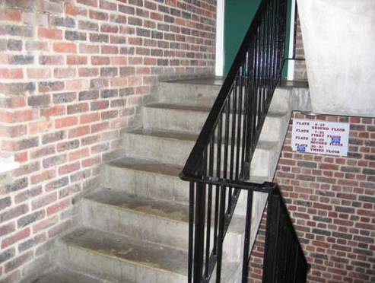

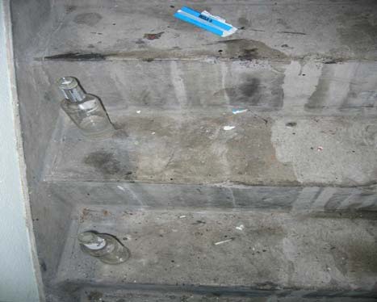

..........................................................................................................................................

**Remove cobwebs from light fitting and doorways, walls and ceilings.**

**Score: ......................... A (4) B (3) C (2) D (1)**

**Comments:**

( Example A score ) ( Example D score )

 

Page 2 of 6

**Dust or wash down banisters, handrails and skirting :**

**Score: ......................... A (4) B (3) C (2) D (1)**

**Comments:**

( Example : A score ) ( Example : D score )

 

..........................................................................................................................................

**Clean and disinfect bin areas / chute rooms :**

**Score: ............................... A (4) B (3) C (2) D (1)**

**Comments:**

( Example : A score ) ( Example : D score )

 

Page 3 of 6

**Internal and external litter :**

**Score:......................... A (**4**)**  B (3) C (2) D (1)

**Comments:**

( Example A score ) ( Example D score )

 

**Paths, roadways and courtyards:**

**Score: ........................ A (4) B (3) C (2) D (1)**

**Comments:**

( Example A score ) ( Example D score )

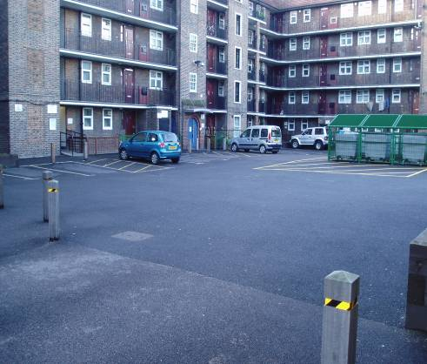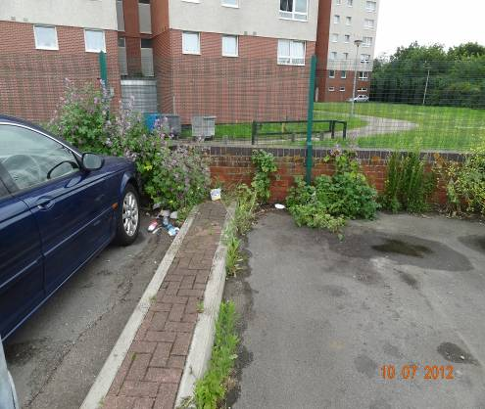

Page 4 of 6

**Grounds Maintenance**

**Score: ........................ A (4) B (3) C (2) D (1)**

**Comments:**

( Example A score ) ( Example D score )

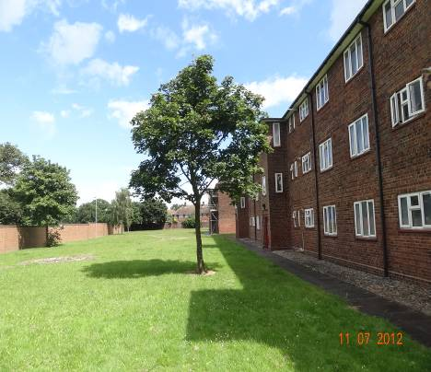 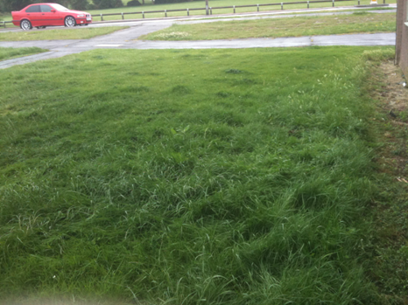

**\*\*\*\*\*\* Please total your score and place it on the front page \*\*\*\*\*\***

**Repairs:**

**………………………………………………………………………………………......**

**………………………………………………………………………………………..**

**…………………………………………………………………………………………..**

**Other Issues:**

**………………………………………………………………………………………….**

**………………………………………………………………………………………….**

Page 5 of 6

**Action Plan:**

**…………………………………………………………………………………………**

**………………………………………………………………………………………….**

**…………………………………………………………………………………………..**

**Completion Date Cleaning …………………………………**

**Completion Date Repairs ………………………………….**



**What’s this?**

This is a Quick Response or QR code. You may have seen these before and not realised what they are or what they can do; this code takes you to our website. A barcode reader application installed on a mobile device can read QR codes. If you have an iPhone, you can download the app free of charge from the App Store or if you have an Android enabled device you can get it from their Android Market Store. Most recent Blackberry phones have the app already installed.

Appendix 4

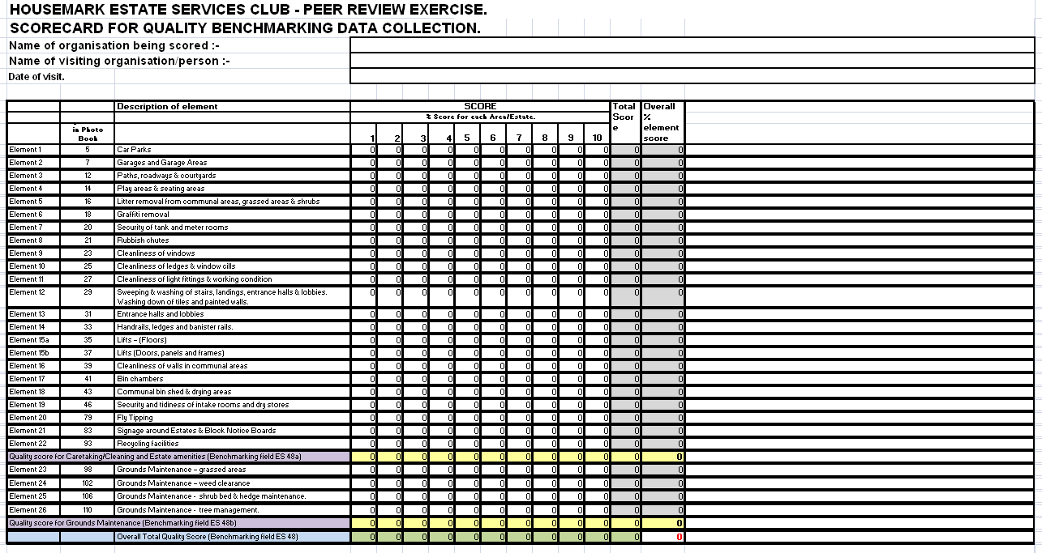

Appendix 5

Officer Survey Results

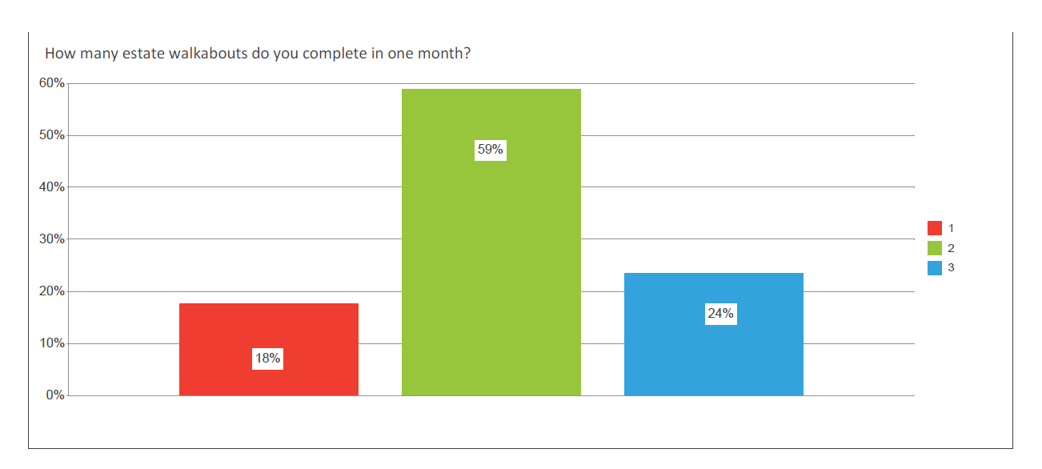

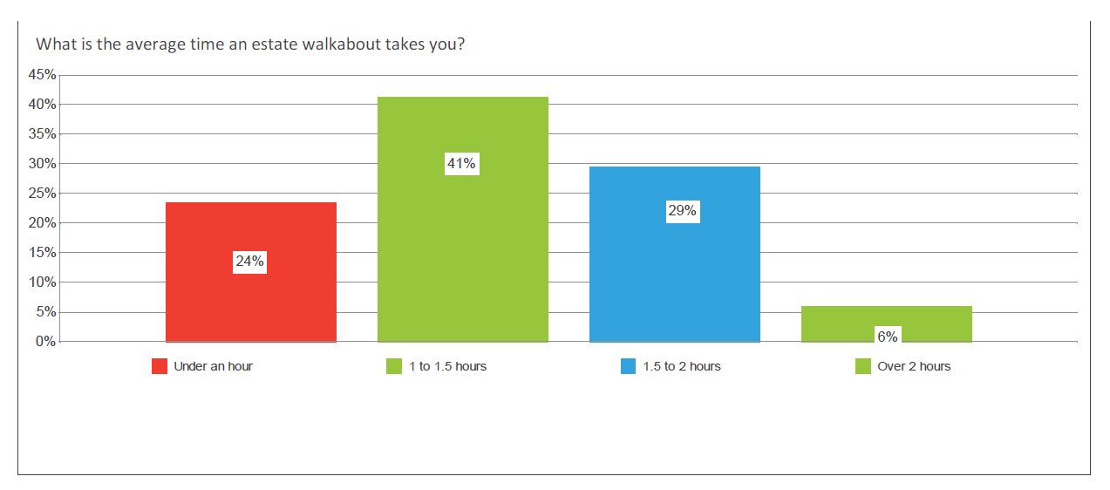

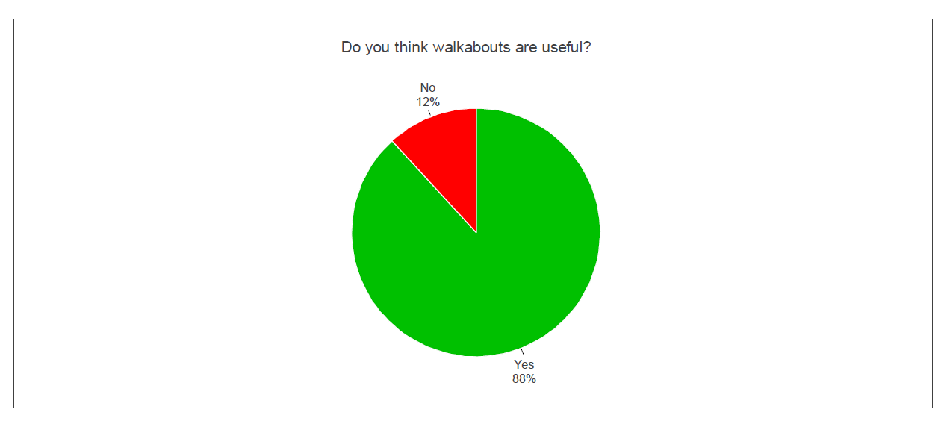

Appendix 6

Resident Survey Results

Appendix 7



Job Title: Tenancy Services Officer

Responsible to: Tenancy Services Manager

**Role**

* To provide a responsive and customer focussed Tenancy services, ensuring efficient and effective management of WPH housing stock.
* To promote effective internal and external communication to champion customer care and continuous improvement.

**Overview**

* To be fully aware of and work towards achieving WPHs 20/20 vision, mission and values.
* To provide services to our customers that, are consistent, professional and accessible to all.
* To contribute to effective service delivery by promoting communication across the organisation and with external bodies including voluntary agencies, statutory authorities and special interest groups on matters affecting neighbourhood services and community well-being.
* To ensure that computerised and manual recording systems are updated and maintained on a timely basis within agreed operating procedures and that service requests are responded to within agreed timescales.

**Core Tasks**

* To support the Tenancy Services Manager in achieving continuous improvement across all service areas within Tenancy Services, taking account of relevant legislation, the Company’s policies and procedures and other current initiatives as they apply to:
* Responding to issues of nuisance and anti-social behaviour including:
* Initially recording complaints.
* Liaising and referring to Tenancy Enforcement Team when appropriate
* Liaison with Crime Reduction Officer, Police and other relevant agencies.
* Managing tenancies including:
* Breaches of Tenancy including commencement of appropriate legal remedies
* Dealing with applications for succession, mutual exchanges & other tenancy variations.
* Taking appropriate enforcement action against squatters
* Carrying out New Tenant visits including 8 Week and Conversion visits
* Carrying our Annual Tenancy visits and identifying and addressing issues of vulnerability and liaising with relevant professional bodies.
* Managing requests for consents and approvals of tenant rights granting permission and providing advice on requests for certain improvements and alterations
* Responding to garden maintenance enquiries e.g. dangerous trees
* Management and monitoring of estates ensuring value for money including:
* Estate Inspections
* Environmental Schemes
* Support to Improvement Programmes
* Liaison with Site Management Officers
* Resident Involvement including:
* Dealing with initial enquiries
* Helping develop and support Tenant & Resident Groups
* Attending meetings, as required
* Liaison with Resident Involvement Officers Tenant Liaison Officers
* Customer Service including:
* Responding to customer enquiries within agreed WPH’s service standards
* Liaison with Income Team, Repair Response Centre and Customer Access Team
* Communicate key messages to customers to enhance reputation

(This is not exhaustive as the Tenancy Service and will develop over time)

* To provide reports where appropriate in response to enquiries and complaints regarding neighbourhood services and property conditions.
* To champion tenant participation and customer involvement at all levels, contributing to appropriate consultation and feedback.

**Health and Safety**

* To adhere to and be aware of the Company’s Health and Safety policies and procedures
* To ensure that any personal protection equipment provided is used appropriately

**Monitor and Develop the Service**

* To work towards achievement of team and individual targets and objectives, attending training opportunities as required
* To contribute to the operational development of services. To support the Team on policy and service development within the Company and with other external agencies.
* To contribute to consultation with the community, statutory and voluntary services and other major stakeholders about development and strategy.

**Risk Management & Financial Control and Resources**

* To identify key risks within the section and contribute to the development of strategies to mitigate such risk
* To seek to maximise the use of resources available through external agencies and voluntary groups by initiating and supporting new developments in conjunction with the Regeneration Team
* To ensure the Company’s policies and procedures are adhered to at all times
* To contribute to the delivery of best value throughout the company in accordance with financial guidelines

**General**

* To promote communicate and support the Company’s vision and values to all stakeholders
* To keep professionally updated at all times
* To follow and promote legislation and Company policies such as race and disability, equal opportunities, health and safety, data protection and human rights to provide a consistent and excellent service.
* To participate in multi-agency meetings, working groups and other meetings as required.
* To have a flexible approach to working hours including evenings.
* Any other duties as may be assigned commensurate with the grade and overall responsibilities of the post.

**Special Requirements**

* **Must comply with the Lone Worker Policy and all systems**

**All WPH employees are expected to:**

* Be flexible in approach, ideas and behaviour
* Be a team worker who builds positive relationships
* Respond positively to change
* Show courtesy and respect to our customers, external agencies and each other
* Abide by our employment policies and procedures

This job description is not exhaustive, nor is it intended to be, but should give the post holder a good understanding of the demands of the job. You are expected to be flexible to maintain the good reputation of the team and will therefore, be asked to carry out other tasks that are unforeseen at this time e.g. legislative changes, improvements in service delivery, project work etc; however you will be given the correct guidance and support to enable you to conduct these duties effectively.

Magenta Living is the collective trading name for Wirral Partnership Home and the other members of its Group from time to time, and references in this document policy to WPH should be taken as referring to Magenta Living.

Appendix 8

Inspection Reporting Form from Calico Housing – We think this is an excellent example of how a scoring system can be incorporated. Below the form is the scoring system Calico use.

Estate:

Inspectors names:

Inspection date:

Neighbourhood Officer report sent to:

Location of photographs:

Weather at time of inspection:

Number of issues on this report:

Number of new issues:

Number of issues resolved from previous report:

Customer Feedback

|  |  |
| --- | --- |
| Name and address of customer |  |
| Score out of ten for neighbourhood as a place to live |  |
| Any issues raised by customer |  |
| How are these issues being resolved? |  |

|  |  |
| --- | --- |
| General Overview checklist: | Findings: |
| 1. Road signs, bus shelters and manholes free of damage? |  |
| 1. Hedges / trees overgrowing walkways? |  |
| 1. Litter bins overflowing? |  |
| 1. Free of fly tipping? |  |
| 1. Any graffiti? |  |
| 1. Any gardens with lots of rubbish? |  |
| 1. Any badly neglected gardens? |  |
| 1. Any white goods needing collection? |  |
| 1. Any bonfires being formed? |  |

|  |  |  |  |  |
| --- | --- | --- | --- | --- |
| Location of problem | Property Type | Description of issue | How is the issue being dealt with? | Job log number/contact/photo reference/other details |
|  |  |  |  |  |

|  |  |  |  |  |  |  |  |  |  |  |  |  |  |  |  |  |  |  |  |  |  |  |  |  |
| --- | --- | --- | --- | --- | --- | --- | --- | --- | --- | --- | --- | --- | --- | --- | --- | --- | --- | --- | --- | --- | --- | --- | --- | --- |
| Street name | Litter | | | | Detritus | | | | Graffiti | | | | Flyposting | | | | Open Spaces | | | | Gardens | | | |
|  | 0 | 1 | 2 | 3 | 0 | 1 | 2 | 3 | 0 | 1 | 2 | 3 | 0 | 1 | 2 | 3 | 0 | 1 | 2 | 3 | 0 | 1 | 2 | 3 |
|  |  |  |  |  |  |  |  |  |  |  |  |  |  |  |  |  |  |  |  |  |  |  |  |  |
|  | 0 | 1 | 2 | 3 | 0 | 1 | 2 | 3 | 0 | 1 | 2 | 3 | 0 | 1 | 2 | 3 | 0 | 1 | 2 | 3 | 0 | 1 | 2 | 3 |

Environmental Quality Indicators and Scores

|  |  |
| --- | --- |
| Litter |  |
| Star rating | Indicator |
| 3 | No litter or waste on street |
| 2 | Mostly free from litter and waste except from some small items |
| 1 | Widespread litter and waste with some small accumulations |
| 0 | Lots of heavy littering with larger accumulations |
| Detritus |  |
| Star rating | Indicator |
| 3 | No Detritus present on Street |
| 2 | Mostly free from detritus except for a light scattering |
| 1 | Widespread detritus with small accumulations |
| 0 | Lots of heavy detritus with larger accumulations |
| Graffiti |  |
| Star rating | Indicator |
| 3 | Street is completely free of graffiti |
| 2 | Some minor graffiti but it could easily be missed by visitors to the area |
| 1 | Graffiti is clearly present and visible and could easily be seen by visitors to the area |
| 0 | Graffiti covers a large part of the area, is extensive and can be seen at most points |

|  |  |
| --- | --- |
| Flyposting |  |
| Star rating | Indicator |
| 3 | The street is completely clear of flyposting |
| 2 | Some minor flyposting is present but it could easily be missed by visitors to the area |
| 1 | Flyposting is clearly present and visible and could easily be seen by visitors to the area |
| 0 | Flyposting covers a large part of the area, is extensive and can be seen at most points |
| Green Spaces |  |
| Star rating | Indicator |
| 3 | Green space is well maintained and is litter and weed free |
| 2 | Green space is mostly well maintained with a small amount of litter and/or weeds |
| 1 | Green space appears neglected with litter and/or weeds |
| 0 | Green space appears to have no maintenance plan and has litter and/or weeds |
| Gardens |  |
| Star rating | Indicator |
| 3 | Gardens and boundary fences/hedges are well maintained along the street |
| 2 | The majority of gardens and boundary fences/hedges are well maintained along the street |
| 1 | A significant number of gardens and boundary fences/hedges need maintenance work undertaking |
| 0 | The majority of gardens and boundary fences/hedges require significant maintenance work undertaking |