Report and Recommendations on the Complaints Service
“Insight” Customer Scrutiny Group

- Who we are
We are an interested and committed group of volunteers who want to make a difference to services at Great Places. We formed following a taster session presented in July 2014. We have been trained, through on the job training and completed this review of complaints over 18 meetings in total.

We would welcome more people joining us. We can always find tasks for customers of Great Places to help with the work or to join the Group full time, (even if you cannot commit to be at all the meetings).

We investigate services and ask Great Places to improve them through an action plan. We act as a critical friend. We will share our report with the Customer Service Voice, managers and with Board for comment, so actions can be agreed of the changes to be made.

  - Why we are involved in scrutiny
We want to improve services. We are generally happy as customers but we know there are areas for improvement, which could enhance our services and neighbourhoods. We want to make a difference, whilst getting involved to do this. Prior to getting involved, we had not been confident on what part, we would play in change. When we saw the advert for the scrutiny group, we felt that the training being offered would help us to do this. It also helped that we would all be going to be learning together.

  - Why we chose the Complaints Service
We looked at performance data and the satisfaction information about from customers. We all made suggestions about the service we would like to scrutinise and in all the top 3 ideas from the Group, the complaint service featured every time.

It was a compact service and some members of the Group had experienced difficulties in trying to complain about services. We all felt we knew how we wanted a complaint to be handled, which gave us confidence to proceed on our first service scrutiny. We felt the complaints service would give us insight into the other services being delivered in every department. The new complaint policy had been implemented one year earlier and so it was a good time to review progress.

2 What we looked at
The following documents were reviewed:
- Policies
- Performance
- Procedures
- Monitoring systems
- Research into what other landlords offer relating to complaints
- Surveys sent to customers about how their complaint was managed

Our aim was to find out:
- Does this happen?
- What should have happened?
- What are the barriers for customers and staff to be excellent?
- If services are working well?
- If efficiencies are maximised and whether Great Places provide VFM?
- If improvements have been made?
- What would make a difference to customers?
- What would make a difference to Great Places services and staff?

We asked other tenants about their experience by calling customers to invite their feedback on how Great Places had dealt with their complaint. We only had four people agree to speak to us and we only managed to speak to three of these customers. We reviewed surveys from 2 other customers.

We spoke to staff in interviews and focus groups:
- Managers explained the service, how it worked, how it was managed and explained the policies and procedure
- Staff were fair, open and honest
- We sourced information from staff across the group who have experience of dealing with complaints and the managers of services
- We spoke to a good range of staff at different levels through group

This worked well and we felt we got a good grasp of the service. In our next scrutiny, we would like to take this further by building in a staff survey for feedback and do some Focus Groups with recent recipients of the service.

3. Key recommendations
We thank the Board, senior team and staff for their strengths and their commitment to the management of complaints. We have listed a number of requests for improvement in each section of the report. We have listed here some of our key recommendations which are generally around improvements in the consistency of service and care given to those who wish to express dissatisfaction:
3.1 Supporting the customer to complain:
- All staff to give a consistent response to customers who complain. Customer Care training to be given to all staff.
- Staff to recognise and acknowledge a NIP and be specific about the action to be taken for the customer.
- Staff need to be able to explain the difference between a NIP (nip it in the bud) and a RFT (right first time) complaint so customers understand exactly how the complaint is being managed and what to expect.
- Great Places to provide a fact sheet about the complaint process, which customers can collect or have sent to them on how to complain and what will happen if they make a complaint.
- Great Places to promote the complaint service through the Neighbourhood Officers who visit local meetings and let customers know how to complain.
- The Great Places website to have a link on the home page to complaints and improve the information on the website (see section 7). The web section on complaints to be accompanied by performance information of complaints, which is currently in a separate website section.
- The newsletters to be available for all customers, newsletters to be on the website and to include key complaint performance information.
3.2 Supporting staff to give information to customers of their complaint:
- Staff training to address gaps in individual understanding. Staff advised us that example or model answers would be useful to help them decide how they may deal with a NIP and RFT.
- Induction training and knowledge transfer needs to be quick when staff start at Great Places. In depth, induction training provided to the Customer Access Team seemed comprehensive, which maybe considered for new starters.
- Staff training on dealing with difficult customers and vexatious complainants might improve staff confidence and empower staff to reach a resolution.
- Managers to raise staff awareness of the range of complaints by enabling staff to listen into calls as part of a training programme to understand the frustration of customers.
- Great Places to improve the number of call back’s to customers, through customer care training.
- Empower staff to make a decision on how complaints could be resolved by considering how to devolve, the decision making of a NIP to front line staff.
- Great Places to provide staff with access to all information about the complaint and ensure staff record comprehensive file notes of actions and contact with customers.
3.3 Customer Feedback during the complaint
- Review the complaint service standards to promote quicker complaint resolution, particularly in the development and the repairs teams.
- Remind the managers of the one to one meeting expected in the Policy and the notification to the Neighbourhood Officer who can keep RFT complainants up to date.
- Revise the time when complaint closure occurs, which to be when the action agreed is completed and not when the action has been ordered.
- Great Places to send the compliant satisfaction form out only on completion of promises made during complaint resolution.
3.4 Improving performance
- Managers to follow up on each complaint out of time in their weekly performance report by contacting the customer and updating information on the complaint database.
- Managers and Directors, across the business, to listen to tapes of calls periodically so they can use their power to improve services.
- Each Great Places team to spend time considering complaint resolution and what might prevent re-occurrence.
- Set targets for information to be provided between departments to enable complaints to be dealt with quickly.
- Remind Managers about the promise of keeping the customer up to date every 5 days with their RFT complaint.
- The Customer Services Voice to review quarterly performance information on how Great Places benchmarks against other landlords.
- Great Places to consider how it learns from complaints. Learning from complaint to be shared with staff and customers.
- Great Places to consider how it can learn from top quartile performers with 2 stage complaint procedures.
- Great Places to work with the Scrutiny Group to develop ideas on how customers can be involved as a Designated Tenant Group (see section 6).

4. How the complaints management for customers currently works
The new complaints policy has introduced a consistent definition of a complaint across Great Places:

‘Where a customer is dissatisfied with the service they have received from Great Places, or one of our contractors, and want us to respond or take action.’

The policy introduces two principles of complaint resolution:

a) Informal - ‘Nip it in the Bud’ (NIPs)

If a customer is unhappy with the service they have received from Great Places or one of our contractors, they to contact Great Places to express their initial dissatisfaction. An officer from the relevant service will investigate the complaint and try to resolve the issue to the customer’s satisfaction within 5 working days.

b) Formal - ‘Right First Time’ (RFT)

Once a complaint has been made formal it will be allocated to an appropriate service manager who will try to resolve the complaint within 20 working days.

The service manager will:
- initially discuss the complaint directly with the customer (preferably face-to-face) to gain a better understanding of the issues and resolution that is being requested
- then carry out a thorough, timely and appropriate investigation
- throughout the investigation keep the customer regularly updated on progress before discussing their findings and resolution with the customer directly
- confirm their decision, an explanation of why they made this decision and their resolution in a formal letter

The customer will be advised that if they do not feel they have been offered a fair and reasonable resolution they can seek independent resolution. The options available are:

- Designated Person – Councillor, MP (or recognised Tenant Group – see section 6 below)
- Housing Ombudsman – direct referral from Designated Person or direct after 8 weeks.

If a customer feels that we have not followed our procedures correctly or have failed to take into account the full details of their complaint they can contact our Complaints Co-ordinator. If evidence is found that we have failed to follow our procedures correctly, or take into account the full details of a complaint, we will appoint an independent manager and trained tenant representative to review the complaint and provide a full response within 15 working days.

Great Places Current Performance

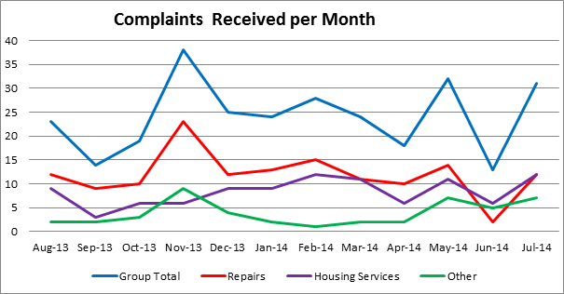
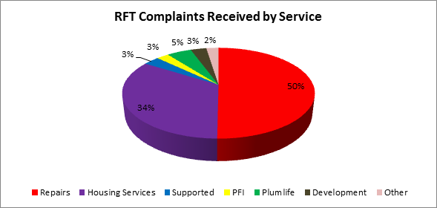

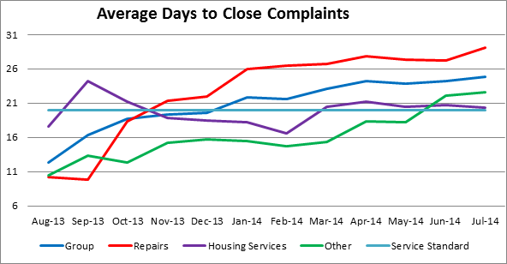
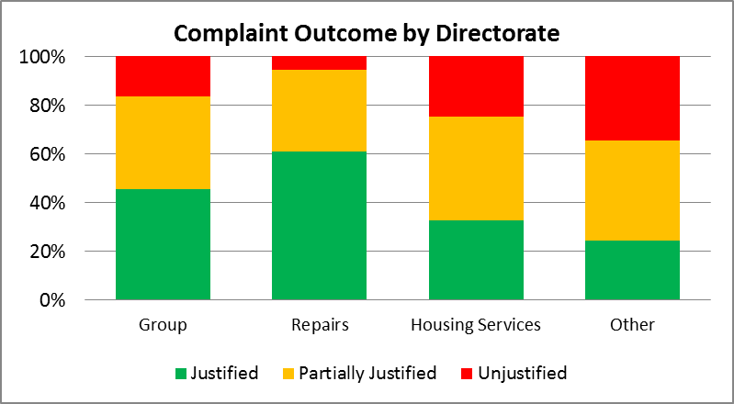

Complaint Satisfaction:

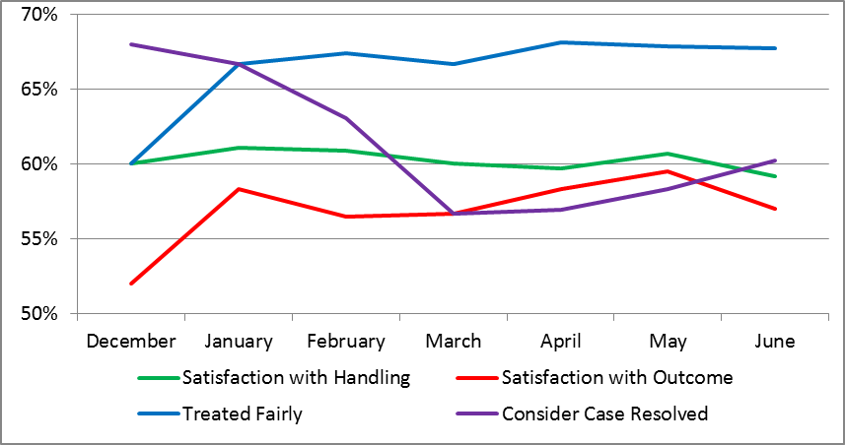

5 What we found during our scrutiny
5.1 Management and systems in complaints - Strengths
- The new policy introduced in July 2013 enables staff on the front line to have more autonomy of decision making and to deal with NIPs.

- 4000 NIPs and 280 RFT dealt with in year one of the new policy, less are going to stage 2, so staff can pick this up on the front line and deal with the issue prior to it becoming formal.

- There has been a 50% reduction in formal complaints as a result of introducing the NIP stage.

- On average it was 23 days now to deal with a complaint.

- Times are reasonable to deal with complaints; targets are set in working days at 5 days to complete a NIP and 20 days for the RFT

- The number of stages for complaint have been reduced from 3 to 2.

- Current procedures have reduced time to take to manage a complaints.

- Staff feel the security of the policy and procedure to guide them through the process.

- Any staff member can take a complaint.

- There is more responsibility for managers to deal with complaints about their area.

- Front line staff can pick up the potential for a NIP.

- The informal method enables a comment to be made and considered as a complaint within NIP.

- The procedure encourages common sense approach to managing complaints and allows a small gift/compensation to be awarded.

- A less formal process encourages NIPs and learning by Great Places

- Complaint process case studies can be placed in Facebook.

- Refresher courses can be put in place for staff who missed the training
- If a complaint came in about staff, it goes straight to RFT via the coordinator
- If a staff members cannot contact the person who dealt with the investigating officer, the details of the co-ordinator are on the letter, so they can also approach them
- The complaint co-ordinator has cover, when she and her colleague are away from the office, to chase reviews.
- An IT system called SATNAV allows managers to drill down on complaints for common reasons and to look at this by diversity group. They can see comments left by customers.

- Soon Great Places will be able to learn from NIPs. As they will shortly be capable of being reported on the IT system.

5.2 Management and systems in complaints – areas for improvement
- The complaints process no longer has a leaflet – customer would like guidance outside the website on how to make a complaint. There is no information for customers on how to make a complaint and that a compliant is welcomed.

- The Quality and Performance Team produce performance information for managers across the group and they are meant to share this with their staff, but use of this this local information is chequered.

- Performance information which is on the website is not included in Springboard which goes to all customers.

- Posters on complaints were sent to offices and to be placed on notice boards, but there is no corporate approach to information on notice boards so it is very “hit and miss”.

- The Compensation Policy to be reviewed to make it less rigid and to empower staff to make local decisions, though it was acknowledged that this has improved

- The complaint process says what is not a complaint, but does not say what Great Places will do if that issue is reported.

- The definitions of complaints from the descriptors of NIP and RFT were different than expected and might usefully be reviewed.

- Great Places do not know how to measure whether a customer knows how to make a complaint.

- Staff performance and learning from complaints is in service teams and not measured centrally by the Complaints Manager.

- There is no corporate approach to sharing learning from complaints in the same job, across the different regions.

- Learning from complaints could be anonymised and shared with the customer base and also considered at a senior level at Great Places.

- Repeat complaints – there is no evidence that there is learning from this.

- Great Places say they compare performance with the private sector as the policies in the public sector have changed, but we could see no evidence of what had been borrowed as a good idea from the private sector.

- A letter states what will happen next on complaints until 14 days after the complaint is closed, when the Quality and Audit Team step in to review the perception of how the complaint was dealt with.

- The RFT investigating managers relying on a secondary person for data told us that this information needs to be provided within a shorter timescale than the deadline for total response. The secondary person to also be held accountable alongside the investigating officer.

- Managers felt we to apologise earlier

- The managers like the pressure to deal with the compliant quickly, so resolution is early

- If a persistent person who might be considered vexatious is contacting many staff, there is a facility to direct this to one person only

5.3 Monitoring of the complaints service - strengths
- Intelligence can be collected and reviewed on RFT and will soon be capable of this on NIP.
- 60% of complaints are dealt with at RFT.

- The CSV and Directors receive information on the progress of complaints monthly, which names and shames those out of date in their actions.

- Performance benchmarking data is undertaken.

- Great Places aims to complete 100% sample of follow up to test satisfaction though the quality and performance team, the results come back to the complaints co-ordinator – this allows the customers to say they are unhappy with part or all of the complaint and how it was dealt.

- Face to face feedback is useful and easier to identify areas of improvement.

- The annual review of regulation is completed, which checks complaints regulation is being met.

- A review of consumer standards is underway.

- Great Places self-assess against the Chartered Institute of Housing standard.

- The complaints co-ordinator checks RFT before the complaint goes, out, she might rewrite to identify a training.

- The complaints coordinator is experienced and can provide an opinion, but is the managers responsibility for the final resolution.

- The coordinator checks that complaints are being dealt with on time, daily.

5.4 Monitoring of the complaints service – areas for improvement
- There is no consistency or directive of how learning from complaints and complaints data is dealt with and reviewed at team meetings, it is up to the individual manager.
- Stop the clock is agreed by the customer if used, because they are going on holiday, so that the timescales measured on performance are quite realistic.
- The repairs team deal with complaints in 26 days and the development team currently deal with a complaint in 22 days, which brings down the overall average of performance.
- The monthly report from the coordinator applies peer pressure to improve performance.
- The Group looked at outstanding complaints and found that there were 13 complaints outstanding over the 20 day deadline for RFT. Of the 10 worst performers, which were 30 to 257 days old, the development team appeared 4 times and had complaints outstanding of 32 days, 58 days, 67 days and 257 days. Reasons include parts not being available and work being chased on guarantee.
  - Customer Satisfaction - strengths
- The quality and data team collect data by calling customers to get feedback on how the complaint was dealt with.
- Learning from complaints is reported in the newsletter.
- One customer we phoned who had made a complaint suggested that she was pleased to receive an apology from the manager.
- Another customer we spoke to felt that the NIP process had resolved her complaint in less than 24hours.
- One survey we reviewed said that communication was very poor prior to making a complaint, however when the complaint was made, the communication was good and they were contacted regularly.
5.6 Customer Satisfaction – areas for improvement
- Of a total of 116 people contacted by the quality and performance team over 12 months:
- 64% were satisfied staff felt that their complaints were dealt with fairly
- 61% felt their case was resolved,
- 56% were satisfied with case handling
- 55% were satisfied with the case outcomes
- 57% felt they were kept informed throughout the complaint process

- 15 of 75 summary comments from returned questionnaires did not feel their complaint was resolved at the time the case was closed.

- In calls made to enquire about satisfaction we found the highest numbers of complaints about the complaint management was:
- Customers felt that the staff member was not empathetic and did not feel listened to and were not taken seriously
- Customers are not happy with length of time to resolve the complaints
- Customers were not happy what the outcome to be
- Customers were still waiting or repairs to be completed
- Overall, customers were dissatisfied with the way the complaint was dealt with because of a lack of communication, the complaint took too long to resolve, the complaint had not been fully dealt with and that staff had a lack of empathy and did not listen
- Overall the customer was not happy with the result of their complaint for because the resolutions did not meet their expectations; the outcome took too long and the outcomes were not agreed.

- Staff told us:
- Communication can be poor, including keeping the customer up to date and we heard from staff this has been main theme for the last 2 years
- Where complaints are going to take longer to resolve, communication is not undertaken to keep the customer up to date
- If a tenants keeps calling, this illustrates the communication could be improved, they feel frustrated and not respected that promises have not been kept
- There is too long a gap between the acknowledgement letter and the resolution letter with no contact in between, when the case is a complex one to resolve

- The number of complaints is calculated by region (based on an average of the number of properties in that area) the number of complaints in Oldham was 0.1% and those in Manchester 3.1%.
- Great Places is in the bottom quartile for customer satisfaction on the complaints service when compared to other landlords. Despite improvement in the policy, the satisfaction levels have remained the same. Staff feel this is part of a cultural change which the organisation needs to make in their approach to issues raised
- Reports can be produced but the quality of data is poorly recorded. The approach to closing a complaint and capturing learning is adhoc.
- Learning from complaints to be centralised as it is ad hoc, not well recorded and unclear to demonstrate this regulatory requirement
- One customer we spoke to had phoned 3 times and felt their complaint was not resolved and had only been resolved when it went to the manager. She was still angry and was made to feel like she had lied when she complained about a member of staff. Generally she would have liked to have been kept informed as the complaint resolution was delayed.
- Another customer we spoke to suggested that no care was demonstrated when he made a complaint and their complaint (like c above) remains unresolved. They felt the tables were turned and Great Places had moved this to a complaint about him. No staff had spoken to him in person and all matters were conducted by phone, which he felt was rude and cowardly.
- All of returned surveys and all of the customers we spoke to were critical of raising issues which led to the complaint. They felt communication when they have contacted Great Places was poor in terms of updating them on what was happening. For example:
  - failure to meet promises from a first report call
  - passing the buck
  - managers not ringing back as promised
  - no written acknowledgement of the initial call which might be a NIP giving the name and number of who to ring back if things have not progressed
These common issues lead us to feel that communication back to the customer when they phone to raise any issue might reduce the number of complaints received.
- Customer have an expectation of what to happen when they make a complaint, it would be useful to acknowledge the boundaries of the action which Great Places can take a result to of the call.
- Customer do not know the Great Places Service Standards, so they do not know whether what they are requesting is reasonable
- The Group wonder if the feedback on complaints through staff calls to be reviewed, to ensure Great Places are maximising feedback opportunities for example: e mail, texting and use of customer mystery shoppers.
- Leaving a message on a NIP can be a call on an answerphone of the customer. It would be better if more than one call was made to try to speak in person to the customer prior to leaving a message on the customer’s answerphone.
5.7 Front line service – strengths
- CAT encouraged to make a thorough investigation of the complaint

- Officers feel have more control and empowered under the new complaints policy. Managers are forced to deal with the issue at RFT.

- CAT has developed their own induction and 4-6 weeks training is given to new staff and then they are monitored by the manager when on calls. They also do e - learning training.

- CAT have a champion role and where expertise is gained, they develop and train others in this area.

- The call centre database does not link to the complaint database, so the front line staff cannot view and let the customer know about progress.

- Generally staff told us that if a customer phones back about an issue, it is assumed to be a NIP.
5.8 Front line service response – areas for improvement
- Staff suggested a checklist of information to refer to at NIP and RTF stage might be useful.

- Staff suggested they needed more clarity on how Case Review applies when the decision on RFT is made and challenged.

- Officer felt that NIP needs to be a better defined. Sometimes, they do not like the answer which is policy. For example issuing rent arrears letters and if a customer is angry, they are not always a NIP, it again might be about a policy decision.

- Not all staff keep the computer system up to date. This is made more difficult for staff when they have to return to the office to update the computer system, or relay on their memory or notes on a notepad. Efficiency might be achieved if the staff are given access to update the system and report issues instead of writing this twice and delaying a response.

- Sometimes when information on available homes to rent leads the customer to bid, taking them out of the bidding process and then making the property available is delayed, complaints come in about being out of the bidding process for that time.

- Staff standards and expectations are different. So an example of what a good answer to be, might be useful for some staff and would make them more confident they are dealing with the issue as expected
- Staff not calling the customer back is frustrating for others who then pick up a follow up complaint. So all managers to keep the customer updated, even if progress is slow
- Diaries are not kept up to date in the IT system. Front line teams need to know how to contact the manager who is dealing with the complaint.
- If more information was kept on the systems by the staff in neighbourhoods, then the NIP might be more easily resolved without referral to busy neighbourhood staff.
- A time barrier is caused when the neighbourhood staff have 5 days to deal with the issue and the officer does not get back quickly to the customer.
- A programme was identified by CAT for other staff to come and listen into calls “Listen up” – this could be developed to enable staff and managers to listen to complaints.

- Letters to not be sent to customer when the staff are going on leave, unless the staff member plans to be in the office for the response, or their notes on the IT system are full, so that it can be dealt with at the front line

- The front line staff do not hear about learning from complaints.

- There have been occasions where staff felt that their manager would pass an issue on to another officer to deal with, rather than enabling the officer to resolve this. This is not a joint decision of Officer and manager and left staff feeling demotivated. There is no consistent procedure for passing a complaint to another officer to deal with.

5.9 Staff training – Strengths
- Basic customer excellence training is given and performance management is relayed within 121s.
- There are plans to complete customer care training.
- 300 staff have been trained on complaints.

- Refreshers are out now and new staff attend these courses. This also enables retraining of those who could improve their performance on complaints.

- Staff felt they were experienced and could deal with difficult customers on the front line.

- Neighbourhood staff have a forum to share learning.

- The complaints manager and co-ordinators shares learning from RFT meetings.

- Learning from complaints, is supported by the coordinator who also keeps a history of previous complaints which are similar.

- More information on NIPs when the IT system is implemented will pick up other training needs.

- The definition on when to log a complaint by a staff member might require retraining, with some recording more than others.

- Dealing with complaints about staff might require some awareness training.

- Staff have recently had resilience training, but was not mandatory, so not all staff have had training to deal with vexatious complainant.

5.10 Training – Areas for improvement
- There is no training on how to manage customer behaviour and expectations, so this needs to be introduced.

- The Board was trained on the new Policy in July 2013, but the board has since been refreshed and no additional training has been given.

- Service Managers might need training on letter writing to complainants.

- Learning from complaints could be done more formally on a regular basis. it has been recognised at the staff learning forum but it is inconsistent in each form.

- Two new staff we met had not received complaints training and had been in post for 3 and 6 months.

- Sometimes there is no induction training, so staff are thrown in at the deep end – new staff found this overwhelming and feel that the training to be always given and as bespoke as possible bespoke to the individuals previous experience.

- Shadowing staff is a good idea, but if the person the staff are shadowing does not know the corporate approach, new staff are not given the correct information. Different staff tell them of different ways to do things – information is not consistent and the policy reading is not sufficient to enable the staff member to know how to approach issues

- Oldham staff had induction complaints training and Manchester staff had not had induction training and this meant that.

- New staff would like to meet others in the group as part of their induction.

- Staff do not feel that managers take behaviour vexatious complainants seriously when staff are threatened. Staff feel the issue to be dealt with faster and put in writing so they feel supported. This might require a review of the way in which unacceptable behaviour and vexatious complainants are dealt with.

5.11 Information signposting for customers – Strengths

Website (see also section 7)
- The website gives a brief synopsis of NIP and RFT and invites the customer to contact the complaints co-ordinator.
- It tells you how to make complaints, when you find the “contact us” section.
- The link on the home page to enable access in other languages.
- Great Places had a Quality and Performance Team who contact complainants about their satisfaction with the complaints process.
5.12 Information signposting for customers – Areas for Improvement
- No information is provided in leaflet form for customers. If a customer does not have access to the website, they do not know how to make a complaint. They have nothing to take away from the office to consider whether or not to make a complaint.
Website (see also section 7)
- It took a while to get to the complaints section from the homes page. It was a long winded process. A link from the home page is good.
- Our interpretation is that the reader is encouraged to contact.
- The website information was short, factual but not that friendly.
- There is no link to give feedback on the complaints page. Great Places allows feedback, but in a very long winded way. Cestria HA which was effortless to enable feedback to be captured.
- The website explains what is not a complaint but does not explain why these matters are not considered, or how to access advice on those problems.
- The section on complaints does not included up to date performance data; Great Places only includes this information in the annual report. Performance information is on another part of the website. Customers would like to be involved in identifying performance information which they might find useful/relevant (like Connect).
- Visually, customers who cannot read English, or are visually impaired might struggle to access the website.

Information in the newsletter
- The PFI customers and Plum Life customers do not get information in the Great Places magazine, so they cannot see that the complaint process has changed.

- There has been no work in communities to share the change in complaints process.

5.13 Customer involvement in service development - strengths
- Complaints Learning Forum was a cross section of staff and customers who worked on the new policy, the manager felt that customers were influential.

- The customer consultative group at that time endorsed the policy.

5.14 Customer involvement in service development - Areas for Improvement
- The Complaint Learning Forum used to review complaints, this was the group of people who got together to review the policy last year.

- A new customer group now review and spot checks 4 cases per quarter.

- Performance benchmarking data is undertaken by the Customer Service Voice. Whilst it is hard to say how this compares with other landlords, the Group would like to see Great Places share and compare with those who have similar policies to them with the forum.

- The customers who are involved in reviewing the complaints have not had any formal training, though they have been involved customers for some time.

5.15 Repairs and Asset Management – Strengths
- Managers helped property services recently due to a restructure in the service.
- The compensation is dealt with after the complaint is resolved for repairs.

- Complaints received about repairs were 14-15 per month and are now 8-9 per month since January.
- When staff are appointed, new staff need NIP, how to log a NIP and compensation training. This has already been identified for action.
- Very angry customers can be passed to a more senior member of staff.
- The computer system “Access” will not close down, unless a note has been placed on the system about the call.
- Senior staff can listen into old calls if a complaint is made.

5.16 Repairs and Asset Management – Areas for Improvement
- A large percentage (50-60%) of complaints are on repair. Repair systems are under review and will be speeded up and improved when the team is in place and this will improve overall performance. It currently takes 26 days to deal with a 20 day RFT complaint.
- Front line staff in repairs will need to take ownership to ensure that NIP is dealt with.
- Staff on the front line do not have information on who the complaint has been passed to and cannot resolve poor workmanship as a NIP.
- Repairs staff felt it was important to close the complaint, not when the repair had been agreed, but later when the complaint is complete
- Some repairs have been ordered which to be dealt with as a defect. The development team are in a different department and ideally to be in the same building. Generally, they do not keep the repair team involved in what is happening on a defect found on new and improved homes under guarantee.
- On hearing a complaint, an operative on site has no procedure to refer a complaint on.

6 Changes to complaints under the Localism Act 2012
In April 2013 changes to complaints happened through the Localism Act 2012, for all landlords. The changes include the creation of a new role for designated persons (any MP, any Councillor in the local Council or an Independent Tenant Complaints Group).
All housing complaints will go to the Housing Ombudsman Service (HoS) on issues of landlord performance, but tenants will have to wait for eight weeks to ask the HoS to intervene, unless referred by designated person(s).
Under co-regulation, Great Places is obliged to work with tenants who may wish to set up an Independent Tenants Complaints Group, provided they meet specific recognition criteria, set locally.
Insight Scrutiny Group would like to see a designated group formed to consider complaints as an alternative to the HoS investigation. We have not investigated this in much detail, but we would like to talk to managers after this scrutiny to consider the merits of setting up such a Group.

7 Reviewing information from other organisations

We researched policy, leaflets and practice from other organisations.
We state below, ideas where we think Great Places could learn from others:

The Group looked at several leaflets and policies from other landlords such as:

Websites

- Cestria Housing Association was easy for tenants to give feedback
- Cestria was more pictorial in nature and friendly and gave more information
- Tesco website, was easy to understand in how to make a complaint

Policies
Sanctuary
- Have a 3 stage process and then an independent review of residents
- They have a comments or compliment form and a separate complaints form

Connect
- This policy had a review date on the policy
- They say they will take complaints in any language
- They publish all performance data on complaints in the complaints section

Viridian
- A Customer Solutions Officer agrees the solution with the complainant within 48 hours and liaises with them throughout the complaint
- The 2nd stage is dealt with in 48 hours by a service manager
- The 3rd stage is a Group of Residents – a designated complaints group
- They had 587 complaints last year and only 7 went to the 2nd stage.

8. To conclude and what we would like to happen next Carol
We hope the Audit Committee at Great Places will monitor the delivery the action plan agreed by the Board, as they do by exception, with Internal Audit Action Plans.

We also hope to meet with manager in charge of complaints quarterly to ensure our actions are progressed for us.

We would appreciate any recommendations from customers, the Board, from Audit Committee, from staff and managers at Great Places for our next and future scrutiny pieces.

We would like to thank all the customers and staff we interviewed and who gave their time to speak to us as part of this service review, for their honesty and for being open to sharing areas which they had identified for service improvement. We would like to thank those involved in the complaint service for sharing data, policies and information with us.

Finally we would like to thank Tracy Gregory from the Customer Involvement Team for supporting and encouraging us every week and Yvonne Davies, from Scrutiny and Empowerment Partners Limited for our mentoring and training.

We look forward to working with you again and sharing our next report with you.

