

Customer Scrutiny panel

“Repairs priorities and tenant responsibilities”

February 2016

Contents

1. Who we are 3
2. Why we chose to scrutinise this area 3
3. Our approach 4
4. Document review 5
5. Further evidence 5
6. Key recommendations 5
7. Additional research 8
7.1 Customer surveys 8
7.2 Customer Service Investigators 9
7.3 Facebook and phone surveys 9

8. Key findings 10
8.1 Repairs timescales 10
8.2 Tenant Responsibilities 11
8.3 Customer Service 13
8.4 Orchard 14
8.5 Operational issues 15
8.6 Out-of-Hours service 18
8.7 Tiered delivery model for repairs 19
9. Right First Time 20
10. Next steps 21
11. Thank you 21
12. Our next Scrutiny review 21

Thirteen Customer Scrutiny panel

“Repairs priorities and tenant responsibilities”

- Who we are
We are the Thirteen Customer Scrutiny panel, a team of customers from the four landlords of Erimus Housing, Housing Hartlepool, Tees Valley Housing and Tristar Homes.

We formed in November 2014 to work in partnership with Thirteen Group and to provide an in-depth, critical-friend role looking at services which we feel are important to customers. In carrying out this review we spent approximately 950 volunteer hours to complete it.

- Why we chose to scrutinise this area
Repairs are currently reported, categorised and actioned in different ways across the four landlords which has led to high volumes of emergency repairs and unclear reporting on performance, especially around “Right First Time.” The need to deliver a standardised, transparent service which is clear to customers and staff alike is essential if Thirteen Group are to realise increased customer satisfaction, efficiencies and achieve Value for Money.

First time access rates for gas servicing have historically been only about 66% with the need for second and often third time appointments to be made before engineers complete this essential task. This is inefficient and expensive and further customer insight is needed to try and understand more clearly why tenants refuse access and how this could improve in the future. The findings from this section of the brief is contained in a separate report.

The panel were asked by the Group Property Services Director to recommend a standard set of repairs timescales for the Thirteen Group that enables the repairs service to be delivered more consistently. The panel were also asked to recommend the types of work that should be attended to within each priority, namely emergency, urgent and routine repairs. In addition to this the panel were also asked to recommend one list of Tenant Responsibilities, which could be introduced and implemented across all landlords.

Extensive consultation had previously taken place with customers from what was then Vela and Fabrick to gather customers’ views on what constitutes “Right First Time” however this work was never concluded. The panel were asked for their views on this and to suggest a definition for the Thirteen Group moving forward.

- Our approach
For our approach we spoke to customers and staff in a variety of ways and benchmarked the Thirteen Group with other landlords. The specific findings of these approaches can be found in sections 7 and 8 of this report, but in doing so we carried out:

- Interviews and job shadowing with Customer Service Advisors to understand how customer repair queries are reported, categorised and passed onto the tradespersons for completion.

Interviews with Out-of-Hours frontline staff to understand how Out-of-Hours repairs are reported, categorised and passed onto tradespersons for completion.

- An interview with the “Repairs and Maintenance” and “Compliance” Managers to understand more fully the operating environment behind repairs delivery.

- An interview with the Accommodation Contracts Manager to understand how the different Tenancy Agreements outline tenant/landlord responsibilities on repairs.

An interview with the Extra Care and Sheltered Housing Manager to understand how elderly/vulnerable people receive a repairs service.

A focus group of tradespersons to gain insight from trades’ staff on delivering the repairs service to customers in their homes.

A survey of customers from the Customer Voice (Thirteen’s database of involved customers) to get their views on repairs timescales for different repairs and what should be a tenant’s responsibility.

- A “Customer Service Investigator” project on gas servicing including surveys and focus groups with customers/staff on how to improve access for gas servicing.

- Analysis of complaints information to understand complaints about repairs and how this relates to categories/responsibilities.

- Benchmarking with other landlords to learn how repairs are categorised and how tenant responsibilities are defined with other organisations.

We had also planned a Facebook survey and a focus group of customers who had recently had a repair, however due to the extent of customer service problems being caused by the failure of the Orchard system on repairs and gas servicing during the course of this review, this was not carried out.

4. Document review
In carrying out this service review we reviewed the following documents:
- Repairs policies for all four landlords
- “Right to Repairs” guidance – Citizens Advice Bureau
- Tenancy Agreements (current and former) across all four landlords
- Findings from “Right First Time” consultations (Vela and Fabrick)
- Examples of customer journeys on repairs
- Response times for each landlord for different repairs categories
- Repairs performance data for each landlord for the different categories
- Customer handbooks for each landlord
- Thirteen Group Older Persons’ strategy 2015
- Dale and Valley Scrutiny panel report on repairs
- East Durham Homes Scrutiny panel report on repairs
- Wulvern Scrutiny panel report on repairs
- Salix Scrutiny report on repairs and their “Repairs Handbook”
- Adactus500 Scrutiny report on gas safety

- Further evidence
We received presentations from the following staff from the Thirteen Group:
- Group Director of Property Services and Head of Building Services
- Contact Manager
- Property, Performance, Projects and Improvements manager

6. Key recommendations
We have listed a number of strengths and areas for improvement in each section of the report. Here we list our key recommendations:

6.1 Repairs and responsibilities

- That the suggestions for Repairs timescales, and types of repairs within each,(as shown in Appendix 1) be considered moving forward as guidance across all landlords within the Group. This recommends that the emergency timescale remain as 24 hours and non-urgent remain as 28 days, however that the urgent category, currently 7 calendar days, be reconsidered as 3 working days.

- That the suggestions for what constitutes a Tenants’ Responsibility (as shown in Appendix 2) be considered moving forward as guidance across all landlords within the Group.

- That a new Repairs handbook be produced which includes the above, as well as other guidance for customers on repairs, including how to report a repair, the Out-of-Hours service, gas servicing access, “Right to repair”, recharging and other useful information. A hard copy of this to be sent to all households and a downloadable version to be placed on the landlord websites.

- A marketing campaign to be agreed to promote the new arrangements and raise awareness of all the above with customers and staff.

- Review the process for how new tenants are educated on using the repairs’ service, including giving them the new Repairs Handbook and a more thorough conversation on repairs reporting and tenant responsibilities at sign up.

- Induction training for all new frontline staff to include the issue of repairs categories, timescales and tenant responsibilities.

- For schemes under retention, the contractors responsible for delivering repairs to be given the Thirteen Group list of what is a Tenants Responsibility so that advice is given consistently to all Thirteen Group customers.

- Co-opt customers onto the staff Recharge group and explore the feasibility of recharging customers for not allowing access to repairs and gas servicing.

- Produce a Leaseholder handbook with details of their repairs responsibilities and place this information on the landlord websites.

6.2 Customer Service

- Customer Service Advisors and Schedulers to be located in the same building at Northshore.

- Explore the feasibility for allowing text replies back from customers to Customer Service Advisors when they are informed of repairs and gas servicing appointments.

- Training to be delivered to frontline staff on customers’ vulnerabilities and how these should be considered in the delivery of a more responsive repairs service.

- The number of missed repair appointments by customers to be promoted every month in the customer outlets and via social media to show how this wastes resources and impacts on service delivery (similar to doctors surgeries).

- Working group of staff and customers to consider the viability of a handyperson service. This could provide certain low-level repairs services as core with additional tasks or services being chargeable and thus generating an income for the Thirteen Group. Such a service would free up trades staff to attend to larger and more substantial repairs and thus reduce waiting times for them.

6.3 Orchard

- Orchard to highlight, for each repair job generated, which named trades staff it has been passed to, to allow the Contact team to provide a more responsive service when customers call.

- Introduce a system for classifying “serial repairs’ reporters” and “no access” customers, and a flagging system on Orchard to identify them on the front screen. Develop a protocol for visiting such customers to address this problem with Neighbourhood Officers.

- Introduce prompts scripts on Orchard for Customer Service Advisors to give basic, safe advice to customers on simple solutions to common household problems which often end up being reported as repairs, for example boiler re-sets.

6.4 Operational issues

- Undertake discussions with the repairs’ trades staff to extend working hours from 8am until 7pm (with the option of working to 9pm if the customer is in agreement)

- Appointment slots to be reduced to one hour slots rather than morning or afternoon appointments, to help reduce no access and create a more customer-friendly and efficient repairs service.

- Develop a protocol for filling appointment slots for repairs which is consistently used across both the Contact and Out-of-Hours teams.

- Consider creating a separate emergency repairs service so routine appointment times can be kept without the need to slot emergencies in, as currently happens.

- Establish a working group of staff and customers to consider the viability of an enhanced repairs service for vulnerable customers including the criteria and cost effectiveness of such a service. This should include consideration of not only elderly persons but also customers with other vulnerabilities such as disability, mental health and domestic violence for example.

- Develop a programme for the trades staff to job shadow the Customer Service Advisors (and vice versa) to encourage learning and understanding of the issues both face when dealing with repairs.

6.5 Out-of-Hours repairs service

- Bring the two “Out-of-Hours” services together in one building as soon as possible, and provide training to upskill them in the use of Orchard and repairs classification to the standard of the Customer Service Advisors.

6.6 Tiered delivery model for repairs

- The panel do not recommend that a tiered repairs service is introduced currently, as there are concerns about the detrimental impact this may have on filling voids, as well as the high number of customers who could be affected by this due to welfare reform and affordability issues. Despite the general feeling that the principle seems fair, concerns that customers might “let their property go” if they are not repaired and it could therefore have an adverse effect. The previous Scrutiny panel report on “Rewards and Retention” focussed on a “carrot” approach to changing behaviours. The panel therefore recommend that such an approach combined with a tiered repairs service might be worth pursuing in more detail.

7 . Additional research

7.1 Customer surveys
As part of this scrutiny project two customer surveys were carried out, one on access to gas servicing and the other on the issues of repair timescales and tenant responsibilities. Findings from the customer survey on repairs are listed below (and in Appendix 3) and the gas servicing survey findings have been incorporated into a separate report.

The Customer Voice was relied upon for both these surveys. The Customer Voice is the database kept by the Customer Involvement team of 1,100 involved customers who have willingly agreed to take part in such surveys. In the future it is hoped sampling might be possible through all 33,000 customers on the Orchard database to add validation to the representativeness of the responses.

An online and postal survey was sent to 400 customers from the Customer Voice (78 responses or approximately 20% response rate) to gather their views on a number of key areas relating to repairs and the timescales they thought Thirteen Group should complete them in, and also what repairs should be the tenant’s responsibility.

7.1.1 Findings from the customer survey on repairs

To gather customers’ view on repairs timescales, a list of 30 common repairs taken from two recognised sources of good practice was listed in a survey;

- Housemark’s recommended list of what repairs should be emergency, urgent and non-urgent (1, 7 and 28 days)
- The Right to Repair list (provided by the Citizens Advice Bureau in November 2015) which lists repairs that Local Authority tenants have a “right to have repaired” within 1, 3 and 7 days.

From the list of repairs customers were asked to choose, for each repair, which of the following timescales they thought most appropriate for that repair to be carried out in…..1, 3, 5, 7, 28 or 90 days. Feedback from the 78 surveys returned has been analysed by the panel (see below) and the panel’s recommendation for what they feel should be considered for customers of the Thirteen Group across all four landlords is shown in Appendix 1.

To gather views on what should be a tenant’s responsibility to repair, a question in the survey contained a combined list of what is currently stated as tenant responsibilities across the four landlords (and in addition some other items which were gained from researching other social landlords) and customers were asked if they thought it should be the tenant or the landlord’s responsibility. The results can be found in Appendix 2 and again the panel have made recommendations about what they feel should be considered for customers of the Thirteen Group across all four landlords.

Other questions were also included in the survey about repairs and listed below are the key findings;

- 81% of respondents stated they would prefer a system which just gave them the soonest possible appointment rather than repairs being done within timescales.
- 51% of respondents preferred morning or afternoon appointments, however a further 30% were also happy with weekend and/or evening appointments.
- 6% preferred evenings only and 3% weekends only.
- 43% of respondents are happy with repairs staring at 8am, 29% prefer 9am and 15% preferred 10am.
- 40% of respondents feel 5pm is the latest time for a repair to be completed in their home, however 22% stated 7pm and 14% were happy with 9pm.
- 74% of respondents feel certain repairs such as fencing, guttering and walls should be batched together rather than repairing them as they arise.
- 89% of respondents supported, in principle, an enhanced repairs service (repairs done more quickly) for elderly/vulnerable customers.
- 67% of customers supported, in principle, that different response times for repairs should be introduced depending if customers keep to the conditions of their tenancy (a tiered response service)

7.2 Customer Service Investigators
The element of the brief relating to gas servicing was commissioned out by the Scrutiny panel to a small group of involved customers known as CSIs (Customer Service Investigators) who worked independently of the panel during January and fed their views and findings back at the end of that month. A separate report outlines the findings and recommendations from this project.

7.3 Facebook and phone surveys
A Facebook survey was planned to gather wider customer views during the last week in January however due to the extent of customer service problems being caused by the failure of the Orchard system on repairs and gas servicing, this was held back. Similarly phone surveys of customers who had recently received a repair, or not allowed access for gas servicing, were not undertaken for the same reason, however the panel were told that extraction of customer data to perform this was going to be problematic due to the system problems anyway.

8. Key findings
The recommendations above in chapter 6 have been made following a number of different approaches gathering evidence from a variety of sources. In this section we outline our findings and observations from these approaches.

Whilst the panel looked to address the key areas within the scope of the brief there were a number of areas which presented themselves during the course of our investigations which are worthy of mention. They are included in this report as they all impact on the delivery of an efficient and cost effective repairs service which not only provides good value for money but which is in keeping with good customer service.

The recent introduction of the new Orchard IT system, while promising vast improvements in recording and delivering repairs, has so far been a great cause of problems for staff and customers alike, and therefore would merit further scrutiny in six months’ time when it is in more of a “steady state.” A chapter on the system and some of the operational/performance benefits it promises is therefore included, although these are yet to be realised.

Abbreviations used in this chapter:
CSAs – Customer Service Advisors
CSIs – Customer Service Investigators
OOHs – Out of Hours

8.1 Repairs timescales
Strengths
- A Customer Service standard event took place with over 100 customers in April 2015 to consult on new Thirteen Group Repairs’ standards. From this, and staff consultations, three repairs priorities have been agreed for the Orchard system which are emergencies – same day response, urgent – within 7 calendar days and routine within 28 calendar days.
- Benchmarking also took place with other landlords regionally and nationally. The categories and timescales being currently used by all four landlords are consistent with those being used by other landlords according to Housemark.
- Having one set of repairs timescales and categories for all four landlords should deliver an improved repairs service as it will allow all fleet vehicles to carry out identical stock and spend less time going to merchants.
- A guide for which repairs fall into the different timescales has been produced to help the CSAs be more consistent in their categorisation. This includes “Right to Repair” timescales. CSAs still have the discretion to change timescales if they feel a customers’ vulnerability could be affected by not doing so.
- CSAs regularly challenge customers on the urgency of their repair and offer advice to customers to try and rectify the problem in the short term, until a trades person can be called out. Their experience in dealing with customers in genuine emergencies has taught them how to drill down when speaking to a customer who might be just looking for a routine repair to be done more quickly. Informing a customer that they will be recharged if the repair is found not to be an emergency usually helps with this.
- The timescale or categorisation of each repair reported by a customer is done by the CSA who takes their call, based on detailed interrogation of the nature of the repair. Once categorised, the diagnostic tool allows very specific information to be passed to the Schedulers/trades including the completion date so all staff at each stage of the process know when it is due to be completed.
- How repairs are categorised by the CSAs can, and often are, challenged by the Schedulers with e mails being sent to the Contact team managers. Schedulers can cancel repairs jobs but often the CSAs feel they do this without knowing the circumstances surrounding it. Calls can be played back to understand this leading to both sides learning the rationale and reasons behind this.
- If a customer cancels an emergency repair then they are called back until it gets done, however for an urgent or routine repair it is only kept on the system for 24 hours, after which if the customer does not call in to reschedule it comes off the system. This frees up appointment space and places the onus on the tenant to take responsibility for this.

Areas for improvement
- New tenants do not get good quality information in the sign-up pack or tenancy agreement about repairs, timescales and what is a customer’s responsibility.
- On some estates we have properties from more than one landlord in the group, each with different repairs timescales. This can cause complaints and unrest with some customers if they see their repairs being dealt with more quickly than others.
- Currently multiple repairs that are reported by one customer are given separate jobs and potentially different timescales for completion, rather than being grouped together to be completed in one visit, which would be more efficient and favourable to customers.
- Trades staff stated they often get a lot of calls to jobs where the customer has over-stated the emergency status of that repair or it is a job that is really the responsibility of the tenant, which diverts resources from where they are really needed.
- Trades staff reported that on occasions high volumes of emergencies are being passed onto the Out-of-Hours team due to not having been completed during that day. It is not known whether these are emergencies not attended to during the day or jobs which are reaching their timescale for completion. The panel were told it was due to severe staff shortages which were the cause of this.

Quote: “we need to distinguish between what’s a want and what’s a need”

8.2 Tenant responsibilities
Strengths
- A consultation group of staff has been set up to look at recharging across the Group, which will in time produce guidance for customers on recharging and what they are responsible for, however the panel would recommend customers have some input into this group.

Areas for improvement
- CSAs reported that knowing if a customer is responsible for a repair is still problematic as all four landlords have differences historically in what is a customer’s responsibility and what is the landlords. However CSAs regularly ask other CSA colleagues if they get a call from a customer from a landlord they are not familiar with.
- Orchard currently cannot identify which repairs are the responsibility of the customer, however scripts are planned for future use. The CSAs currently make this judgement call and decide if the tenant or the landlord should carry out the repair, which can lead to inconsistencies in this area.
- If elderly/vulnerable customers ring to report a repair which is a tenant’s responsibility, the CSA will ask if there are other family, friends, carers or neighbours who could help them with it, to try and prevent a call-out. However, they can make a discretionary judgement and raise a repair order if they feel the customer is vulnerable. This is not recorded and reported upon however.
- The most frequently misunderstood repair which customers call in for, which is their responsibility, is the replacement of light bulbs, starter motors and batteries for heating programmers.
- New tenants are not being told how to turn on/off gas/electricity/water supplies and therefore this is often rung through as a repair, which could be avoided and reduce the number of repairs call-outs and damage caused as a result of not knowing this.
- There are an increasing number of call-outs where digital room thermostats are not working which are due to the tenant not knowing how they work.
- At individual and group sign-ups for new tenants, staff do talk through with customers what their responsibilities are for repairs but no list is given to customers about repairs timescales or responsibilities, for future reference.
- Currently what is a tenant’s responsibility does not depend on the age or vulnerability of that tenant, however some elderly/vulnerable tenants clearly cannot fulfil some of the basic areas this involves eg changing light bulbs. Therefore one size while, being suitable for the majority of tenants, will not be practicable for some.
- Two of the Sheltered schemes under retention in Gateshead have repairs services provided by Keepmoat the contractor responsible under the warranty. They respond to a lot of call out from elderly customers that are not their liability/responsibility and are those of the tenant. As a result of this Thirteen are being recharged for minor tenant repairs such as light bulb replacements, battery replacement in boiler programmers and room thermostat issues. Such call outs are all over £100 each as a recharge to the Thirteen Group.
- Some call outs for repairs are due to customers’ previous expectations of what their landlord would repair in the past and which they do not realise is now their responsibility.
- Orchard can identify recharges for repairs and the CSAs can pass this information onto a customer but not an exact figure. This is being picked up by the Recharge group.
- Rechargeable repairs and the recovery of such monies from customers has been difficult to administer over recent years. There is no consistent approach to this and as such a culture of non-payment with no penalty has become the norm.
- Leaseholders and shared owners’ misunderstanding of what is their responsibility regarding repairs is widespread, and can be attributed to the large number of leases in place and a general lack of advice and guidance for them. This can lead to a higher than necessary number of calls regarding repairs to the Contact teams.
- Drainage workers can often get regular calls to the same customers who are blocking the drains with baby wipes and nappies, which even after having been reported to the Neighbourhood Officer persists. This is a drain on resources which could be used on other repairs.

Quote: ”you wouldn’t ring Sky and ask for someone to come out and replace the batteries in your remote”

8.3 Customer service
Strengths
- Trade operatives can now ring schedulers when on site with a customer, to arrange a further appointment “there and then” if more work is required. This will reduce further contact between the customer and contact/scheduler teams being necessary and give the customer an immediate advance notice of an appointment.
- The CSAs can, when speaking to customers about their repair problem, direct the customer to perform simple tasks (where appropriate) to see if the problem can be rectified without an operative being called out (for example re-setting a trip switch). Vulnerable and/or elderly customers are not asked to do this if they are not comfortable or able to do so.
- The allocation of jobs in Orchard will be done by Schedulemaster and give a morning or afternoon appointment for each job. A text message will be sent to the customer giving them 24 hours’ notice of their appointment.
- Since the CSAs have been brought together the wait times for customers reporting repairs has reduced, as other CSAs can pick up calls that are waiting, which was limited before when the staff worked in smaller CSA teams.
- The link between Orchard and the landlord websites promises to provide a much more accessible and effective self-service portal for customers wanting to report repairs.
- Under a future phase of Orchard a smartphone App will be released which will make it easier for customers to report a repair from their mobile devices and as a result increase customer choice in reporting repairs.
- If a customer has had a failed appointment or repair then Orchard does allow a future appointment to be “locked” assuring the customer of a time and date suitable to them in the future so no further service failure occurs.
- CSAs feel customers would welcome a weekend repairs service especially those who are working and currently have to take time from work to be in their home. Also some repairs which are attended to at the weekend could prevent them from becoming an emergency on a Monday morning.

Areas for improvement
- Information gathered at the application stage about a customer’s support needs and/or vulnerability is not carried over into Orchard into their customer profile. The CSAs do not have the full picture about that customer when they call in a repair or their ability to carry out a repair themselves. This could have an impact on health and safety of the tenant and impact on how repairs are dealt with by the CSAs.
- If a customer receives a text reminding them that a tradesperson is due to call out to do a repair, then if they want to cancel it they can only do so by ringing or emailing their landlord, and not by sending a text reply. Due to the time it takes to ring through a lot of customers might not choose this option to let the landlord know if they cannot be in and “no access” can result.
- While the idea for a handyperson service seems favourable to most managers this has not been explored in any detail within the Thirteen Group. The current reliance on the general repairs service for all repairs could be mitigated by a handyperson service.
- Customer vulnerability was expected to be on the information given to the trades staff by the PDAs however they state this information is not available.

Quote: “there are a lot of people in the organisation not living the vison and the values”

8.4 Orchard
Strengths
- The new Orchard system has brought all previous systems together into one place, and the CSAs can record all repairs irrespective of which landlord the customer is from. However the Out-of-Hours teams are still using the old systems.
- Orchard has a built-in diagnostic tool which allows a more accurate diagnosis of the repair that is needed when a customer rings in. Pictures prompt the CSA to ask questions about their repair to inform this process.
- Orchard promises to be able to produce lists of properties and customers who receive repairs the most. This will allow properties where the condition of the asset might be a concern and warrants an MOT.
- Orchard promises to be able to flag customers who consistently report repairs as emergencies which are subsequently found not to be, and further action can then be taken to prevent this drain on resources.
- A predictive tool is to be installed into Orchard to identify when gas boilers are due for servicing thus preventing emergencies in the future.
- The customer profiling within Orchard allows flags to be added for persons with disabilities which can result in a more sensitive approach to repairs resolutions for such people, however there is no agreed protocol for how staff should do this.
- Orchard has the facility to show CSAs (and other staff) much more information than previously held about a customer, such as all previous repairs and communication history, their rent arrears, whether a gas servicing is due and if a complaint has been sent. It forces users of the system to add text to each entry giving more information relating to a repair for example, which speeds up and clarifies the repair diagnosis and resolution for everyone.
- Orchard also allows all documentation relating to a customer to be readily accessible such as copies of their tenancy agreements, any letters sent/received and any documents provided by the customer. This gives the CSA staff more relevant information about a person’s repair history and how any problems have been dealt with and responses at the various stages of a repair.
- Orchard promises to provide a wide array of performance reporting to be produced on repairs for the various operational levels within the Thirteen Group. It will allow reports on customer reporting levels across repair categories, appointment failures, times taken on individual repairs by the trades, numbers and types of repairs taken and categorised by the CSAs and much more. It will also report the average time to complete a repair and the average number of jobs per day per operative. Customer satisfaction will also be part of the reporting matrix.
- Orchard promises to allow detailed information reports on customer profiles in the future showing the diversity and ages of customer reporting repairs as well as “serial reporters” who report high numbers of repairs.

Areas for improvement
- Orchard does not prompt the CSAs to offer any other appointments outside of morning or afternoon only, such as school run appointments, which are available and if offered could result in fewer no access issues, when parents leave their home to pick up their children from school.
- CSAs feel the implementation of the Orchard system was too rushed and should have been tested more thoroughly. This is because of the number of system issues that have arisen since it went live especially the passing of jobs from CSAs and the schedulers/trades. This has caused extensive delays for customers and has led to manual recording of repairs by staff to compensate.

Quote: “we have no confidence in the service we can deliver with the way the Orchard system is operating”

8.5 Operational issues affecting repairs
Strengths
- In August 2015 the three Customer Contact teams were brought together for the first time in Northshore. Through their close proximity they can listen and learn from each other regarding repairs.
- Schedulers and CSAs have job shadowed each other, and held regular team meetings between the two with a rolling action plan in place to address ongoing issues.
- The Customer Contact team have three “Repairs Champions”, who can not only act as experts in repairs recording/actioning, but who also can buddy up with new starters in both the Contact and Repairs teams and advise them more effectively.
- The scheduling team have been restructured so that schedulers now deal with repairs jobs according to “trade types” rather than dealing with all scheduling types based on their geographical area. This will be more efficient and provide a more consistent response for customers.
- New jobs raised on the system will be released to the trades automatically one at a time based on the trade group, geography and priority, via a PDA. This will make job allocation more efficient, quicker and reduce travel time between jobs across the region.
- A one year project plan is to be introduced to evaluate the issues and training requirements of multi-skilling for the trade operatives, which if implemented will allow them to undertake a variety of trade jobs at a customer’s home without the need for multiple visits from different trades.
- CSAs can actively see where trades’ vans are geographically and can pass jobs to the van which is closest to a customer for emergencies.
- Schedulemaster is a tool connected to Orchard which assigns repairs jobs automatically to trades staff, however if there is an influx of emergency repairs then manual intervention can override the system, which allows a flexible, more customer-focussed service.
- There are five Extra Care schemes across Middlesbrough, Stockton and Redcar who have caretakers funded through service charges and who can provide small “handyperson” type repairs within those schemes such as changing light bulbs or painting small areas following a repair. Four schemes in Hartlepool have a mobile caretaker who can perform the same tasks. This is not a service which is provided officially (rather on an ad-hoc basis), however it reduces the need for repairs call-outs.
- There is some good evidence from the customer surveys carried out as part of this scrutiny piece that customers would embrace a repairs service which worked later on the evenings and included weekend working. In addition a pilot was carried out by Erimus a few years ago with extended working hours (8-8pm) and this was very popular with the customers.

Areas for improvement
- There is no job shadowing by the trades staff with the CSAs which could improve their understanding of the issues the CSAs face with diagnostic and allocating repairs.
- There are some customers who are known to CSAs who are “serial reporters” of repairs, however this tends to be landlord specific. This means CSAs from Erimus background know the Erimus Serial reporters, but CSAs from, say, a Housing Hartlepool or Tristar Homes background will not. There is no way of recording this on Orchard to allow common knowledge to be shared which could reduce repair call outs, emergency and otherwise.
- Scripts for CSAs to help customers rectify basic repairs that are commonly reported are not in place on Orchard. For example, how to reset your boiler after a pre-payment card has run out, would be useful as a prompt in Orchard to prevent unnecessary call outs as emergencies.
- Once a repair is logged the CSAs cannot see who the job was passed to until later in the day and this can cause problems if the customer calls back enquiring about a delay for example.
- There is no group-wide policy for dealing with repairs for elderly and/or vulnerable customers. Only Tristar Homes have a bespoke priority service for these customers. CSAs can still over-ride repairs categorisation if they feel a customer falls into this group and are trained to take responsibility for each call individually, making an informed choice based on their perception of each customer’s needs.
- There are problems when emergencies are logged onto the system and they push out morning appointments into the afternoon slots, as Orchard automatically cancels the afternoon appointments with rescheduling them.
- If one repair is reported by multiple tenants (for example in communal areas) then each call will be logged and a repair generated for each call. It can often take up to 10 such calls being logged before the trend is realised by the CSAs. Therefore more repairs (emergency and otherwise) are being recorded and paid for than need to be.
- Currently repairs are being booked in at the earliest possible appointment due to the backlog in Orchard however under steady state this is not the case. There is no protocol for the CSAs on how to book appointments for urgent/non urgent repairs to keep empty slots available for emergencies that inevitably come in daily. This can result in re-categorisation and re-booking of repairs which can cause disappointment and dissatisfaction for customers
- Contractors frequently pass emergency work given to them back in-house and this is being counted as two emergencies, which artificially inflates the figures
- There is no current system for recharging customers for “no access” at a repairs appointment, which would amount to approximately £45-50 per visit if it was enforced.
- If an appointment is made by a customer as an emergency which is subsequently found not to be so by the trades operative, then this is not recorded on Orchard and there is no way therefore to flag this when future repairs requests are made.
- One of the trades staff stated he had had up to 18 emergency call outs during one night shift because of jobs that were not completed during that day (due to a shortage of electricians), which increases significantly the level of emergency repairs being categorised and paid for at a higher rate.
- The trades staff interviewed have heard of, but are not clear on, what multi-skilling will entail and to what level they will be required to work in trades’ areas which are not their key skill. This is causing some concern and unrest among trades teams which is already creating a negative view about its introduction and feasibility
- The current contracts with trades operatives restrict the hours they can work during the day/evening (8-4pm) with no flexi working arrangements. In order to extend the working day from say 8-8pm (with variable shift patterns for the trades staff) terms and conditions would have to be negotiated with Unions.
- Certain repair types, such as external drains issues are known to occur in certain geographical areas on a regular basis. These should be built into a preventative repairs programme covering multiple properties on estates rather than being attended to as individual jobs.

Quote: “our customers have a range of expectations and in some cases we are over-delivering”

8.6 Out-of-Hours service
Strengths
- The OOH staff currently based in Hartlepool are soon moving to the “Centre for Independent Living” also in Hartlepool. Plans are in place for all the Thirteen Group’s OOH service to be co-located here in the future and for the staff to deliver the same service as the CSAs across all service areas rather than just emergency repairs. This will allow for a more consistent repairs reporting service 24 hours a day.
- The team always challenges if a call is an emergency or not and can make a confident decision on it.
- There is an on-call inspector available to the OOH team who can help them make a decision if needed on any particular repair and its classification. This provides a valuable support service similar to team leaders for the CSAs.
- If there are multiple reports about the same repair the OOH team, being the only staff contactable about this, will log this as one job only. This differs from the CSAs who might receive such repairs separately and not realise until later it relates to one common problem.
- Should a customer be elderly or vulnerable the OOH teams will try to sort out the problem as soon as possible.

Areas for improvement
- The OOH team record everything that happens over a shift on a spreadsheet including the repair category eg emergency/routine and this is sent to the CSAs for inputting into Orchard the next day. Disputes often arise between the OOH staff and the CSAs over the categorisation of repairs.
- The OOH team working from Welton House provide a different service to the OOH team from Hartlepool, as they will respond in person to incidents or emergencies which occur, leaving one staff member to man the OOH phones at all times. The OOH service across the Group is therefore different depending on which town you live in.
- The OOH team in Hartlepool feel that under the new guidance on repairs they are classifying more as an emergency than before.
- The OOH team in Hartlepool only had one day training on Orchard but didn’t learn anything as the system was down and the team working from Welton House haven’t received any training at all on Orchard.
- The OOH teams feel that all OOH and CSA staff across the Groups should be working on the same system, with the same training and same guidance.
- The OOH team feel younger tenants use the service more than any other type of tenant, and do not know understand the procedure for reporting repairs during normal hours or what is their responsibility.
- The two OOH teams do not communicate on a regular basis and therefore are not delivering a consistent service on repairs categorisation and reporting.
- The OOH service will eventually be able to pick up queries coming from the self-service portal but cannot at present.

Quote: “we need to harmonise services”

8.7 Tiered delivery model for repairs

The Scrutiny panel were asked for their views on introducing a tiered approach to repairs that could be set across a tenancy-based set of criteria. This could for example be based around a 3 level approach of gold, silver and bronze as set out below;

- Gold – no rent arrears and no tenancy issues = full responsive service
- Silver – low levels of rent arrears with payment agreement in place and no other tenancy issues = emergency repairs plus some other non-essential works
- Bronze – rent arrears and/or tenancy issues = emergency and compliance only

Previous Scrutiny work carried out in 2014 by the Fabrick Scrutiny panel investigated the issue of “Rewards and Retention” in great detail, and a working group of staff and customers researched and planned how such an approach might work for the Thirteen Group. One of the central elements of the proposed Rewards prize draw (which was ultimately withdrawn and not introduced as a result of the financial impact of reduced rental income) was the concept of “something for something” as an approach to incentivising change and nudging behaviour towards greater responsibility regarding paying of rent, keeping to the terms of the tenancy and allowing access for gas servicing.

During the course of our Scrutiny research we found that Orchard could classify customers according to a tiered repairs response service if required to (eg gold, silver or bronze) however the idea of having a tiered response to repairs, while having some merit among the staff interviewed, would need to be carefully thought out so that those genuine customers who are struggling with welfare reform and affordability issues are not increasingly marginalised and their properties fall into disrepair.

The general feeling of the panel is that while the customer survey responses showed the majority backing the principle of a tiered delivery model for repairs, in practice because of the reasons outlined above it could have an adverse effect and that customers might “let their property go” if they are not repaired. Previous research looking at the Irwell Valley Housing’s scheme found it applied a “”carrot and stick” approach, rewarding those who comply, so there is an incentive too, as well as the application of sanctions.

Therefore the panel felt that the introduction of such a tiered service should not be considered at present.

9. Right First Time (RFT)

Extensive customer consultation took place with both Vela and Fabrick customers in 2013-14 on what “Right First Time” means to them, as well as what repairs should sit within each repair category, however this consultation was never pulled together into a final report with conclusions that was shared with those customers who took part in shaping it.
The panel considered a number of definitions of RFT from other social landlords and have produced a definition for the Thirteen Group which it feels encompasses the key elements moving forward.

Definition of Right First Time
The panel have agreed the following definition;

“Right first time is where a customer is satisfied that what was promised within the timescales for each aspect of a repair is completed, and that problems relating to each aspect do not re-occur where the operative needs to be called out again within a 12 month timeframe”

In essence there are two aspects to RFT, regardless of how many stages to completing a repair there may be. If the customer is informed at the outset of each stage what the timeframe will be for completing that stage will be, and if each stage is completed to their satisfaction, then all should be well.

Clearly some customers will have higher expectations than others for how long each stage should take, but by clear communication and honest information, satisfaction should be maintained with the customer.

The second aspect is that the trade operative should not need to be called out again to any stage of the repair, and which gives an indication of the “quality of work” aspect of each repair.

If all repairs are monitored for completion within timescales every month then the first aspect can be monitored. If then, each month after that, any call outs to a job again are monitored, then a percentage can be measured of the second aspect.

Call-outs can be monitored by trade operative or product failure as these are the two main elements of any repair. Customer satisfaction monitoring of each stage will identify failure in this regard and a full picture will be achieved of RFT. The panel have heard of a landlord that asks two basic questions after each repair visit;

- Score the repair visit out of 10
- If below a certain score, it presents a list of common reasons that the customer can tick as many as they like and press submit

As long as this can be done anonymously in front of the operative on a PDA then confidentiality is maintained.

10. Next steps
In line with the Customer Involvement strategy we expect the Audit and Risk Committee to monitor the delivery of the action plan that accompanies this report, as they do by exception, with internal audit action plans. We also expect to meet with any managers responsible for the service areas we have covered to ensure our recommended actions are progressed for us. This is to be done every six months until the actions have been progressed.

11. Thank you
We would like to thank all the customers, managers and staff we interviewed and who gave their time to speak to us as part of this service review, for their honesty and for sharing areas which they had identified for service improvement. We would like to thank those involved for sharing data, policies and information with us.

The Thirteen Customer Scrutiny panel who undertook this piece of work are;

Michelle Bendelow (Tristar Homes)
Brian Binns (Housing Hartlepool)
Ann Carter (Housing Hartlepool)
Tom Casey (Tees Valley)
George Cook (Tees Valley)
Anne Lancashire (Erimus)
Jimmy McElvaney (Erimus)
Melvyn Rhodes (Erimus)
Stewart Wraith (Erimus)

The “CSIs” who undertook the project on gas servicing were;

Gill Baines (Erimus)
Janet Hoggett (Erimus)
Brenda Pearce (Tristar Homes)
Jean Price (Hartlepool resident)
Jenny Shotton (Tristar Homes)
Cath Torley (Hartlepool resident)
Mavis Videmour (Erimus)
Jackie White (Tristar Homes)

Finally we would like to thank Jonathan Cannon for supporting us.

12. Our next Scrutiny review
The Scrutiny Panel is seeking recommendations from customers, the Boards, Thirteen Customer Council, the Audit and Risk Committee, Director/Heads of Service for our next and future scrutiny piece(s).
Appendix 1 Repairs timescales

Appendix 2 Tenant responsibility survey results

Appendix 3
Repair timescales/tenant responsibilities survey results

Rather than promising to have you repairs done within certain timescales, would you prefer the soonest appointment?”
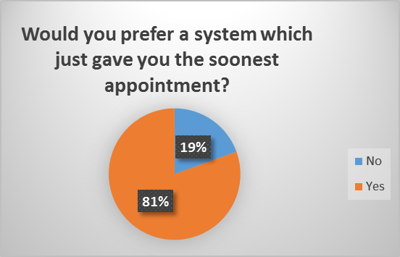

Customers were asked to choose which appointment times suited them, (they could choose more than one)
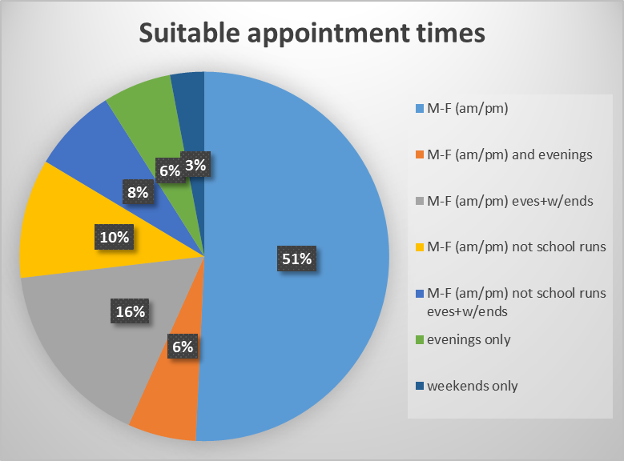

Customers were asked what was the earliest start time for a repair in their home?
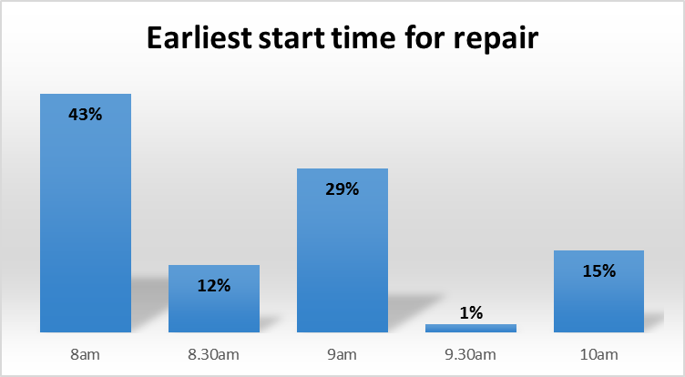

Customers were asked what was the latest time for a repair to be completed in their home?
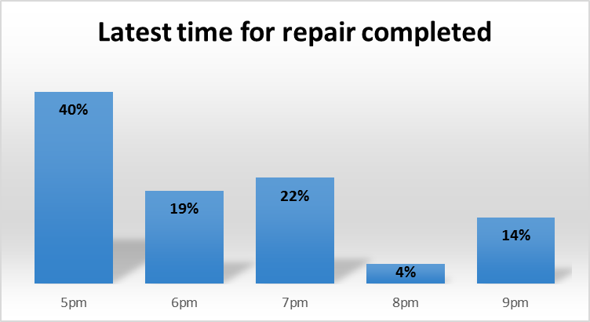

Should we batch repairs together eg fencing, guttering or do as they arise?
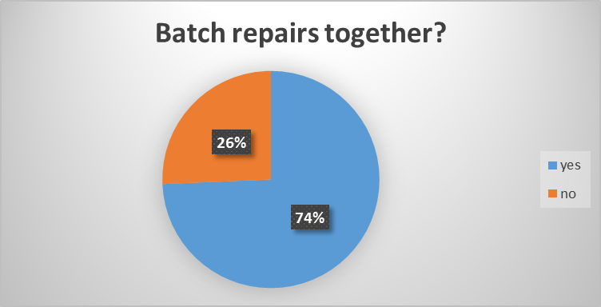

Should have an enhanced service for elderly/vulnerable customers?
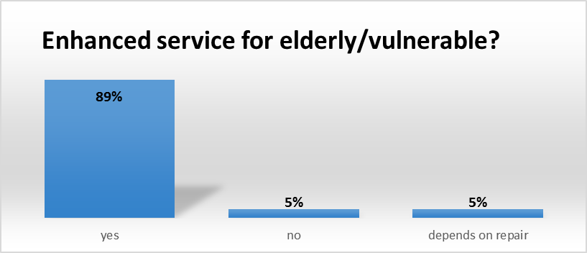

In principle should we introduce different response times to some repairs depending if a customer is meeting the conditions of their tenancy? (apart from emergency repairs)
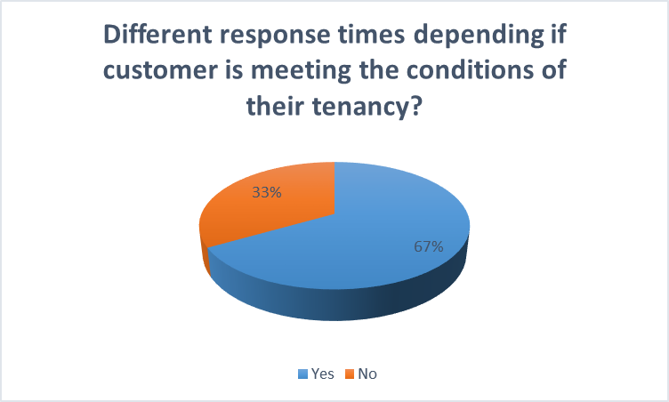

Customers were asked if they knew where their water stop cock and gas/electricity turn off switches are?
