Appreciative enquiry

Appreciative Inquiry is a strengths-based approach to creating change. Although it is often discussed in the context organisational change, Appreciative Inquiry can be applied in a range of contexts.
The following is a great overview by Jackie Kelm from Appreciative Living:
The positive core is like the half full glass often referred to in strengths-based practice. It includes strengths, positive experiences, stories, etc. that can be found in all communities, organisations, groups and individuals.

The five principles (Cooperrider, Whitney, & Stavros, 2008, see also the Center for Appreciative Inquiry) are:

- The Constructionist Principle which suggests that language and words create reality. The questions we ask become the material from which the future is conceived and constructed. How we describe or talk about things changes how we see them, which shapes what happens. (The story of two communities is an illustration of two ways of describing a community, both of which reinforce different aspects of community life.)
- The Simultaneity Principle which suggests that inquiry creates change. Inquiry and change are simultaneous events because the questions we ask focus our attention and create new awareness which leads to change: inquiry is an intervention. The moment we begin to inquire into something, change begins to happen. The questions we ask set the stage for what we discover and this information become the stories out of which the future is conceived and constructed.
- The Poetic Principle which suggests that we can choose what we study. An organisation’s story is constantly being co-authored and by focusing on strengths and what is working, these are what are nurtured. Our choice of what to focus on or to study, helps to create the world as we know it. In choosing the topic we are helping to write the next chapter of the organisation.
- The Anticipatory Principle which suggests that our image inspires action. Our vision of the future has a major impact on the action we take now. The more positive and hopeful the image of the future, the more positive the present-day action.
- The Positive Principle which suggests that positive questions lead to positive change. Positive images lead to positive actions.
- The four (or five) D cycle is a process that is often used in Appreciative Inquiry. By starting with strengths, assets and what is already working it is an example of a strengths-based approach.

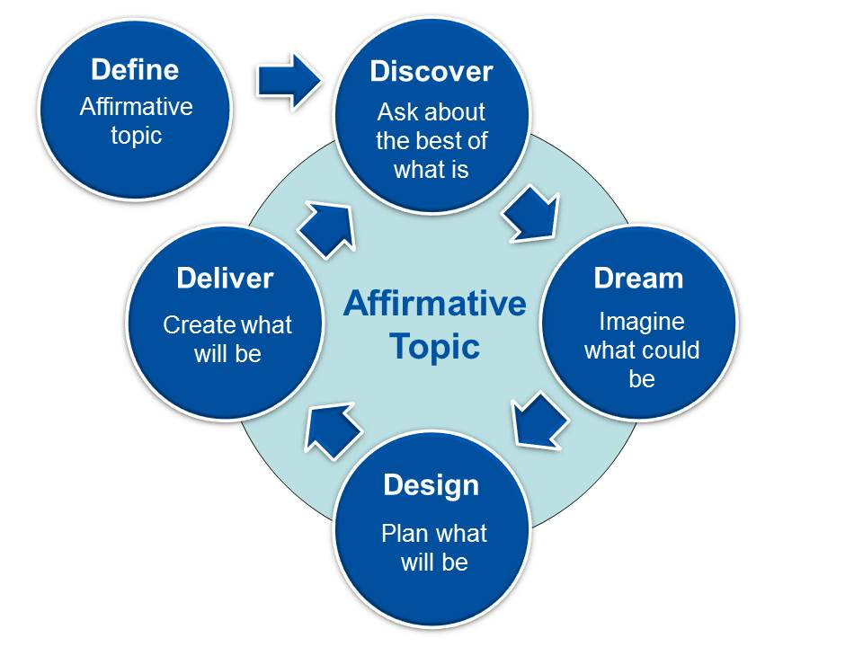

There are various tools and processes (like the Appreciative Inquiry Summit) that can assist in adopting Appreciative Inquiry. Like many of the processes I discuss in the blog, I encourage you to give it a go and to see what you learn from doing it.

