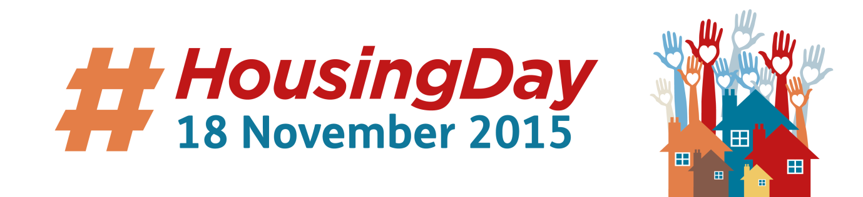

Housing Day is about social housing tenants telling the world that they are proud to be tenants. It’s about us reminding everyone that there are fantastic people living in social housing and that we do lots of great things.

Housing Day is largely a celebration of tenant activity over the internet. It is primarily about sending twitter messages to **#HousingDay** and to **#proudtenant**. If you don’t know how to do this, your landlord should be enthusiastic to help you send a Twitter message. The people organising Housing Day are also looking for 50 tenants who want to be connected together on social media on the day. If you are interested, please contact **@HousingDay**.

At up to 3,000 tweets per hour **#HousingDay 2014** travelled as fast as a comet. The housing sector and its tenants came together for a truly amazing social media event, producing a staggering 30,000 tweets and countless real stories. It provided a *feel good factor* for everyone taking part - a reminder of just how brilliant tenants are and the people who work with them. Trending on Twitter all day, it peaked at number two, reaching an audience of 7 million people. Let’s get it to number one in 2015!!!

Housing Day this year has borrowed the ***Proud to be a Tenant***theme from the fabulous **Berneslei Homes** in Barnsley. Tenants there are spearheaded a campaign to get their tenants to let everyone know they are *proud to be a tenant.* Why not ask your landlord if they would like to run a campaign for you and your fellow tenants? If you ask them nicely (at #proudtenant), Berneslei Homes might let you use their wonderful logo.

