**MASS-DELIVERY OF MANUFACTURED HOMES FOR RENT**

***By Jamie Ratcliff[[1]](#footnote-1)***

*“Land monopoly is not the only monopoly, but it is by far the greatest of monopolies -- it is a perpetual monopoly, and it is the mother of all other forms of monopoly. Unearned increments in land are not the only form of unearned or undeserved profit, but they are the principal form of unearned increment, and they are derived from processes which are not merely not beneficial, but positively detrimental to the general public.”*

Winston Churchill, 1909

**Introduction**

Building the homes London needs is not straightforward. Strong political will to solve this problem has apparently existed at various points over the last thirty years and yet still supply has not consistently matched demand. At its simplest, just three things are needed to build homes: land, funding and demand. This chapter sets out a new way of building homes which could provide the first two in abundance. London, a booming city growing in population by around 100,000 people every year, does not need any help with the latter.

In order to guarantee success, Government would need to make bold changes to the laws surrounding compulsory purchase of empty *commercial* properties, to create a significant supply of land for new housing, as well as provide significant up-front investment match-funded with private sector equity funding to pay for the land acquisition, land redevelopment and large scale house building.

Bringing forward land for housing in this way would fundamentally be about rebalancing land use in our Capital, helping the land market to adjust more quickly to the growing demand for housing use and declining demand for other uses – most notably industrial. Prominent examples include the redevelopment of Docklands in the 1980s and, more recently, the Olympic Park.

These twin measures have the potential to build 420,000 *additional* homes over a twenty-year period, or 21,000 additional homes a year – roughly the number we need to plug the gap between current levels of supply and the approximately 50,000 homes a year London needs.

The success of this investment model would depend on a new way of building homes – actually manufacturing them in factories - that would deliver at scale and pace, so that equity investors can quickly reap a return on their investment. This also presents an opportunity because it would, as a by-product, support a new high-growth potential and UK-based industry in manufactured homes. This could potentially be based in an emerging “Northern Powerhouse”.

**The problem of housing delivery in the Capital**

There are two big blockages that prevent London from dramatically increasing the supply of new homes. These are a lack of land availability for new housing and a lack of innovation and capacity in the housebuilding sector. The former is a longstanding problem but the latter is more the product of the economic cycle - shorter term skills shortages, and even a shortage of bricks.

1. A lack of land availability for housing

As the graph below shows, it is unfair simply to criticise the planning system for not brining forward enough land for housing - for not producing land planning permissions for new homes and for being slow in progressing consents. Planning approvals have been running at an average of 55,000 homes a year for the last ten years, over double the rate of housing completions (27,000) and more than the homes London needs (50,000). This has contributed to a growing stock of unimplemented planning permissions which now stands at around 215,000 homes.

But it is obviously too simplistic to say that the supply problem is solved from a planning point of view. Many of these permissions will be on very large sites, which at typically slow build-out rates will take decades to complete, and the more recent permissions are likely to still have a large number of pre-commencement conditions that have to be met before construction can begin. Some permissions will never be built due to unsuitable design, change of ownership, viability or a mixture of these factors and more.

This conveys a simple truth that, broadly, the conversion rate of homes “approved” by the planning system into eventual homes built in London is only about 50 per cent, which is lower than in the rest of England.

One issue with London’s supply is a lack of contingency of land identified and earmarked for development. When producing a local development plan, Local Planning Authorities are required to identify only *sufficient* land for the homes that need to be built in their area and no more - i.e. the quantum of land identified in London is for 420,000 over 10 years - whereas we probably need far more than that to ensure that 420,000 actually get built. If we are serious about delivering the homes London needs then it is important to identify and earmark a contingency of land over and above that required. This contingency should probably be at least 50 per cent, enough additional land to build 21,000 homes a year.

Planning permissions vs. housing completions in London.

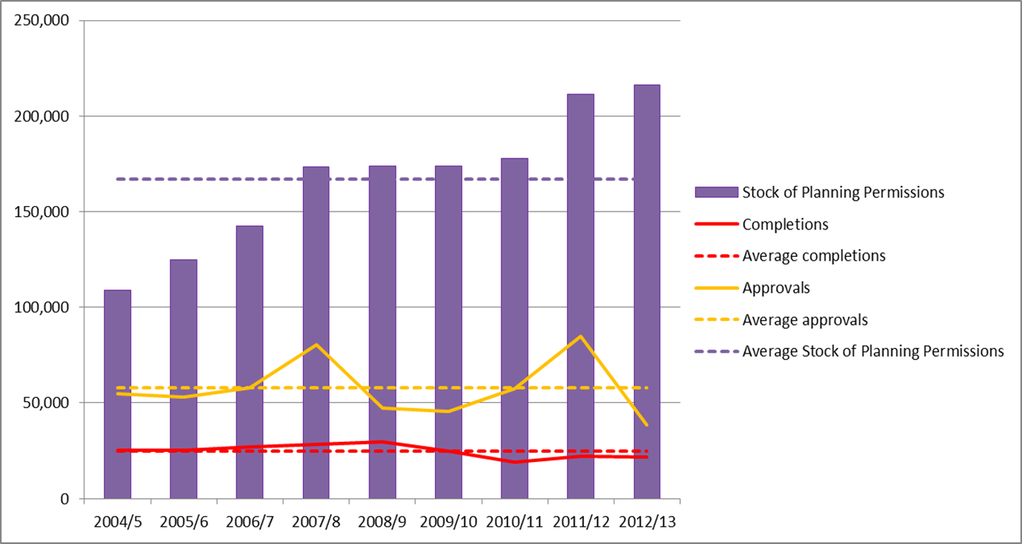

*Source: London Development Database*

By planning for only “just enough” land to deliver the homes that are needed, the planning system implicitly assumes that nothing will go wrong, that no site will have unexpected problems, or at least that any that do will be counter-balanced by new sites or increased densities on existing ones. The system is thus set up to fail.

Above all, housing should be treated as *infrastructure*, as this would allow for contingency as a matter of course. For example, for High Speed 2, £14.4bn out of a total of £42bn is set aside for contingency - a contingency of over 50 per cent on the expected cost. While a contingency of 50 per cent sounds a lot, HM Treasury’s Green Book, the bible of option appraisal in Government, says that in the early stages of an infrastructure project - which the identification of land for housing must surely be - an optimism bias of *70 per cent* should be applied.

But as far as housing goes, the position is actually *worse* than zero contingency; i.e. at a London-wide level in planning for housing this contingency or optimism bias is arguably *negative*. To meet the 49,000 annual new housing supply requirement calculated in the Strategic Housing Market Assessment (SHMA), the Strategic Land Availability Assessment (SHLAA) only identified actual sites to deliver 29,024 (59 per cent) of these homes annually. A fairer comparison would perhaps be against the minimum London Plan target of 42,000 homes a year - meaning 69 per cent are on identified sites. This means assumptions for delivery on small sites, conversions of homes and empty homes coming back into use make up the remainder - over 30 per cent of the total.

10-year housing supply identified in London Strategic Housing Land Availability Assessment

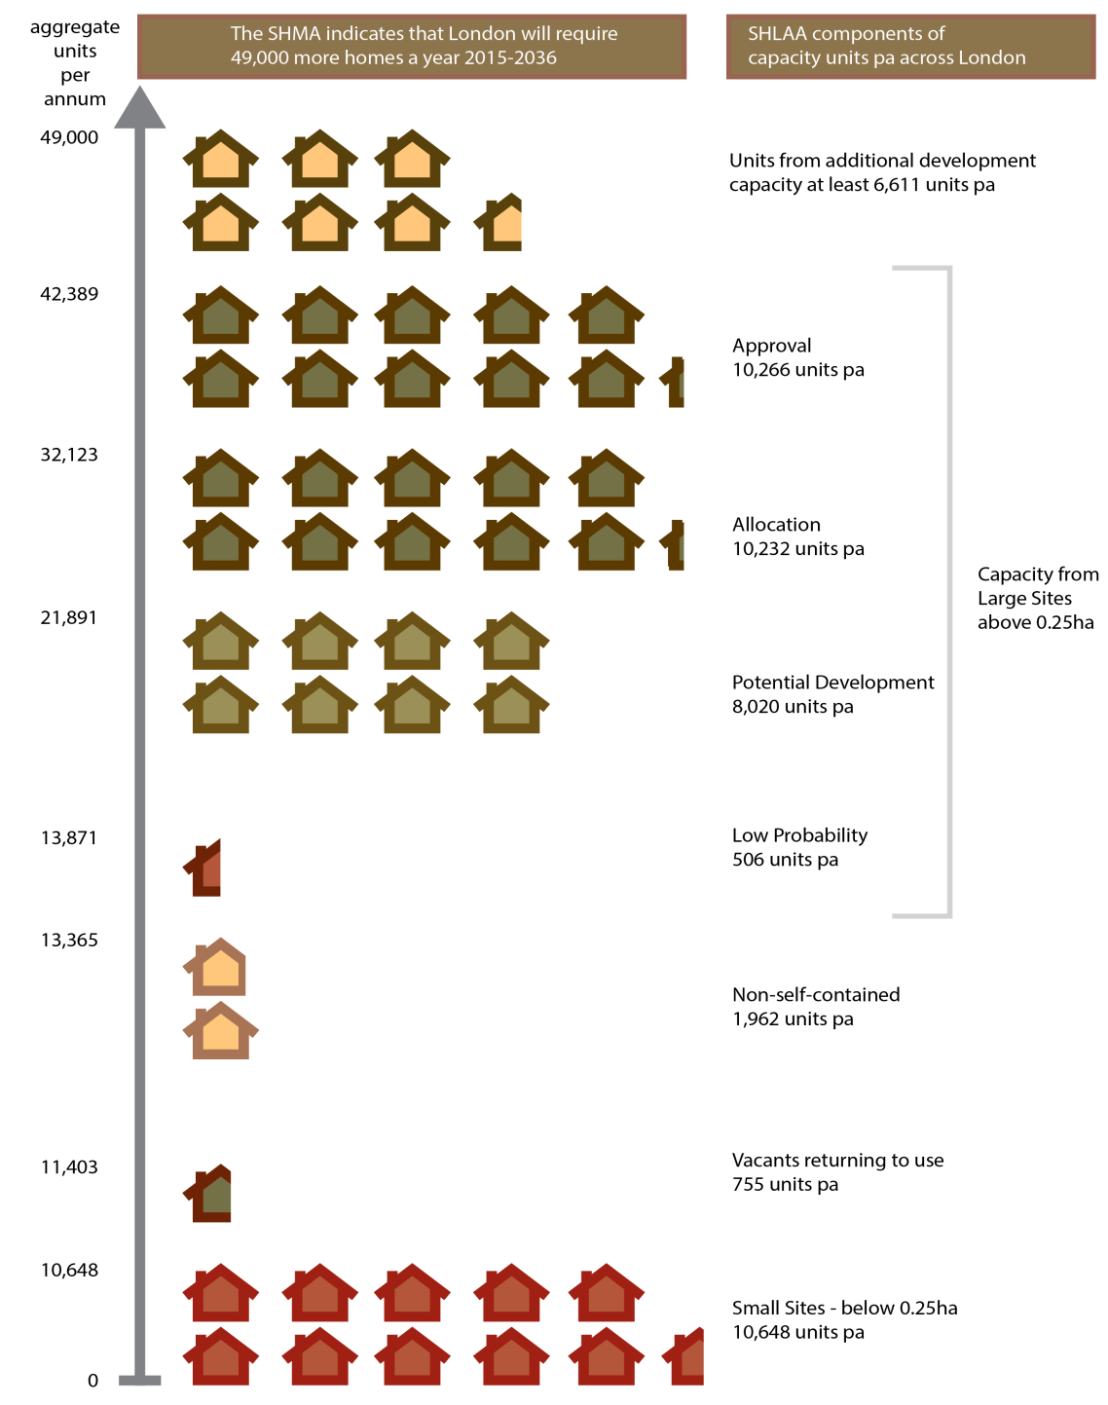

*Source Greater London Authority*

It is self-evident London will not deliver an unprecedented number of homes with no contingency for problems, error or slippage. This has to begin with a contingency of land supply.

1. The current developer business model

This next problem is in large part a symptom of the first - stating the obvious, the quantum of land for housing released into the system has ramifications for the quantum of homes that house builders are *able* to build. But their *willingness* to build is about their business model, in turn driven by their need to maximise profit. It is a significant factor behind the 50 per cent conversion rate of homes approved by the planning system to those actually built.

Given current land supply levels, the traditional house builders have been building an average of 13,000 new homes a year in London for the last decade. When combined with affordable housing and other sources of additional homes (e.g. conversions and sub-division of larger homes) the average total is around 27,000 homes a year[[2]](#footnote-2) . Without an increase in the supply of land for housing, it is probably not realistic to expect the house builder contribution to dramatically expand from this level.

Traditional house builders’ ‘build for sale’ business model is fundamentally reliant on margins and not volumes. This is necessarily so, to manage the risks and uncertainty inherent in the London (and UK) housing market, most notably the cyclical risk. Developers typically buy land many years in advance of building homes on it, and have to predict the outcome of a potentially long, drawn-out, planning process and future house price changes.

Land acquisition is one of the most significant and risky cost outlays for any developer. It is priced on a residual basis, meaning that it is worth what is left *after* deducting build costs, financing, on-costs and anticipated profit from predicted home sale values. As such, a small difference on the anticipated the sale price of a new build home will have a disproportionate impact on land value it sits on - all other things being equal a 10% decrease in the house price could result in a more than 20% decrease in land value – a loss the developer would have to absorb.

Successful house builders have become adept at managing the risks. To a large extent this explains why a small number of house builders build most of London’s homes. Small builders have been unable to withstand the realisation of these risks over many economic cycles and many have failed in property market downturns. Over the course of time this has had a “ratcheting-down effect” on the sector’s capacity to build.

Furthermore, the way these risks are managed significantly limits the incentives of house builders to increase volumes. House builders will incrementally increase delivery in buoyant markets but limit build-out rates to optimise returns and hedge against market downturns. In a 2014 study[[3]](#footnote-3) of large sites – those with more than 500 homes planned - Molior London found that an average of 68 private homes were started on each site in 2011 and 85 private homes were started on site in 2013. They suggested that no large site scheme should be assumed to complete more than 100 homes in any given year. In other words, a build out rate of a maximum of 20% of the consented homes.

We cannot assume affordable housing providers will make up the housing supply gap either. From the 1920s to 1970s large proportions of London’s housing supply were built directly by the public sector - latterly by London boroughs but in earlier times by the London County Council and the Greater London Council. More recently this role has been played by housing associations who currently build around 40% of the new homes in London. But direct outputs of affordable housing are closely linked to Government policy decisions including the availability of subsidy in the form of grant. Given the current fiscal context, the best case scenario is that housing associations and local authorities continue to deliver a similar number of homes as they have in recent years. They are unlikely therefore to be a source of increased housing supply.

So instead of expecting house builders to behave differently, railing against their rational responses as somehow anti-competitive, or bemoaning the lack of government investment in affordable housing, it is important that we bank these vital contributions to housing supply and look to what else can be delivered, either through more land release, or through a new type of housing provider with a new business model.

1. A lack of sector innovation

Through technological advances, almost everything we buy costs significantly less than it did forty-years ago, most of it is also significantly better. Many of the things that make up significant proportions of consumer spending were not available for purchase forty years ago but have gone through massive innovation. The moon landing cost NASA around $100bn in today’s money, but the phone in your pocket (which probably cost you or your network provider less than £500) probably has more computing power than all of their navigation systems did. In 1939 a black and white 15 inch television (with a valve and casement almost three times that size) was state of the art but now it is pretty much impossible to buy a television that small and a 55-inch ‘4k Ultra HD OLED’ television in 3D with internet access is far cheaper in real-terms. Advances in technology and cost reduction have occurred across the board in fields as diverse as cars, clothing and white goods.

Pretty much the only area that hasn’t seen these advances is housing construction. Homes in 2015 are more or less built using the same methods they were 150 years ago. Calculations carried out for this chapter show that build costs are 24 times higher in 2015 than they were in 1971 (a real terms increase of 1.78). This is largely because homes are hand-built, using labour intensive methods, in largely uncontrolled conditions. These construction methods are inefficient, slow, require interaction by a large number of different trades, and are negatively affected by adverse weather.

As if such low-productivity was not enough, there is also an acute skills shortage in the housebuilding industry. Both impact on the sector’s capacity. The skills problem is actually a longstanding one, though exacerbated periodically by economic downturns. According to EC Harris[[4]](#footnote-4) even at the height of recruitment in 2005 the construction industry was not attracting sufficient new entrants to replace the 700,000 workers who were due to retire within the next ten years.

So unless we move rapidly to a new way of building homes, rather than just hand-made ones, it will be impossible to build enough homes to meet the demand with the immediacy we need. Nowhere is this more true than in London.

**The potential for a new form of housing**

There is actually plenty of land in central London to build homes. There is the potential to make that land available for new housing and at the same time bring about a new developer business model - to get the houses built on that land quickly, rather than the traditional build to sale model with its slow build out rates. This would require building new homes in a different (and faster) way, as well as institutional investors to fund it - with the homes built not for outright sale, but for rent or part rent.

1. Land in central London suitable for housing

London is not full; it remains a relatively low density city with plenty of land suitable for increased housing provision. Just look on Google Maps in or around central London and you won’t fail to be struck by the vast swathes of vacant or under-used land, used for surface car-parking, storage or warehousing. In total, 3,414 hectares of land would be needed to accommodate 420,000 homes at a density of 123 homes per hectare[[5]](#footnote-5).

Some land that is suitable for housing is already owned by the public sector, but many of the public sector bodies that own them will not be directly concerned with housing delivery. Moreover, the experience of the past [[6]](#footnote-6) suggests that shuffling land around the public sector does not necessarily build homes faster. The future can be expected to be better than the past with a strong land coordinating role for the London Land Commission and close involvement of Transport for London in building on and around new and improved transport infrastructure. Savills estimate that surplus public land in London could have capacity for 100,000 homes[[7]](#footnote-7) so, generously, this could provide for nearly a quarter of the proposed contingency of 420,000 over the 20-year period. Given that many of these surplus public-sector sites are already well-progressed, this number could already be lower.

Industrial land could also make a significant contribution. There are 6,899 hectares of industrial land in London – twice as much as the 3,414 hectares needed to accommodate 420,000 homes. Some of this land could be used for housing through a change of land use. As a start, there are 543.5 hectares of vacant industrial land going to waste, enough for nearly 67,000 homes.

In all, London has 196,000 hectares of land used for “non-domestic buildings” and “other land uses” (though this would include offices, as well is industry, warehousing and car parking). Using just 1 per cent of this land for housing instead would be enough for nearly a quarter-of-a-million homes.

1. Off-site manufacture to build at scale and pace

To overcome the house-building sector’s capacity constraints as well as to deliver new homes at scale and pace would require a new construction method - of homes manufactured in factories, or so-called off-site manufacture. The approach sees components or modules precision-manufactured in factories before being assembled like a high-tech jigsaw on site. This approach would allow standardisation but with sufficient variability to ensure it did not result in uniformity. Design codes or ‘pattern-books’ could even be adopted within each of the redevelopment areas (i.e. where land had been released for housing from a different use previously) with the input from local people.

These homes would not be like the ‘prefab’ homes of the 1960s, made from pre-cast concrete slabs like the Aylesbury Estate and Robin Hood Gardens in Poplar, both of which suffered from problems of quality and poor design (see pictures). Modern manufactured homes can be clad in a variety of materials including bricks and are therefore visually indistinguishable from homes made from more traditional methods. What they have in common is the production of high-quality precision engineered homes with high-levels of energy efficiency. There are significant advantages in this construction method over traditionally built homes: reducing the effect that weather has on production; fewer material deliveries – bringing with it reduced disruption and fuel consumption; fewer defects, reduced wastage, and improved safety.

|  |  |
| --- | --- |
| C:\Users\christopher.651\AppData\Local\Microsoft\Windows\Temporary Internet Files\Content.Outlook\WAF275P6\HH Nottinghill Aylesbury August 068.jpg | C:\Users\christopher.651\AppData\Local\Microsoft\Windows\Temporary Internet Files\Content.Outlook\WAF275P6\IMG_1751.jpg |
| C:\Users\christopher.651\AppData\Local\Microsoft\Windows\Temporary Internet Files\Content.Outlook\WAF275P6\_DSF3655.jpg | C:\Users\christopher.651\AppData\Local\Microsoft\Windows\Temporary Internet Files\Content.Outlook\WAF275P6\IMG_1840.jpg |
| C:\Users\christopher.651\AppData\Local\Microsoft\Windows\Temporary Internet Files\Content.Outlook\WAF275P6\HH Nottinghill Aylesbury August 059.jpg | C:\Users\christopher.651\AppData\Local\Microsoft\Windows\Temporary Internet Files\Content.Outlook\WAF275P6\IMG_1759.jpg |

There are already British-based companies such as Laing O’Rourke, SIG, AECOM and Buro Happold who are active in the thinking or application of manufacturing homes but they currently lack the scale of demand to rapidly grow to the scale required. As already noted, the increased speed of construction is not particularly useful for house-builders and many housing associations are risk averse, with their minds clouded by past negative experiences. These factors mean that some great solutions from innovative companies have not been adopted. Some of this is changing with increased interest in ‘build-for-rent’. The recently announced strategic alliance between Laing O’Rourke, Legal & General and Touchstone to deliver 2,000 homes a year[[8]](#footnote-8) indicates growing appetite in this area.

Although current costs quoted for these modern methods of construction are comparable to traditional build methods, this would dramatically change over time as the benefits of standardisation, scale and initial investment in manufacturing technology were recouped and costs fell. The experience of just about every other industry means it can be predicted with confidence that manufacturing homes would reduce their build costs in real-times. The time savings are already apparent, a quick search on YouTube will bring up hundreds of videos of homes built in a day. A London block of flats could be constructed in around 12 weeks compared to a typical 18 months for a more traditional construction method.

Brick-clad homes constructed with factory-built closed-timber-frames, Rainham

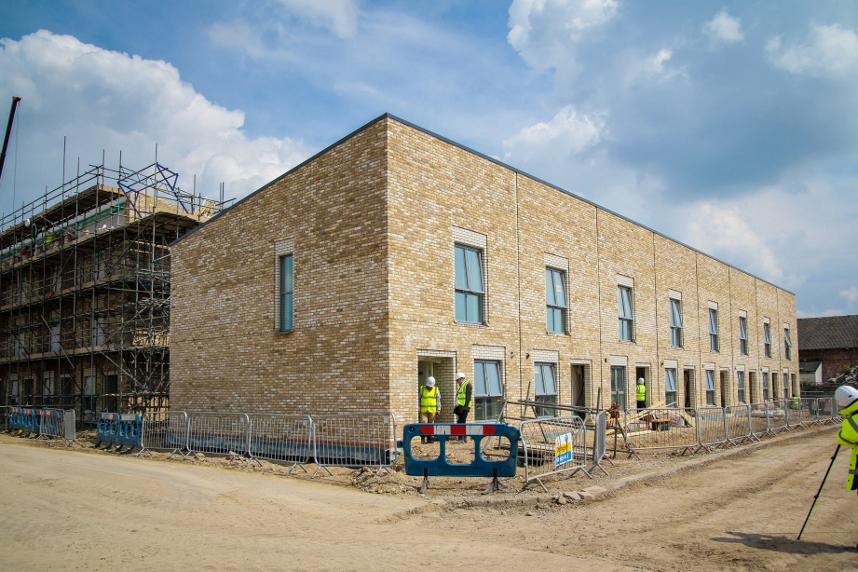

Apartments constructed with manufactured concrete panels, Barking

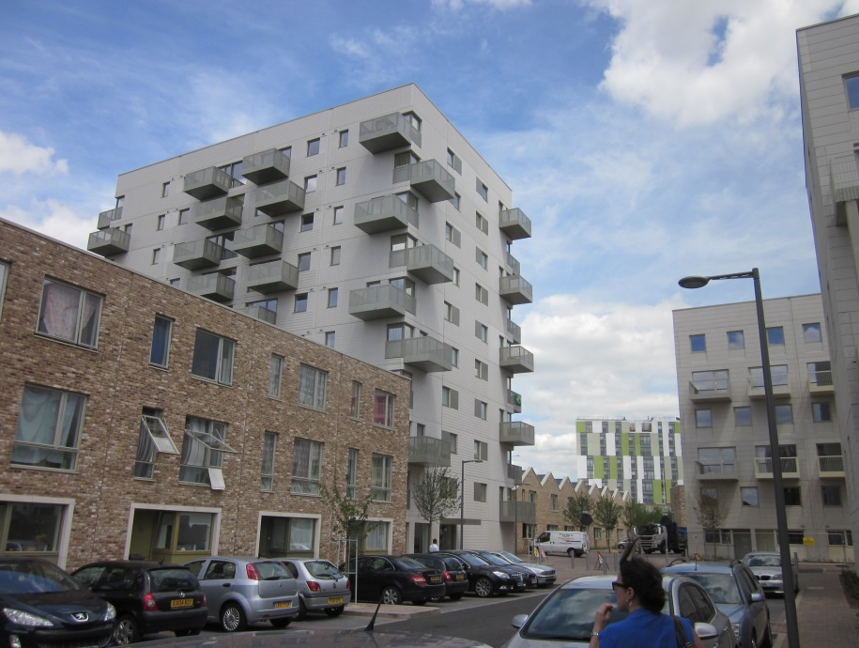

1. Institutional investor demand for homes to let or part let

Pension funds and other large investors are increasingly either buying up blocks of existing rental accommodation or embarking on so-called “build to rent” – a trend familiar to investors and tenants in the US, Canada and continental Europe, but not in the UK. These purpose-built, large-scale properties (typically apartment blocks) offer longer-term tenancies, more predictable rents and shared services.

In other countries, unlike in the UK, long-term investment into housing by similar institutions is tried and tested. It is already widespread and many of these companies, like the North American property company Greystar, Canadian real estate company Realstar and the Kuwaiti bank Gatehouse, are actively looking for opportunities in the UK. Large well-known pension funds too, such as Legal & General, Aviva and Prudential, and public sector pension schemes including those for London and Lancashire, have all publicly expressed their desire to increase their investment in large scale properties for rent. But despite these positive signs it is still early days. Many investors remain cautious of the potential risks involved in development (development risk) and have struggled to find sufficient number of large-scale opportunities.

Large-scale rental property portfolios are attractive to long term investors to hold because they provide a steady, long-term, income stream from rents generally rising with CPI inflation (or possibly even with earnings). The liabilities of institutional investors (e.g. pension payments) tend to rise with inflation, so rental income that also grows with inflation provides good liability-matching.

A new form of housing delivery model in London could harness the strong growth potential of purpose-designed apartment blocks of build for rent homes funded by the ‘wall of equity’, as London seeks to grow its institutional private rented and shared ownership sectors. The majority of the homes built by such investment funds would be high quality purpose built homes for market rent.

As a city which has historically had and continues to see high levels of mobility from the rest of the UK and the world, London needs a significant and well functioning private rented sector (PRS). The market is currently dominated by part-time landlords, the vast majority of whom own only one home. Large-scale long-term investment would not only drive up the quality of PRS homes themselves but also of their management, so improving the consumer experience.

There is also the opportunity for investing in part-buy-part-rent (shared ownership), enabling Londoners on ordinary incomes into partial home ownership and to ‘staircase’ to full ownership if and when their circumstances allow. In many ways part-buy-part-rent offers a more investible proposition than market rent. The rents are index-linked (the holy grail for long-term investors who need to match their liabilities), long-term leases mean that there is no void risk, there is no repairing liability and with natural churn through ‘staircasing’ it also offers access to investment returns from house price inflation. There has already been investment from large investors such as Aviva and CBRE[[9]](#footnote-9) into existing part-buy-part-rent homes and the Greater London Authority is close to announcing initial deals for investment into new supply. The appetite is there and ready to be unlocked.

It is also worth making the point that new build private rented homes can be absorbed into the market at up to fifteen times faster than new build homes for sale[[10]](#footnote-10). According to Molior London, as of June 2015 there were 19,000 ‘build-for-rent’ homes under contract in London, a drop in the ocean but an increase of 46 per cent compared to February 2014. This is a remarkable increase and it indicates the huge potential of the purpose-built private rented sector in our Capital.[[11]](#footnote-11)

**Making it happen – policy proposals**

Central Government should support the next Mayor of London to take a more proactive role in housing delivery, providing the essential ingredients to build new homes - land for housing and upfront “pump-primed” investment funding. The Mayor should be given a new power to quickly requisition disused or under-utilised commercial land and property for the purpose of building new housing, with reasonable (but not excessive) compensation. Government would then work in partnership with long-term investors, such as private pension funds, and/or local authority pension funds and insurance companies, and contribute to a joint equity funding venture. This would pay for (i) the land acquisition and the preparation of the sites for redevelopment, possibly even providing “readymade” land for housing and (ii) the rapid delivery on these sites of new homes - a mixture of build for rent and ‘part buy part rent’ (shared ownership), using off-site manufacture techniques.

1. More land supply for housing – a new land contingency

As we have seen, the planning system constrains the availability of land suitable for housing with no contingency provision. But there is a good reason why the planning system functions in this way. The Town and Country Planning Act 1947 nationalised rights of development, taking them away from the land-owner, so that they now rest with the Local Planning Authority. Even a pro-growth Local Planning Authority is likely to be wary of allocating more land for development than is needed. They would undoubtedly lose a degree of control over house-building in their area and be suspicious that builders would prioritise the easiest sites, leaving problematic but strategically important ones neglected.

It is therefore proposed that additional capacity is identified *as contingency* but that all of these contingency sites are delivered with strong strategic control by the Mayor of London – a new mayoral contingency system.The focus would be on quality, through a streamlined and bespoke planning system (as well as through a new model of development of manufacturing homes for the institutional private rented sector). This would ensure that the London Boroughs, together with existing house builders, continue to deliver homes on sites identified through the conventional planning system. The contingency arrangement would therefore deliver *additional* homes over and above current levels, and could be set at 420,000 homes over a twenty year period, or 21,000 homes a year: contingency of 50 per cent against current minimum targets. So if current house building levels of 27,000 homes were to continue being built through the conventional system, these would be topped up by another 21,000 (the maximum) through the Mayor’s new contingency system.

The process for identifying the land for these contingency sites could be one natural progression of the London Land Commission. But, as already discussed, it would need to go significantly beyond existing publicly-owned land to ensure we can accommodate all of the 420,000 ‘contingency homes’ needed. Whilst the Mayor of London should have overall strategic responsibility for selecting the required land, this should be informed by considerations of housing need, demand, and land availability, as well as representations from London Boroughs, business and community groups as well as members of the public. This could be similar to the current process followed for Strategic Housing Land Availability Assessments but open to a much wider audience.

Given only some of the land suitable for these contingency sites is owned by the public sector, it is inevitable that the vast majority of sites would need to be purchased from the private sector, or private land-owners. But the contingency model needs to take a strategic and pan-London approach. This would recognise the shifting trends in land use. London continues to deindustrialise – according to a report produced for the GLA, the amount of industrial land declined by 9.4% in the 10 years to 2011, the latest available data.[[12]](#footnote-12) The amount of land actually in use for industrial purposes (i.e. *excluding* vacant industrial land) declined by 6.1%. People are also increasingly working from home and decreasingly in offices – hot-desking practices, with a typically diminishing ratio of desks to employees, are becoming the norm. More and more shopping is now done online, with UK online retail sales growing around 16% in both 2014 and 2015. Online spending now has a 15% market share, a share that continues to grow strongly, with ramifications for conventional shopping.

But markets – especially land markets controlled by the planning system - do not always adjust quickly, and certainly do not in a frictionless way. The number of empty properties, including derelict land, warehouses and shops, is one symptom of this and can be symptomatic too of run-down communities. For example, according to the Valuation Office Agency (VOA), the amount of *vacant* retail floor space grew by 5% in inner London and a whopping 47% in outer London from 2007 to 2012. This highlights an inefficient use of land that could be recycled and used instead to create desperately needed housing for hard working Londoners, as well as to regenerate these places as vibrant communities.

Just identifying the land for contingency sites will not be straightforward, but the acquisition would be even harder without policy changes needed to make it happen. A need to acquire land through mutual agreement with private owners is likely to prevent housing delivery at the scale and pace needed to make the envisaged model work. Even setting aside the lengthy and complex process of negotiation haggling over the price, the expense of acquiring land in this way would be prohibitive. That is because, although the existing use value of this land (e.g. that of continued operation of the business located on it) is likely to be significantly lower than the potential use value for housing, landowners are likely hold out on any sale until a price approaching that for residential use is achieved, thus ensuring they capture precious land value uplift as profit. The proposal outlined here argues that more of the value-uplift should accrue instead to the Mayor of London to build homes.

The GLA already has powers to requisition privately owned land, with compensation to the owners, through the Compulsory Purchase Order (CPO) powers. But not only is the CPO process long and drawn out, the compulsory purchase price is usually at market value under the new use - where applicable - plus compensation for any upheaval. This makes CPO very expensive: to illustrate, a plot of industrial land (i.e. at existing use) worth £3,000,000 might instead be worth £5,000,000+ if used as residential land.

There are also very limited grounds for using CPO powers for housing purposes. In many cases there will be a planning consent already in place and in all cases there must be strong evidence that delivery will happen swiftly. Individuals opposed to redevelopment can even use the CPO process to derail it, potentially reutilising arguments which were unsuccessful in the planning process, meaning that the CPO process can take years and years.[[13]](#footnote-13) Even after gathering the required information it can take over a year for a hearing to be convened and final written judgements can take the same time again before being published.

To assimilate the land for contingency housing that is needed - and expedite the adjustment of land use for urban regeneration in the parts of our capital that need it the most - the Mayor of London should therefore be given enhanced compulsory purchase powers. The Mayor should be empowered to purchase land at current use value and to acquire it quickly (i.e. with fewer grounds for challenge), where the business premises have been empty, or the land disused, for a certain period of time (e.g. 2 years), applying the “use it or lose it” principle. The current land uses would include all non-residential uses – e.g. industry, storage and warehousing, retail and offices, as well as other land use such as carparks.[[14]](#footnote-14)

To help prevent gaming by landowners, premises that have already been empty for 2 years or more continuously, but that have subsequently been brought back into use recently, perhaps within the last year, would also be included within these new enhanced compulsory purchase arrangements. Such long-standing empty properties, disused land, and low utilisation rates are indicative of a lack of demand for that particular use of land in a given locality. Land use needs to be more responsive to these market signals. Given the strong public interest for greater land provision for housing across London, the land should instead be used for housing. Landowners should not, for example, be able to hoard this land in the hope they will be able to sell it on for residential development at a large profit in the future.

To enable this to happen, there would need to be a radical overhaul of the compulsory purchase powers in respect to empty premises or disused land, going far beyond current Government proposals[[15]](#footnote-15) to shorten timescales and introduce electronic communication. Two significant changes to the CPO framework in respect to empty premises or disused land are proposed:[[16]](#footnote-16)

1. To change the CPO process so that the only requirement to lodge the compulsory purchase is a properly taken decision by the Mayor of London to acquire the land for additional housing delivery within a defined period of time (e.g. 5 years), subject to the property having been empty or the land disused for a defined period of time (e.g. 2 years). This would remove the current lengthy CPO process; and
2. To change the compensation regime so that the level of compensation would be set at no more than existing (i.e. commercial) use market value - established subsequently to (1) above, which could be independently assessed by the existing Tribunals system, and within a set timeframe, for example, 1 year from the compulsory purchase having been lodged.

In the United States, there is a long-standing power, exercisable by the Federal Government and the States, of “eminent domain”, which is similar, though it extends to *all* property.[[17]](#footnote-17) Eminent domain is the right of Government to expropriate private property for public use, with payment of fair compensation. In accordance with their powers and the correct procedures, public bodies are able to unilaterally declare land as eminent domain. The only question to be subsequently determined is that of compensation value. This is a significantly shortened process in comparison to the current compulsory purchase regime in the UK. The establishment of the post-war New Towns in the UK also involved a comparable process (of New Towns “designation”), which effectively re-allocated land ownership within a drawn redline area, with compensation at existing use value determined through a more detailed process. However this power has fallen into disuse with no New Towns designated since 1970. Taking the best of these two examples and applying them to land and buildings that are not being used offers an opportunity to significantly reduce red-tape and bureaucracy and free up the land for the housing London needs.

However, the existing CPO arrangements would remain in place for all other property that has *not* been empty for two years or more.

In addition to the enhanced compulsory purchase powers for empty business premises or disused land, the Mayor of London should be empowered to offer any landowner the current use value *plus* a fixed mark-up to purchase the land through mutual consent. This would apply to all business premises and land currently in use[[18]](#footnote-18), including hardstanding land (carparks), as well as any commercial use premises or land that had been empty or disused for *less* than 2 years.

Giving the owners of non-residential land the option of selling up *with* a modest mark-up on the current use market value would provide a powerful financial incentive for early settlement (as well as quicker re-use of the land). Otherwise they could still be subject to the current CPO powers, which could end up being financially disadvantageous to them. It might also be attractive for some landowners, as they would be able to buy a bigger or better business premise elsewhere with the extra capital. This would be especially true where the business concerned could reasonably relocate, possibly further out from the city centre in the case of industry and warehousing, with the appropriate compensation to cover relocation costs where the business premise or land was still in use.

The magnitude of the mark-up on the market value at existing use could be a percentage, perhaps the order of +33%, but there could be merit in it being a fixed amount of, say, £1 million per hectare, or around £10,000 per equivalent home plot. This could provide a more powerful incentive in locations where market demand - and thus land value - at the current use is lower but where, most likely, the demand for housing would be still be high.

More generally, the mark-up amount would need to balance the need to provide a sufficiently strong financial incentive for the landowner to sell, and the need to minimise the purchase cost for the Mayor of London - i.e. to ensure the financial viability of redeveloping the site and the surrounding area for housing as part of the urban regeneration policy.

Once enacted, these new tools would enable the mass purchase of land not currently used or intended for housing by the Greater London Authority, at significantly below residential use value, including in prime London locations. Existing industrial land, in a location suitable for building homes at reasonable density could be acquired for around £30,000 to £40,000 per plot, a fraction of that for land permissioned for housing (often £100,000+).

1. Upfront Government investment

Upfront Government investment would be intended to catalyse this new form of housing delivery and provide the pioneering needed to “try and test” the model, in order to de-risk subsequent private sector investment. Over time the Government funding role would therefore diminish. The acquisition of land, remediation, provision of required infrastructure and build of 420,000 homes would cost approximately £126bn[[19]](#footnote-19) over 20 years (£6.3bn a year), effectively three High Speed 2 projects. Thankfully though, even in the pioneering phase, the requirement for Government funding would be far less than this. Unlike High Speed 2 – which also involved the widespread compulsory purchase by Government of private property - a significant proportion of the cost could be met by the private sector.

In one model (other variants could be explored), Government or the Mayor of London would contribute 49 per cent of costs, or £62bn over 20 years, to a private/public joint venture with an institutional investor (or group of investors). The joint venture would provide upfront funding to acquire the land, probably through the compulsory purchase of commercial property under the new powers described above. The joint venture would also pay to remediate the land, put the site infrastructure in place, master-plan the site and obtain planning permission. The joint venture would then commission an off-site home manufacturer or a number of home manufacturers to build the homes.

Upon completion of each site phase, the homes would be made available to let or to part-let-part-buy ( - i.e. shared homeownership with the joint venture investment fund). The private equity fund(s) comprising the joint venture with Government would also have an option to buy out the Government’s 49% stake at any point. This model would require Government or Mayor of London funding of £62bn over 20 years or £3.1bn a year. However, assuming that the Government share in the homes is sold to the private equity fund investors 4 years after they have been built (on average)[[20]](#footnote-20), the ongoing returns from sales of homes would mean that the peak cumulative funding requirement would *not* be the £62bn mentioned, but closer to £15bn, which is significantly less than the current Help to Buy scheme.[[21]](#footnote-21) Depending on market conditions, the Government’s investment could be run-down so that it recouped all of its investment within the 20-year period.

Crucially, such Government investment would enable London to deliver these additional “contingency” homes but without negatively impacting on its mandate to reduce the fiscal deficit. The current Government has a clear mandate to reduce Public Sector Net Borrowing (PSNB), but fortunately the investment into this vehicle if structured as a Financial Transaction would not impact upon that measure.[[22]](#footnote-22) Although this would represent a very significant level of Government investment and delivery on a scale not seen in London since the 1930s, this level of commitment would create a market for investors to enter at the scale required. The cost of borrowing for Government is also at an all time low, making it possible to take advantage and invest heavily in housing as infrastructure for London

Again Government or the Mayor of London would eventually recover the investment. The total scheme cost of building each home (including the land and infrastructure costs) would be £300,000, but each would sell for over £415,000, on the basis of the average London sale price for a new build home. It would be important for Government to have a clear exit strategy - it would sell its equity stake in the joint venture in tranches to its partner or other private equity investors, once a sufficient number of the homes had been built and let. The Government’s share sales could be managed in a similar way to the privatisation of Lloyds Banking Group PLC by UK Financial Investments Ltd and, like that privatisation, eventually include a retail offering.

1. Supporting building capacity and a new growth industry

In order to have greater confidence in the delivery at the required scale and pace the joint venture investment fund -described in the previous section - would choose to partner with a homes manufacturer (or a number of them) to build the new homes, eschewing traditional construction methods. This would not only provide cost certainty and scale economy savings but also improve returns to the fund by allowing the homes to be built much faster - the faster the homes are built, the faster they can be let and start paying rental returns to the institutional investors.

Again these homes would be very different to the pre-fabricated homes built by local authorities in the 1960s. At that time there was limited incentive to build quality homes as sub-market rents meant the demand was practically unlimited and central Government subsidies provided perverse incentives to build certain types of homes. These mistakes would be avoided because it would be in the Fund’s financial interest to create a high-quality product, with long term value, which would drive positive ongoing returns. This inherent focus on quality would enable the relaxation of planning and other regulations on the homes built by the Fund, as happens in California for factory-built homes. This in turn would reduce unnecessary costs and quicken the pace of delivery.

Government investment on the scale envisaged in this paper could drive massive benefits to UK PLC by creating a significant industrial base in manufactured homes at scale, to world-leading designs. This industrial base could potentially be based in an emerging ‘Northern Powerhouse’. There is already a growing homes manufacturing industry in Germany and Chinese and Indian companies are gearing up. But with the right Government backing and sufficient demand, a significant manufacturing capacity could be created right here in the United Kingdom. Due to the size and weight of manufactured home components – as well as a production process that is relatively capital as opposed to labour intensive - factories in the Midlands or ‘Northern Powerhouse’ could enjoy a significant competitive advantage over Asian counterparts in supplying the London market. The benefits to the wider UK economy could be significant.

**Conclusion**

Building the homes that London needs requires bold solutions. The proposals in this paper for a radical change to the Compulsory Purchase Order process, maximum Government investment of £15bn and mass delivery of manufactured homes to rent and part buy would not be easy.

But the additional supply of 420,000 homes by 2035 would be well worth it. It is the number London needs over and above current levels of supply. They would not only provide high quality places for people to live in the long-term, but also significantly reduce the pressure on the wider housing market in London and the greater South East, whilst creating a new homes manufacturing base outside of London, potentially in the Northern Powerhouse.

To realise this model requires both an acceptance that housing is an important part of this great city’s infrastructure, and leaders who are prepared to follow Bazalgette and other pioneers who laid the foundations of the London we live in today.

1. Writing in a personal capacity. [↑](#footnote-ref-1)
2. London Plan Annual Monitoring Reports, <https://www.london.gov.uk/priorities/planning/research-reports/monitoring-london-plan> accessed 12 September 2015. [↑](#footnote-ref-2)
3. *Barriers to Housing Delivery – update report July 2014,* commissioned by the Greater London Authority <https://www.london.gov.uk/sites/default/files/Barriers%20to%20Housing%20Delivery%20Update%20Report%20-%20July%202014.pdf> accessed 24 August 2015. [↑](#footnote-ref-3)
4. <http://www.echarris.com/pdf/People%20and%20money%20-%20fundamental%20to%20unlocking%20the%20housing%20crisis.pdf> accessed 16 August 2015 [↑](#footnote-ref-4)
5. The assumption used in the London Strategic Housing Land Availability Assessment for urban locations with a Public Transport Accessibility Level of ‘4’. [↑](#footnote-ref-5)
6. In April 2012, the Mayor of London inherited the land portfolios of the Homes and Communities Agency in London, the London Development Agency and the London Thames Gateway Development Corporation. Since then, there have been 3,503 starts-on-site on Mayoral land. [↑](#footnote-ref-6)
7. Savills <http://www.savills.co.uk/_news/article/72418/184238-0/11/2014/public-land-could-deliver-as-many-as-2-million-new-homes> - accessed 24 August 2015. [↑](#footnote-ref-7)
8. <http://www.costar.co.uk/en/assets/news/2015/June/LG-Laing-ORourke-Touchstone-form-Local-Authority-housing-alliance/> - accessed 25 August 2015. [↑](#footnote-ref-8)
9. CBRE investment of £9m into shared ownership with Derwent Living case study - <http://www.chaco.org.uk/wp-content/uploads/2015/05/CBRE-Derwent-Living-Case-Study.pdf> - accessed 25 August 2015. [↑](#footnote-ref-9)
10. Based on press releases on the Get Living London website where the gap between the 100th property let and the 1,000th was 214 days, a letting rate of 1,536 homes a year <http://www.getlivinglondon.com/pressmedia/press-media.aspx> accessed on 24 August 2015. [↑](#footnote-ref-10)
11. The Mayor’s London Housing Strategy has set a target of 5,000 build for rent homes built each year. Assuming four years from planning permission to completion, this may be achieved by 2020 on the basis of the 19,000 figure. However a more radical approach is clearly needed to go beyond that. [↑](#footnote-ref-11)
12. London’s Industrial Land Baseline https://www.london.gov.uk/what-we-do/planning/london-plan/london-plan-technical-and-research-reports [↑](#footnote-ref-12)
13. Haringey council’s proposed compulsory purchase of Archway Sheet Metal Works to allow Tottenham Hotspur football club to redevelop their stadium is one such high profile example, though sale was eventually agreed between the firm and club. [↑](#footnote-ref-13)
14. in most cases offices can also be converted to residential (homes) through the existing permitted development rights [↑](#footnote-ref-14)
15. <https://www.gov.uk/government/consultations/improving-the-compulsory-purchase-process> accessed 12 September 2015 [↑](#footnote-ref-15)
16. This paper does not propose any changes to process for acquiring someone’s home. It is clearly important to maintain a proper balanced test in these circumstances. [↑](#footnote-ref-16)
17. http://www.justice.gov/enrd/history-federal-use-eminent-domain [↑](#footnote-ref-17)
18. Landowners attracted to such an offer but *letting* their premises to a business would obviously have to abide by any tenancy agreement in place, and to reach their own accord with their tenant if they wanted to terminate the agreement early through mutual consent, in order to sell their business premise and/or land. [↑](#footnote-ref-18)
19. Assuming industrial land costs of £30k per home – based on the existing use value of an industrial estate in an unspecified London Borough, remediation and infrastructure of £120k per home – based on GLA sites and taking account of reasonable decontamination costs, and and build costs (including on-costs and professional fees) of £150k per home. [↑](#footnote-ref-19)
20. This is broadly in line with industry expectations about the stabilisation of a rented portfolio. [↑](#footnote-ref-20)
21. £18bn in total, £12bn allocated for the mortgage guarantees and £6bn for equity loans. [↑](#footnote-ref-21)
22. In 2012-13 the UK Government introduced an additional type of capital funding in order to boost investment – so called Financial Transactions. Financial Transactions do not strictly add to capital expenditure per se, as they are not regarded by HM Treasury as spending transactions. Financial Transactions in general consist of the transformation of one type of financial instrument into another – for example cash into lending. Lending increases fixed assets on the Government’s balance sheet but is not an item in net investment and therefore does not contribute to Public Sector Net Investment (PSNI) it also does not increase Public Sector Net Borrowing (PSNB). It may increase the overall stock of financial debt, as measured by the aggregate Public Sector Net Debt (PSND). [↑](#footnote-ref-22)