ON THE DAY BRIEFING – AUTUMN STATEMENT 2016

NHC Policy Team

OVERVIEW

The tenor of the Chancellor’s speech was prioritising infrastructure and innovation spending with additional borrowing in order to increase productivity; delivering a high wage, high skill economy. Phillip Hammond noted that the government would maintain a commitment to fiscal discipline but with the caveat that “fiscal headroom” would be given to support economy through the transition which suggested that some borrowing for investment in infrastructure was permitted.

He also announced there the government would not aim for a surplus in 2019/20 and that he was committed to seeing public finances return to balance “as soon as practicable” suggesting ‘as early as possible in the next Parliament’.  This represents a significant change in tone from the former Chancellor.

While much of the Autumn Statement focused on what the Chancellor will do with new money; he reiterated the commitment to strict departmental spending plans. However, he did over some incentive for departments to find cuts as he promised that any funds saved could be kept by the departments in question.

Oddly for a Chancellor making his first Autumn Statement, he also announced that it would be his last Autumn Statement announcing that the Budget would take the place of the Autumn Statement and that the spring date for the Budget would be taken by a Spring Statement instead.

HOUSING

The Autumn Statement held clear evidence of the new government’s new thinking on housing. Housing’s big day will come with the launch of the government’s Housing White Paper which we are told will be released by the end of the year.

Until that, the Chancellor’s announcement of a new National Productivity Investment Fund (NPIF) shows that the government are starting to think strategically about housing’s importance in the economy, particularly for productivity, and that the previous administration’s focus on home-ownership may be softening as the Chancellor announced a loosening of grant restrictions.

What was surprising was some of the issues the Chancellor didn’t mention: notably Starter Homes. It is likely that the issue of Starter Homes and the possibility of a broadening of the definition of the policy will be announced as part of the Housing White Paper.

Overall, the Autumn Statement committed £7.2 billion to support the construction of new homes, including spending by Housing Associations.

**National Productivity Investment Fund (NPIF)**

As previously alluded to, the government announced a new National Productivity Investment Fund which will provide for an extra £23 billion of spending between 2017/18 and 2021/22. This will be targeted at 4 areas that are critical for improving productivity: housing, transport, digital communications, and research and development (R&D). The NPIF will take total spending on housing, economic infrastructure, and R&D to £170 billion over the next 5 years.

[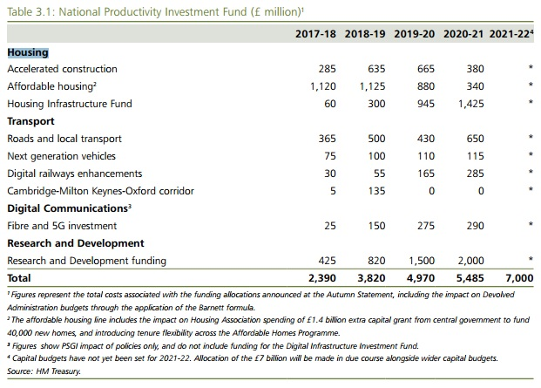](http://docs.northern-consortium.org.uk/wp-content/uploads/sites/3/2016/11/Untitled.jpg)

It should be noted that the affordable housing line includes the impact on Housing Association spending of £1.4 billion extra capital grant from central government to fund 40,000 new homes, and introducing tenure flexibility across the Affordable Homes Programme.

**Relaxed Restrictions on Grant Funding**

The government have committed to relaxing restrictions on grant funding to allow providers to deliver a mix of homes for affordable rent and low cost ownership. The thrust of this policy is to allow housing providers to meet the housing needs of people in different circumstances at different stages of their lives.

[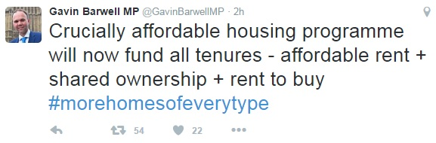](http://docs.northern-consortium.org.uk/wp-content/uploads/sites/3/2016/11/barwell.jpg)

This is good news for NHC members as it is something raised time and again an approach which is holding back housing providers from developing more tenure-appropriate properties across the North. The NHC’s recent Commission for Housing in the North called for precisely this kind of grant flexibility so we are delighted with this announcement.

**Accelerated Construction**

Following on from the government’s announcement in October, the Autumn Statement pledged £1.7bn by 2020/21 through the NPIF to speed up housebuilding on public sector land in England through partnerships with private sector developers.

The NHC suspect that more details of this will be contained within the Housing White Paper due by the end of 2016 and that one of the chief ways of accelerating construction will be through investment in off-site manufacturing. This continues to be an area of interest for many members the NHC will soon be launching an off-site manufacture group to share best practice and aid learning about this resource.

**Housing Infrastructure Fund**

The Autumn Statement announced a new Housing Infrastructure Fund of £2.3 billion by 2020/21 which will be funded by the National Productivity Investment Fund (NPIF) and will be allocated to local government on a competitive basis. It will provide infrastructure targeted at unlocking new private housebuilding in the areas of greatest need. The government estimate that this will deliver up to 100,000 new homes. Within this, there is also a commitment that government transport funding better supports housing growth.

**1% Rent Reduction Exemptions**

The Autumn Statement confirmed that refuges, almshouses, Community Land Trusts and co-operatives will be exempt from the policy to reduce social sector rents by 1% a year for 4 years from 2016-17. This comes after significant lobbying – particularly from co-operatives and almshouses – for such an exemption with many arguing that they would not be able to meet the costs of new development or ensuring the needs of their tenants were properly met.

**Pay to Stay**

Pay to Stay will now only be voluntary for local authorities. This was announced in a written statement to Parliament on Monday 21 November and reiterated in the Autumn Statement document. The Housing Minister, Gavin Barwell, said in the written statement that “the government remains committed to delivering its objective of ensuring social housing is occupied by those who need it most. But we need to do so in a way that supports those ordinary working class families who can struggle to get by, and in a way which delivers real savings to the taxpayer. The policy as previously envisaged did not meet those aims.”

Charlotte Harrison, Executive Director (Policy and Public Affairs) at the Northern Housing Consortium said “we are pleased that CLG officials and Ministers have taken the views of our members on board in reaching this decision not to proceed with the policy as originally intended.”

**Right to Buy Pilot**

The government announced that they will fund a large-scale regional pilot (rumoured to be the West Midlands) of the Voluntary Right to Buy for housing association tenants. Over 3,000 tenants will be able to buy their own home with Voluntary Right to Buy discounts under the pilot.

The costings for this in the Autumn Statement itself show that the Government do not expect the majority of spending on the pilot to occur until 2018/19 and 2019/20 which reflects the Government’s [recent admission](http://www.independent.co.uk/news/uk/politics/right-to-buy-housing-associations-extension-tories-theresa-may-long-grass-delay-a7395776.html) that the policy is no longer at the top of its to do list.

We will update members when the location of the pilot is confirmed.

**Letting Agent Fees**

In what will be a good measure for the nation’s 4.7 million private renters, the government announced its intentions to ban letting agents’ fees to tenants to improve competition and give more certainty to renters. The Department for Communities and Local Government (DCLG) will consult ahead of bringing forward legislation.

DEVOLUTION

The Northern Powerhouse Strategy, published alongside the Autumn Statement sets out government support for the North of England across themes such as “connectivity, skills, transport and innovation and trade and investment”.

We particularly welcome the section with a commitment to “make the North a great place to live and work” and are pleased to see echoes of the [recently released New Framework for Housing in the North](http://docs.northern-consortium.org.uk/wp-content/uploads/sites/3/2016/11/Commission-Report-Nov-2016.pdf) recognising the need for flexibility across housing investment programmes, and a commitment to ensure “we build more of the right homes in the right places, recognising the role the housing sector plays in economic growth”. We look forward to working with government on this New Framework.

The strategy sets out the productivity challenge facing the North of England which (measured by per capita GVA) is 13% lower than the UK average and 25% lower than in the South and identifies the four areas detailed above as particular challenges for the North.  The strategy links to the infrastructure funding announcements made in the Autumn Statement which will improve transport, unlock housing and enhance digital productivity.   £556million of investment will be allocated to Northern Local Enterprise Partnerships through a third round of Growth Deals from the Local Growth Fund.

The government confirmed commitment to devolution process and identified London and Greater Manchester will receive the budget for the Work and Health programme. Further elements were confirmed to London including £3.15bn from the affordable housing settlement.  In more general terms, the government will give mayoral combined authorities powers to borrow to include “investment in economically productive infrastructure, subject to agreeing a borrowing cap with HMT. It is hoped that this will include borrowing to deliver housing.  Outside of the mayoral combined authorities, the Autumn Statement announced a consultation on lending up to £1bn to local authorities to support infrastructure projects that are high value for money.

The Northern Powerhouse Strategy recognises the benefits for the North of supporting educational achievement and will look to support approaches to retain high quality teachers across the north – something that ResPublica North have called for and in particular the Department for Education will work with northern city regions to explore how to improve the delivery of early years outcomes.

HEALTH

Surprisingly absent from the Autumn Statement – and likely to be a considerable disappointment to local government sector across the north – was the challenges facing social care.  The demands of an ageing society are well known and increased pressure will come onto both health and social care budgets.  The chancellor acknowledged that increasing longevity would be need to considered in future fiscal decisions (although the triple lock was confirmed in this Autumn Statement) – it may be that financing of social care will be considered in that wider fiscal environment.

WELFARE AND TAXATION

The government intends to deliver on its aim of creating a ‘sustainable welfare system’, and will deliver the welfare savings previously announced.  The government has no further plan to introduce any additional welfare savings over the course of this Parliament.

**Universal Credit Taper**

The Chancellor announced today that the universal credit taper rate will be reduced from 65% to 63% from April 2017, which according to the government will increase the earnings of more than three million working families.

The aim of universal credit upon its inception was to ensure ‘work always pays’, under the legacy welfare system individuals on certain income levels would not be financially incentivised to work additional hours, as universal credit operates a constant withdrawal rate on net earnings – the taper rate.   This announcement today will allow individuals to keep more of what they earn – 2p for every pound they earn in employment and strengthen the incentive for individuals to progress through work.

Although NHC welcomes this announcement, there are some concerns that this doesn’t go far enough to support certain groups, that are ‘just about managing’ and those who are falling further and further behind.  Analysis by the Resolution Foundation states  that single parents still lose up to £2,800 from work allowance cuts while some only gain up to £200 via the 2% taper cut.  As highlighted by the table below by the Resolution Foundation.

[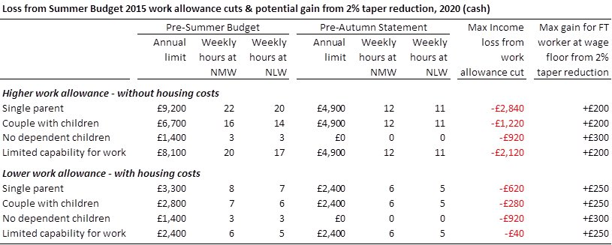](http://docs.northern-consortium.org.uk/wp-content/uploads/sites/3/2016/11/res.jpg)

Other welfare changes already previously announced include:

* [Revised rollout of universal credit](https://www.gov.uk/government/uploads/system/uploads/attachment_data/file/571711/universal-credit-transition-rollout-schedule-phase-4-to-6-2017-to-2018.pdf)
* Support for refugees – refugees and their family members will be exempted from the Past Presence Test, meaning that they will no longer have to be resident in the UK for 2 years before they can receive disability benefits
* Personal Independence Payment (PIP) – The Autumn Statement accounts for the government’s previously announced decision not to go ahead with changes proposed at Budget 2016 to PIP.
* Digital services – HMRC will allow new Tax Credit claims to be made using digital devices from April 2017.
* Child Tax Credit – HMRC will make in-year award adjustments so the disability elements of Child Tax Credit will be paid to a group of recipients who are eligible, but not currently receiving this entitlement.

**Welfare Cap**

To maintain control of welfare spending the government is introducing a new medium-term welfare cap. The cap is based on the OBR forecast in the Autumn Statement of the benefits and tax credits in scope as set out in Annex B, and will apply to welfare spending in 2021-22. To manage unavoidable fluctuations in welfare spending there will be a margin rising to 3% above the cap; the cap will only be breached if spending exceeds the cap plus the margin at the point of assessment.

**Employment**

**National Living Wage and National Minimum Wage Rates**

In today’s announcement the government will increase the National Living Wage from £7.20 to £7.50 an hour, an increase of 4.2% from April 2017.  According to the government this will mean a pay rise for over a million workers.  Chancellor Philip Hammond will give a big boost to the so-called ‘National Living Wage’, launched under George Osborne, in a bid to get it to £9 by 2020.

The government will also accept all of their recommendations for the other National Minimum Wage rates (which were last increased in October 2016) to apply from April 2017, including:

* increase the rate for 21 to 24 year olds from £6.95 to £7.05 per hour
* increase the rate for 18 to 20 year olds from £5.55 to £5.60 per hour
* increase the rate for 16 to 17 year olds from £4.00 to £4.05 per hour
* increase the rate for apprentices from £3.40 to £3.50 per hour 3.48 National Minimum Wage enforcement.

The government will invest an additional £4.3 million per year to strengthen National Minimum Wage enforcement. This will fund new HM Revenue and Customs teams to proactively review those employers considered most at risk of non-compliance with the National Minimum Wage. The government will also provide additional support targeted at small businesses to help them to comply; and a campaign aimed at raising awareness amongst workers and employers of their rights and responsibilities

**Tax**

**Income Tax and National Insurance**

Personal allowance and higher rate threshold – The government will meet its commitment to raise the income tax personal allowance to £12,500 and the higher rate threshold to £50,000, by the end of this Parliament. Next year, the personal allowance will rise to £11,500 and the higher rate threshold to £45,000.

Once the personal allowance reaches £12,500, it will then rise in line with CPI as the higher rate threshold does, rather than in line with the National Minimum Wage. This will lock in the increases the government has made to the personal allowance over the past six years, so they are not eroded by inflation, while increasing the sustainability of the public finances in the long term.

National Insurance thresholds – As recommended by the Office of Tax Simplification (OTS), the thresholds for employers and employees will be aligned from April 2017, this will mean that both will start paying National Insurance on weekly earnings above £157. The aim of this is to simplify the process of payment of National Insurance for employers.

**Remuneration Tax**

Employers can choose to remunerate their employees in a range of different ways in addition to a cash salary. The current tax system treats these different forms of remuneration inconsistently and sometimes more generously. The government will therefore consider how the system could be made fairer between workers carrying out the same work under different arrangements and will look specifically at how the taxation of benefits in kind and expenses could be made fairer and more coherent.

The government will take the following action:

* Salary sacrifice – following consultation, the tax and employer National Insurance advantages of salary sacrifice schemes will be removed from April 2017, except for arrangements relating to pensions (including advice), childcare, Cycle to Work and ultralow emission cars. This will mean that employees swapping salary for benefits will pay the same tax as the vast majority of individuals who buy them out of their post-tax income. Arrangements in place before April 2017 will be protected until April 2018, and arrangements for cars, accommodation and school fees will be protected until April 2021
* Valuation of benefits in kind – the government will consider how benefits in kind are valued for tax purposes, publishing a consultation on employer-provided living accommodation and a call for evidence on the valuation of all other benefits in kind at Budget 2017
* Employee business expenses – the government will publish a call for evidence at Budget 2017 on the use of the income tax relief for employees’ business expenses, including those that are not reimbursed by their employer.