|  |
| --- |
| Trafford Housing Trust |
| Neighbourhood Champions Handbook |
| Creating clean, safe and attractive neighbourhoods a place you can call home… |

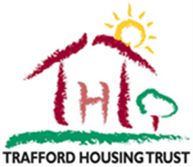

|  |
| --- |
| Anna Evans  -2016 |

**Contents**

1. About Neighbourhood Services
2. Customer promise
3. What is a Neighbourhood Champion?
4. Block Champions
5. Green Champions
6. Estate Champions
7. Working with THT/residents
8. Code of conduct
9. Neighbourhood Champions Procedure
10. Useful contacts

**About us**

Neighbourhood Services is a business area in Trafford Housing Trust that manages the mobile cleaning and estate services and manages the contract of the grounds maintenance service. We also work in customer involvement and plan to develop it as much as we can with many plans for the future. We have a team of dedicated professionals who clean and maintain our blocks and estates ensuring ***‘we create clean, safe and attractive neighbourhoods a place you can call home’.***

We work towards our mission statement and everything we do we have it in mind for our customers. Numerous changes have been made operationally and it is all for the benefit of our tenants and leaseholders, we are also continuing to make positive changes and developing our team further. The team was formally named the caretaking service and was changed to re-brand the service, ‘caretakers’ are now named Neighbourhood Servicing Operatives or NSO’s for short. We wanted to give everything a re-vamp including our customer involvement arm.



**Customer Promise**

Our customer promise is a pledge to our customers and they are standards you can expect from us when we deliver our services to you. They have been created to improve your experience when dealing with us and to make you proud of where you live.

Trafford Housing Trust’s Neighbourhood Services team have created the following promises which are tailored to compliment the service we deliver to you.

We Will…

* Attend your block every fortnight to carry out site servicing, ensuring that it is left clean, safe and attractive.
* Report bulky waste/ fly tipping when we attend on site and ensure that all schemes have a completed health and safety check.
* We will complete onsite repairs and update our report log on each visit.
* We will carry out a schedule of deep cleaning on a bi-annual basis
* We will provide value for money for your service area.



**What is a Neighbourhood Champion?**

Neighbourhood Champions is an umbrella for 3 different involvement mechanisms; Block Champions, Green Champions and Estate Champions. Although different, they are all aiming towards the same outcome which is being proud of where you live and assisting us in achieving our mission statement.

It all began a number of years ago when Block Champions was created, we then created Green Champions, and this came from QIP’s recommendations which we developed from their scrutiny. The 3rd and final mechanism we have created is Estate Champions, this is the most recent we developed.

*As a neighbourhood champion some of your duties may include…*

• Door knocking in the blocks and neighbourhood

• Estate walkabouts and block inspections

• Attending neighbourhood champions meetings

• Carrying out surveys within your block/neighbourhood to gain feedback

• Speaking to residents within your community

Please note if any of the above duties you do not feel comfortable with you do not have to take part in.

All Neighbourhood Champions will only report findings from a communal perspective, Anti-social behaviour, money support issues and repairs in your home will be reported through the usual channels by calling us on

0300 777 7777 or going on our website [www.traffordhousingtrust.co.uk](http://www.traffordhousingtrust.co.uk)

**Block Champions**

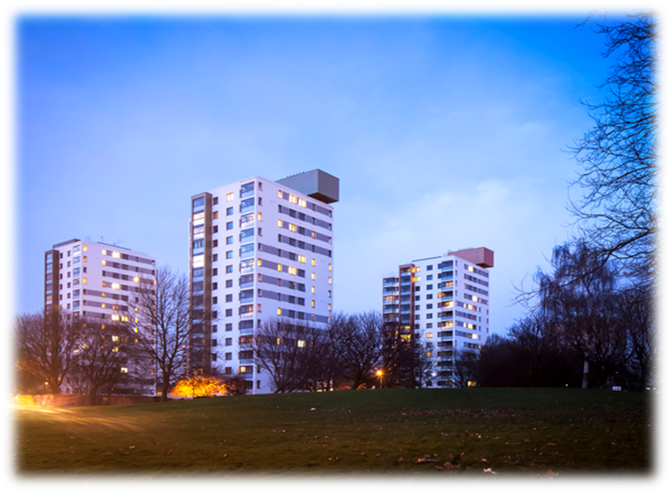Block Champions are the eyes and ears of the block they live in they will inspect the block reporting anything to the business if they have concerns with the cleanliness, graffiti, bulk refuse and communal repairs. They are a massive asset to the block and improve the standards making it a more attractive and safe place to live. Block Champions can live in a low-rise or high-rise block.

You will be a representative of the block you live in, people may come to you with communal issues which you can report on their behalf (optional). Block Champions are responsible for reporting the internal and external issues within the block they live.

**Green Champions**

Green Champions is the same concept as Block Champions but they will be the eyes and ears of the grounds they live on, whether you receive a service from Cleanstart or Greenfingers you can report this to us in the same way Block Champions can, you will just be looking out for different issues.

Trafford Housing Trust wanted to do green champions so we can target people who live in houses, bungalows and other properties which are not block of flats. We want to give everyone the opportunity to get involved with us and help us look after the community they live in. Green Champions can also live in blocks.

Green Champions was originally created because of a recommendation from our scrutiny panel, they wanted a tenant group to have the same impact on our grounds as they do on our blocks.

[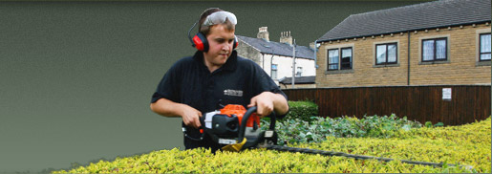](http://www.google.co.uk/url?sa=i&rct=j&q=&esrc=s&frm=1&source=images&cd=&cad=rja&uact=8&ved=0ahUKEwjYwIXZrNzOAhVBlBQKHaNgDpwQjRwIBw&url=http://www.greenfingers-group.co.uk/jobs.aspx&bvm=bv.130731782,d.ZGg&psig=AFQjCNG0yzNc9avE4UwIki7YhgnC8rdNBA&ust=1472207024202799)

**Estate Champions**

[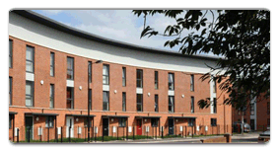](http://www.traffordhousingtrust.co.uk/your-home/)

Estate Champions is again the same concept as both Green and Block Champions this will be just looking out for Estate issues such as; fly tipping, abandoned vehicles, street light repairs etc. You may want to take part in regular estate walkabouts with staff or other residents and report wider issues.

This programme is aimed at customers who do not live in a block or don’t pay for a grounds maintenance service and want to look after the estate they live in. We want to try and reach out to all tenants in all different properties and communities giving everyone the chance to get involved and make Trafford a better place. Estate Champions can live in all our properties across Trafford.

You can also report Trafford Council issues, no matter if it’s our land or not we will report everything for you. On the next page is the map of your area showing what our land is and what Trafford Councils is.

**Working with Residents and THT**Neighbourhood Champions are required to work with THT staff as much as possible, doing so will result in the best outcome possible for your community. Customers can choose which Neighbourhood Champion they would like to be and we will support them through it from the initial stage to reporting findings to us. We will always support you if a neighbour is being hostile towards you because of the Champions status.

You can also involve your neighbours with your work, you can invite them to estate walkabouts or block inspections, get their feedback through a survey or even create a TRA group to get funding for your communal garden or something you would like to change within your community. You may even develop new skills as a champion such as confidence building in talking to general public. Working with residents is completely optional and we only want you to take part in activities you feel comfortable with.

As a neighbourhood champion you are in the best position to know what issues are in your community and will have a better idea on how to improve it and make it a better place for everyone to live.

We will not leave you empty handed for your work with us, we will provide you with £20 Love 2 Shop vouchers for every 3 inspections you do. They allow you to purchase items from a number of high street stores and is a great way to treat yourself or family.

**Code of Conduct**Neighbourhood Champions agree…

* To be open and honest when dealing with Trafford Housing Trust staff and partners.
* To treat each other fairly and respectful at all times.
* Not to use offensive or abusive language to Trafford Housing Trust staff, tenants or partners at any time.
* To refer to the handbook for guidance and follow procedure.
* That they will receive the same level of service given and will not expect preferential treatment.
* That their first point of contact will be Neighbourhood Services Team and not senior managers.
* To work closely with Trafford Housing Trust to maintain the quality of service within their neighbourhoods.
* To be open and understanding that you may not always get the outcome you want.
* That any information you give us as a Champion should be treated as confidential unless you give the permission to share it