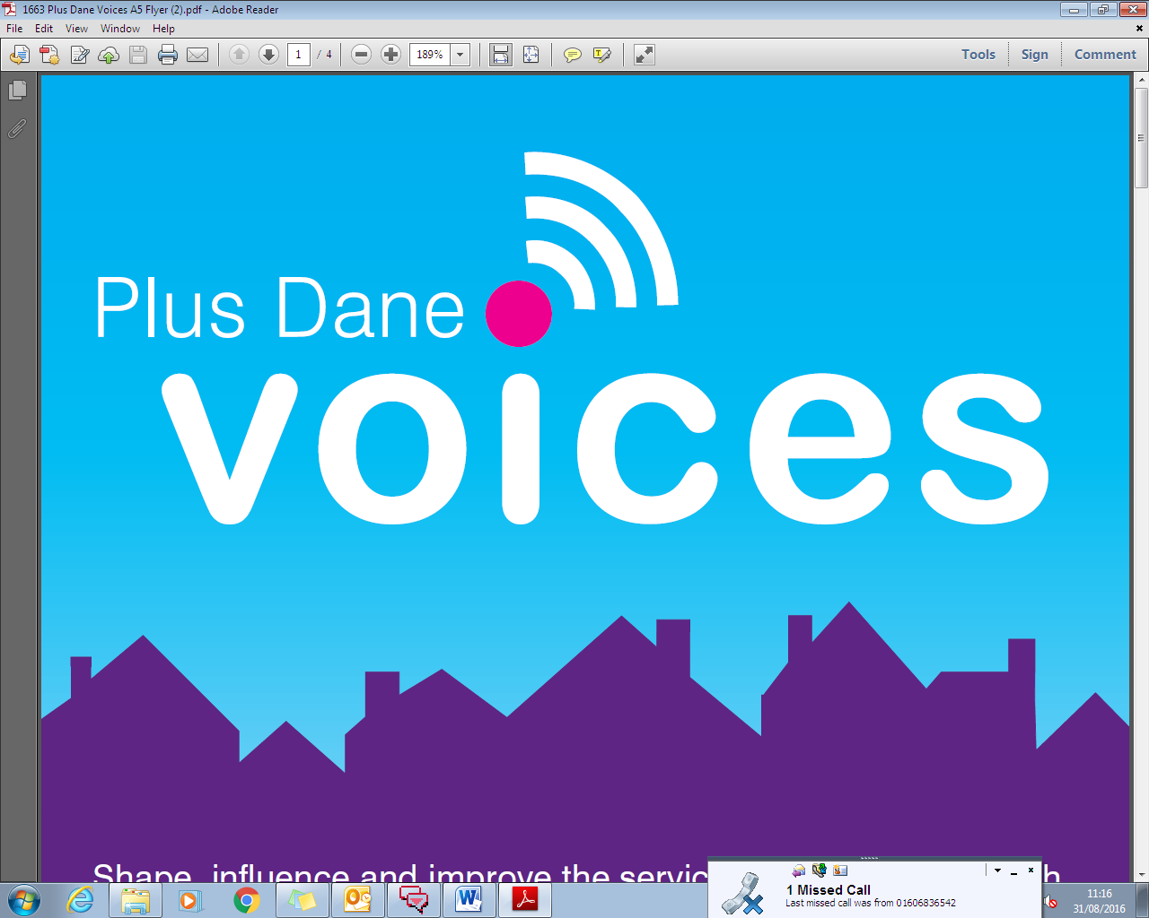

**Consultation Application Document**

**Plus Dane Voices Consultation Application form**

This brief has been developed by the Plus Dane Engagement Team to help us understand the support you need from us and your exact requirements for your consultation.

|  |  |
| --- | --- |
| **Service Manger Name** |  |
| **Department**  *(Customer Access, Housing, Allocations, Income, Welfare, Landlord Plus, Involvement, Property, Trades, Health & Safety, Communications, Supported Housing, Shared Ownership)* |  |
| **Date** |  |
| **Service Area**  *Homes*  *Neighbourhoods*  *Customer*  *Home Ownership* |  |
| **Location**  Cheshire, Merseyside, EPN or group wide  *e.g. is it a supported housing consultation for Cheshire only* |  |
| **Consultation subject**  Property & repairs  How we let our homes  Managing your tenancy  Rents and your finances  Supported housing  Health & safety  Grounds maintenance  Community safety & ASB Projects/activities  Customer service  Communications  Involvement opportunities  Complaints  Leaseholder  Right to Buy  Shared Ownership |  |
| **Consultation title**  e.g. what are your thoughts of our website content |  |
| **Deadline**  Please detail deadline for consultation |  |
| **Objective** | Why are you involving tenants/customers?  What do you hope to achieve from this consultation?  How will this be measured?  Links to the Big 4:  Products & Services Financial resilience  Growth People |
| **Tenant & Customer requirements** | Tenants and/or Customers:  How many Tenants and/or Customers (min and max no.):  Do you have gender preferences:  Do you have specific age preferences:  Neighbourhoods/areas you want to consult tenants/customers from:  Do you have any other requirements: |
| **Tenant & Customers preffered method/s for involvement** | How would you like to involve tenants/customers in your consultation? Once you have chosen your method then please specify your questions in the below section/s  Postal SurveyEmail SurveyText  Telephone SurveyFocus Group Meeting |
| **Postal Survey**  Please specifiy your survey questions | Title of survey:  Q1.  Q2.  Q3.  Q4.  Q5. |
| **Email Survey**    Please specifiy questions, Engagement staff will send survey link to tenants/customers | Title of survey:  Q1.  Q2.  Q3.  Q4.  Q5. |
| **Text**  Please tell us your text message (character limit 152) | Message: |
| **Telephone Survey**  Please specifiy your survey questions | Title of survey:  Q1.  Q2.  Q3.  Q4.  Q5. |
| **Focus Group Meeting**  Please specify the resources you require | Book a venue/location/date/time:    Refreshments for Tenants/Customers:    Anything else: |

|  |  |
| --- | --- |
| **Post consultation evaluation**  Once the consultation is completed, service managers/team are required to evaluate the consultation by answering the 3 questions.  Once this is complete then please electronically send this form to the designated engagement officer who will load these outcomes on the website on the Plus Dane Voices landing page for tenants and customers to view. | 1. Overview of tenant/customer feedback from consultation: 2. Key recommendations from consultation: 3. What will Plus Dane do as a result of this consultation |

**For office use:**

|  |  |
| --- | --- |
| **Checklist** | **Engagement staff to complete** |
| Number of actual tenants/customers involved |  |
| CRM activity history updated |  |
| Post consultation evaluation submitted on  Website |  |
| Minutes attached |  |
| This document is to be stored in O drive_Plus Dane Voices Consultations |  |