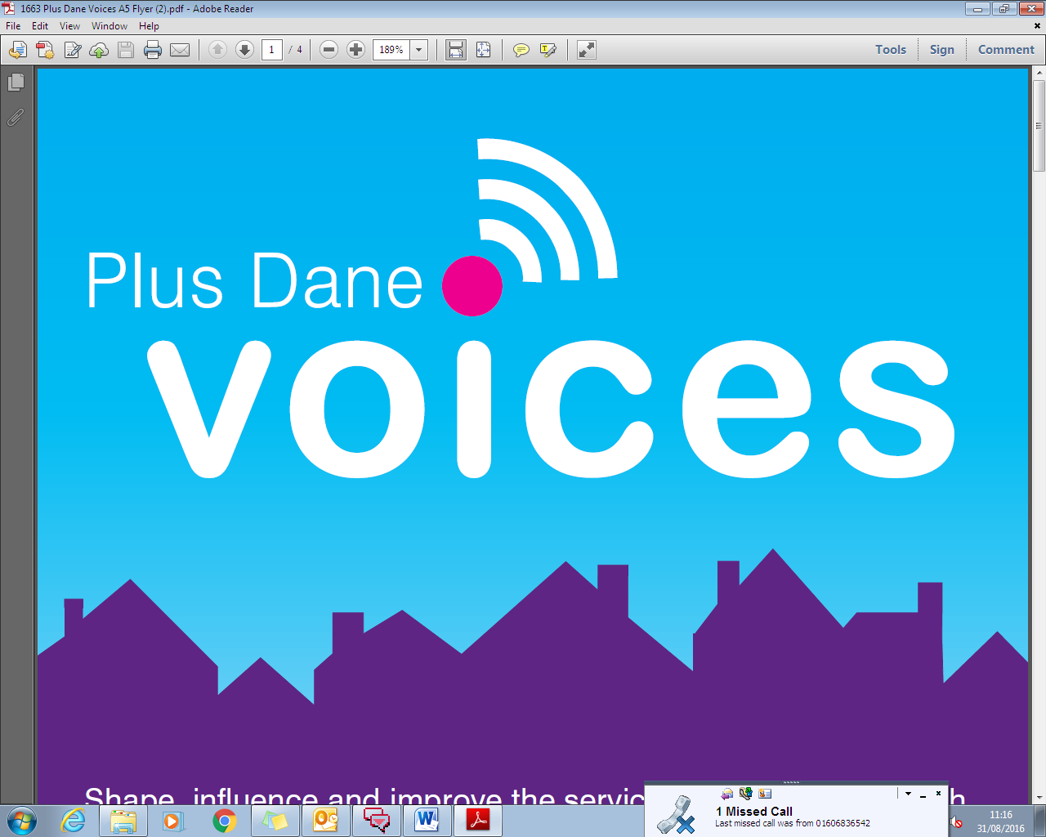

**Consultation Request:**

Please complete this form and email directly to [PlusDane.Voices@plusdane.co.uk](mailto:PlusDane.Voices@plusdane.co.uk) . A member of the Engagement Team will contact you within a week to arrange a meeting to discuss your requirements in more detail.

Information on the different ways to engage with tenants and the lead times for these methods are detailed in the Plus Dane Voices information document which is available on the intranet.

1. **Department:** *E.g. Neighbourhoods*
2. **What do you want to consult tenants about?** *E.g. we need to get tenants feedback on a new voids standard*
3. **What is the deadline for your consultation?** *E.g. 30th September 2016*
4. **Who should the engagement team contact to discuss this consultation further?** *E.g. Jenny Priest ext. 8262*