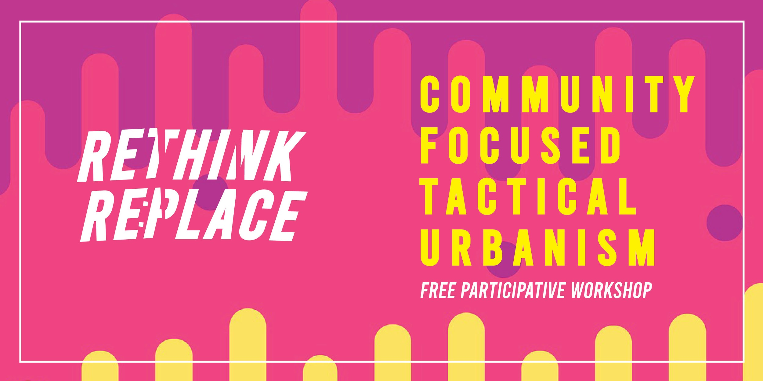

Here we have provided some text you can use for your Eventbrite or invitation method you choose to use - you will also find the above banner as a separate file you may use.

**Community Focused Tactical Urbanism**

*Join us for a free participative workshop*

Tactical urbanism is a form of community driven placemaking. Often, people who want to improve their areas expect that it can only be done with government approval and financial backing - however, this workshop aims to teach ways in which the community themselves can improve their surroundings through cheap and effective methods.

We believe that ideas are free, and this workshop will provide the information needed to inspire your participants to enact change in their areas.

**In this workshop you will learn:**

* What tactical urbanism is and how it’s different to placemaking, through straightforward and easy-to-understand language
* Examples of tactical urbanism in practice from around the globe
* How to begin your own projects, through engaging activities and hands on learning

So, if you work in the third sector, a social activist or a local government worker, come and learn how you could use tactical urbanism in your community.

If you have any questions, please email: