

**Tutorial to edit your event poster**

Here are the guidelines to edit the poster for your event. Here is a step by step guide of how you can edit it in Google Slides since it is a free to use piece of software, you can also Microsoft Powerpoint but if you choose to do it that way you must install the Bebas font on your computer.

In order to use Google Sheets, you will need a Google Mail account.

First, type <https://www.google.com/drive/> into your browser then click ‘New’ and then file upload.

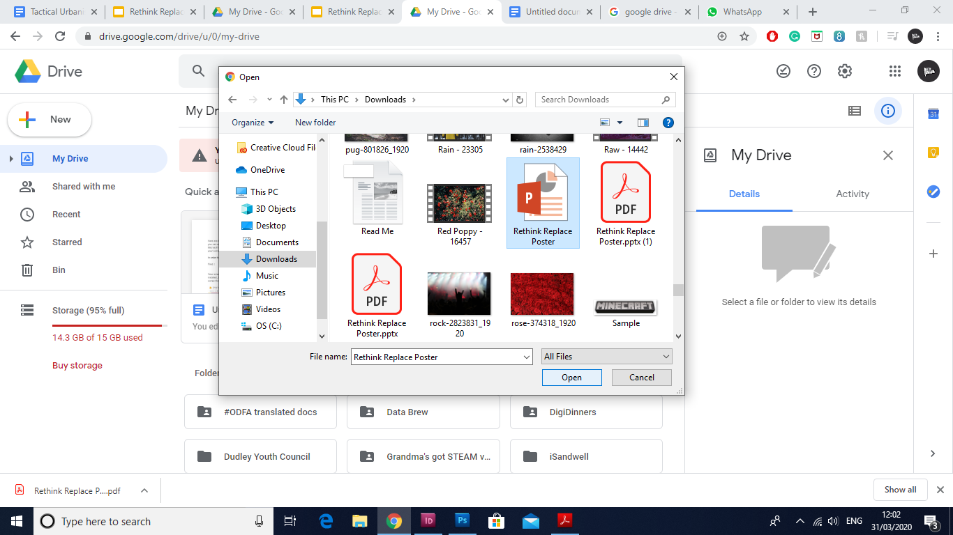

Once you have done that click open with Google Sheets.

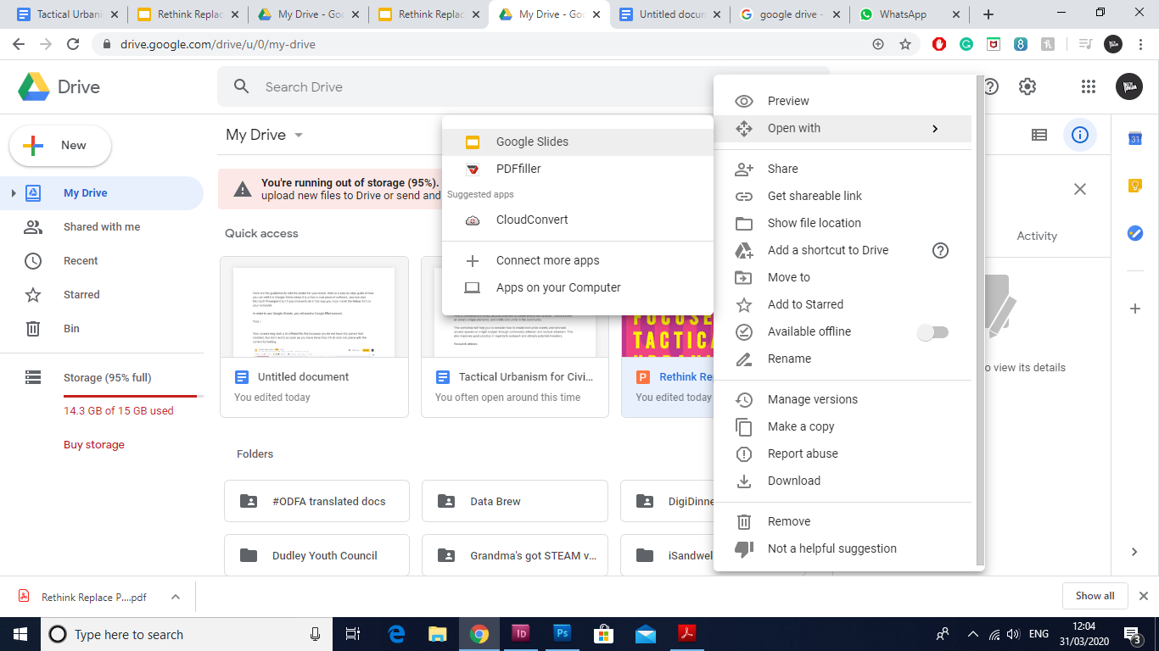

Your screen may look a bit different to this because you do not have the correct font installed, but don’t worry as soon as you have done that, it’ll all click into place with the correct formatting.

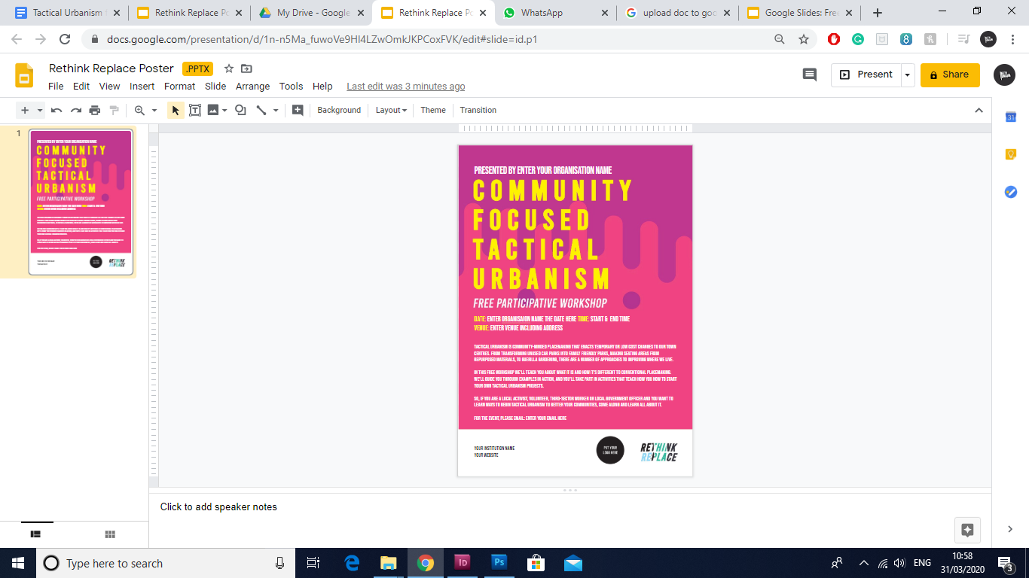

It’s really easy, all you need to do is click in a text box. And then click on the font and proceed to ‘more fonts.’

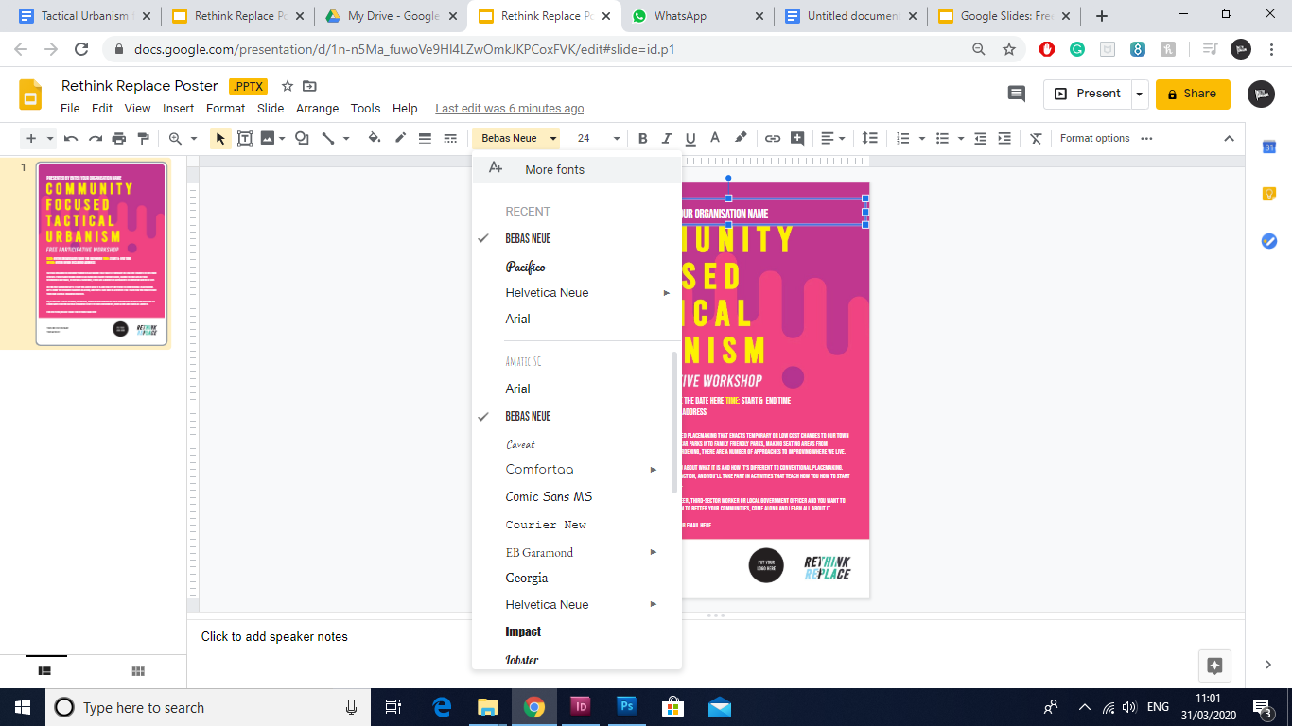

Now type in Bebes and click okay - done!

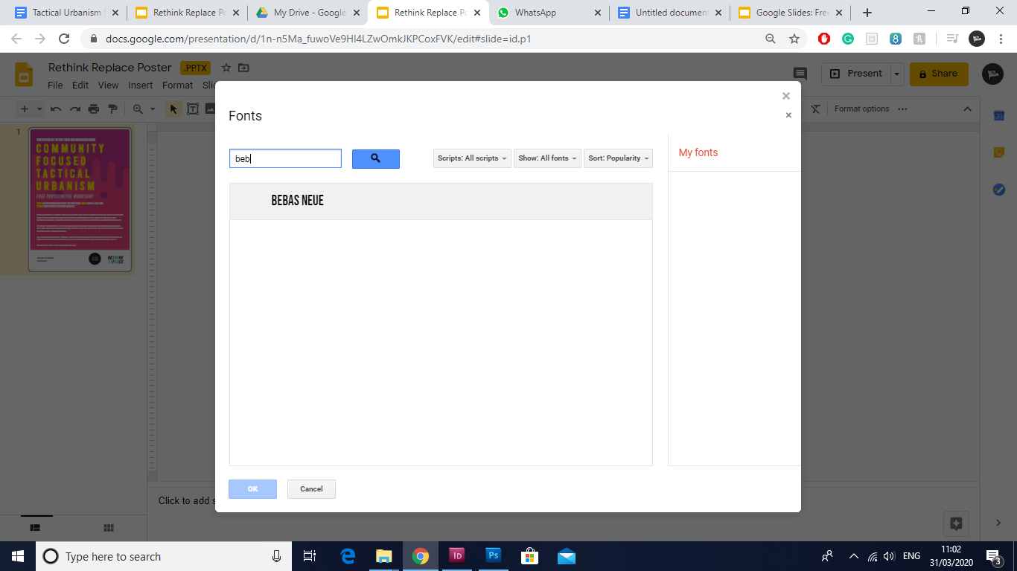

Now you are presented with this screen, it’s time to edit your poster.

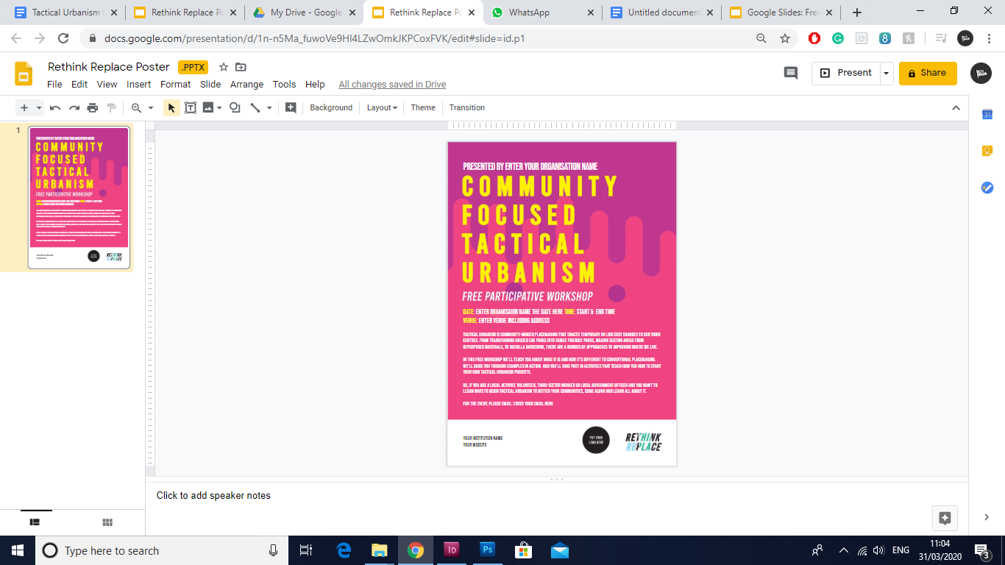

Let’s start, enter your organisation name at the top text box so it reads Presented by YOUR ORGANISATION - for this example, I’m going to edit it so it looks like New Union is going to hold this event.

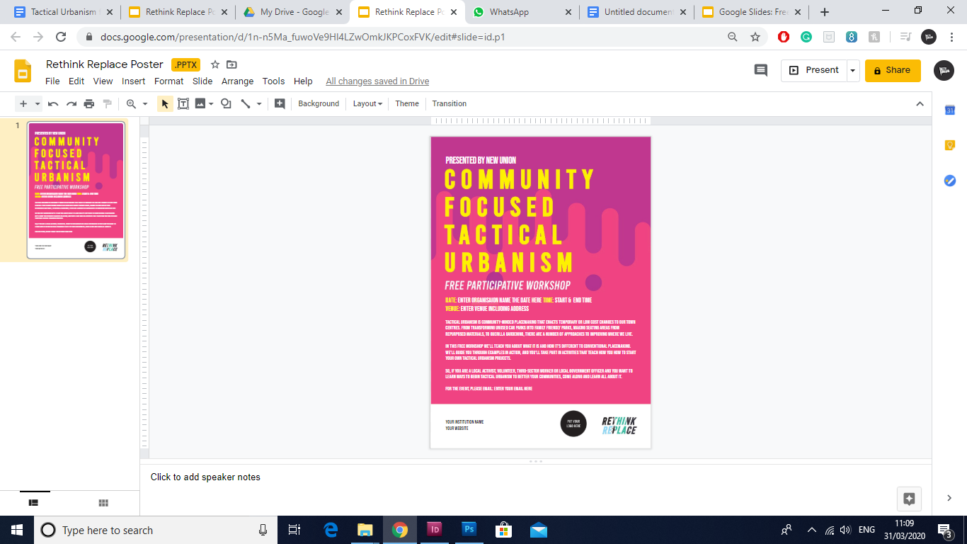

Now that’s done, it is time to fill out where the workshop will be taking place.

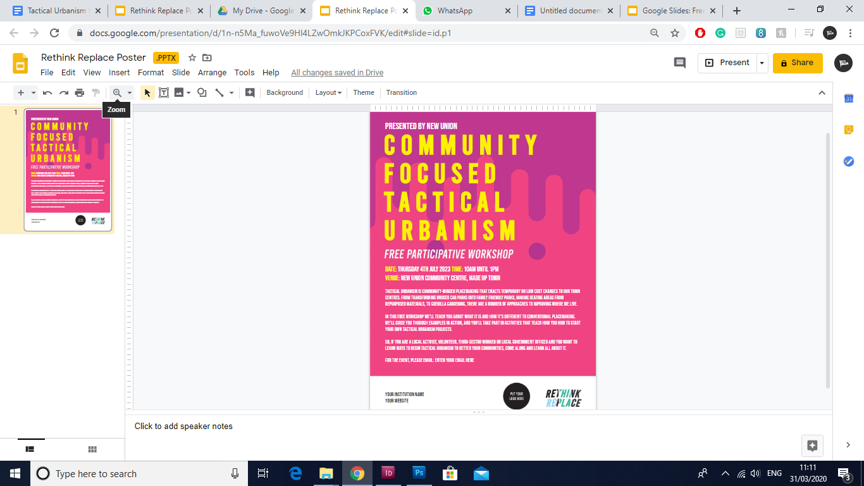

Now I have edited my 2nd text box, you can use the zoom tool to get a better look at what you are editing.

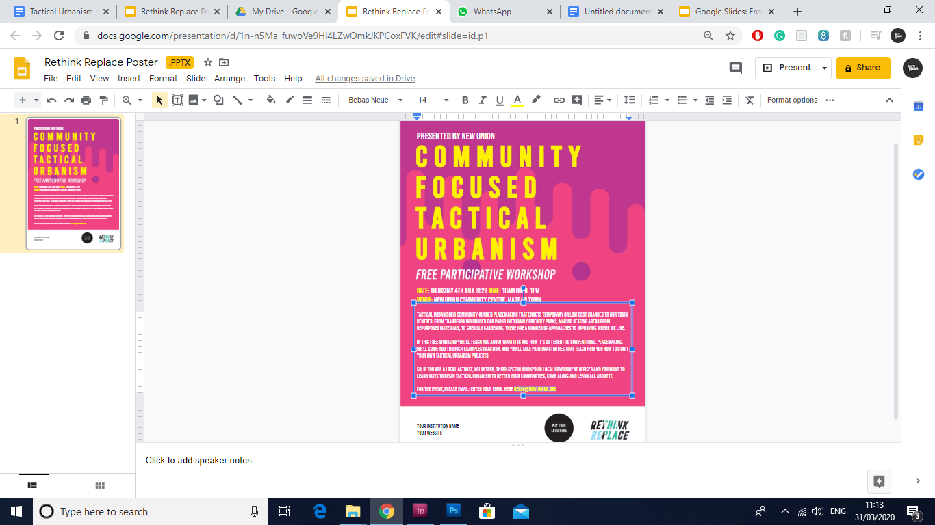

Okay, in the 3rd text box I have added my email so people can ask me questions or sign up for the event.

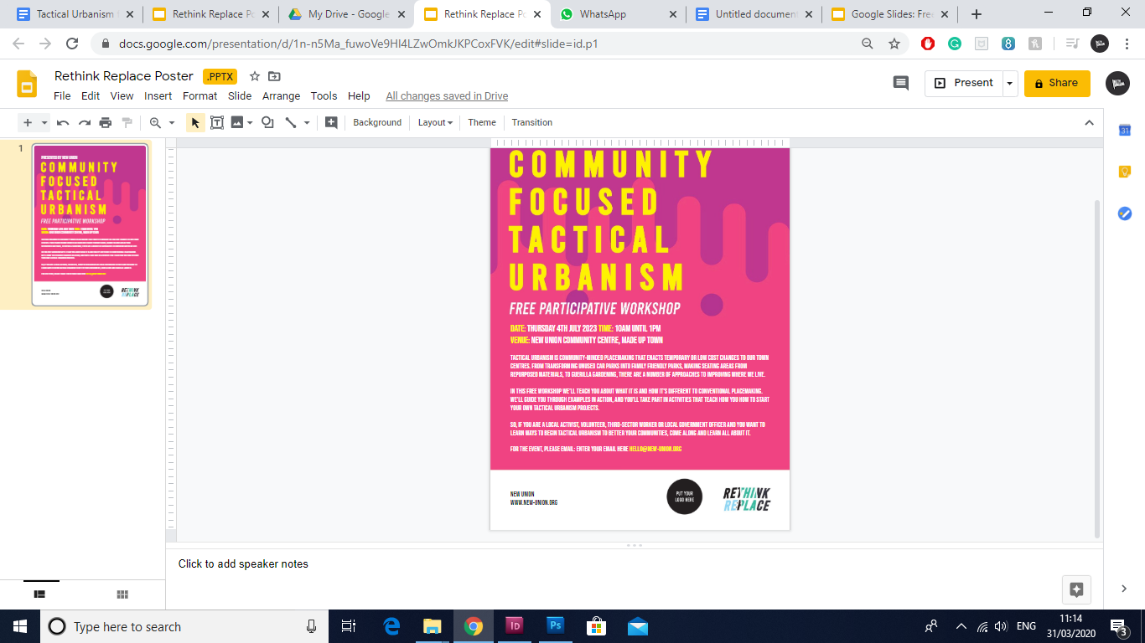

The final text box is right at the bottom, here enter your details, you can add your Twitter handle too if you like.

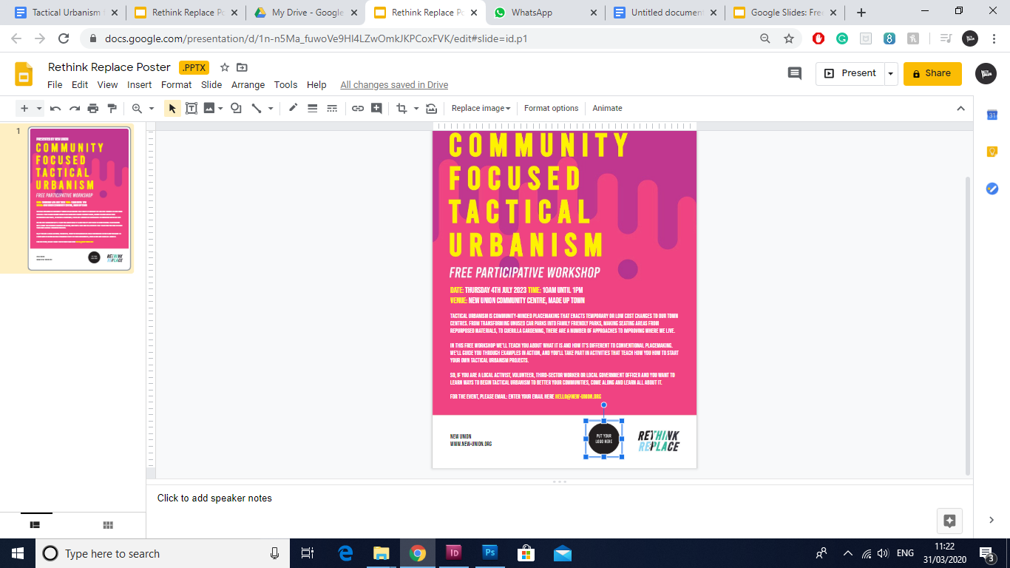

Finally, click on the black circle where it says “put your logo here.”

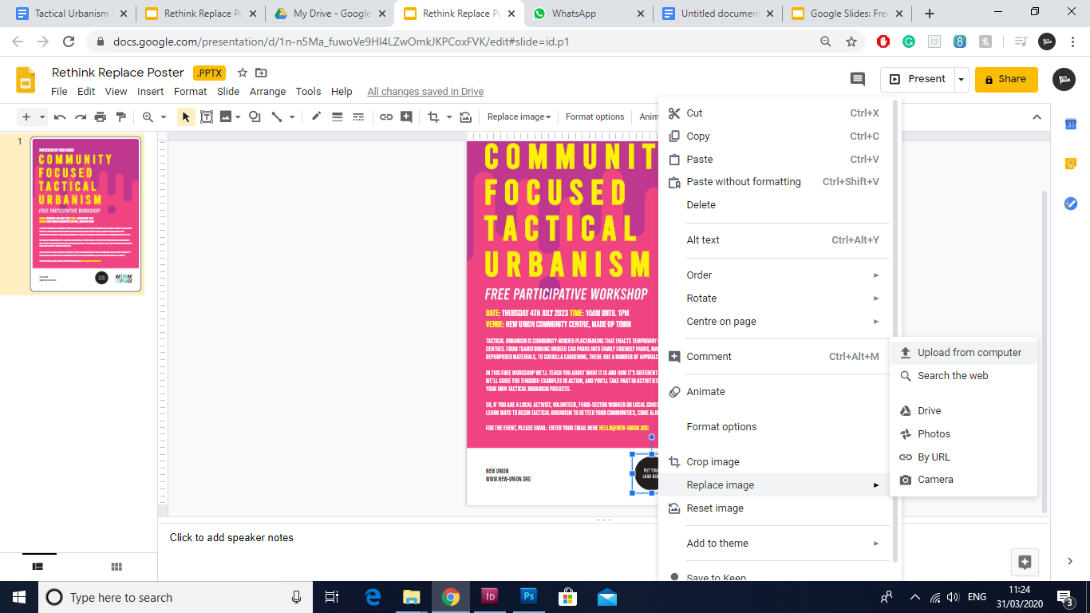

Right click on the image, now scroll down to ‘Replace Image’ and the ‘Upload from computer.’

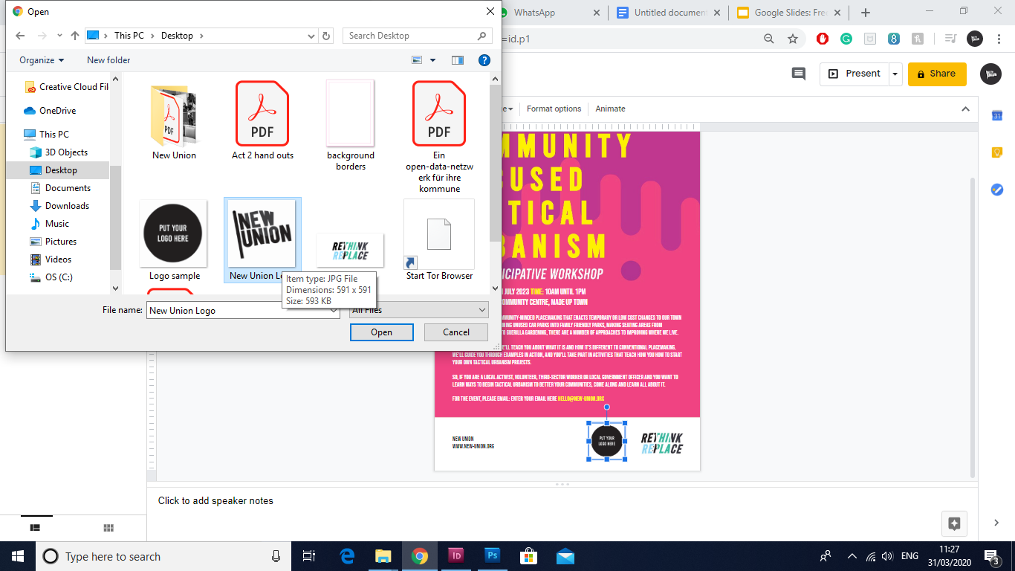

Find the image you want to use and click open - you may have to resize your image, simply hover over the image until you see the transform tool and drag while holding down the shift key as that will keep the image in proportion.

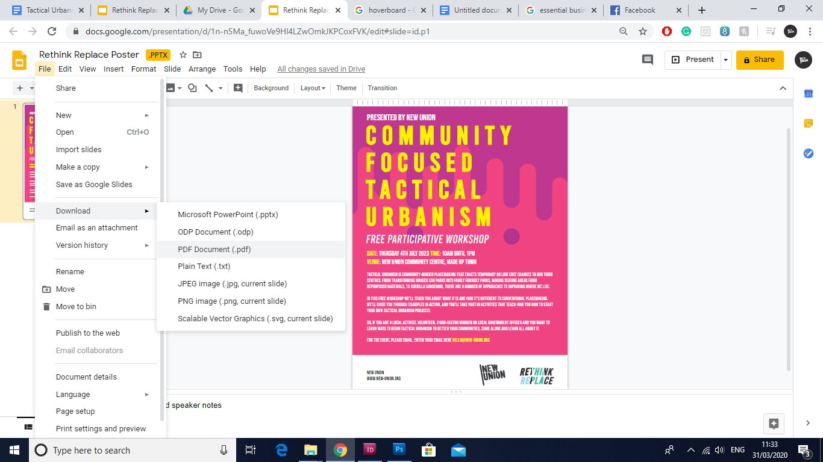

All you need to do now is head to file, then download and click PDF Document.

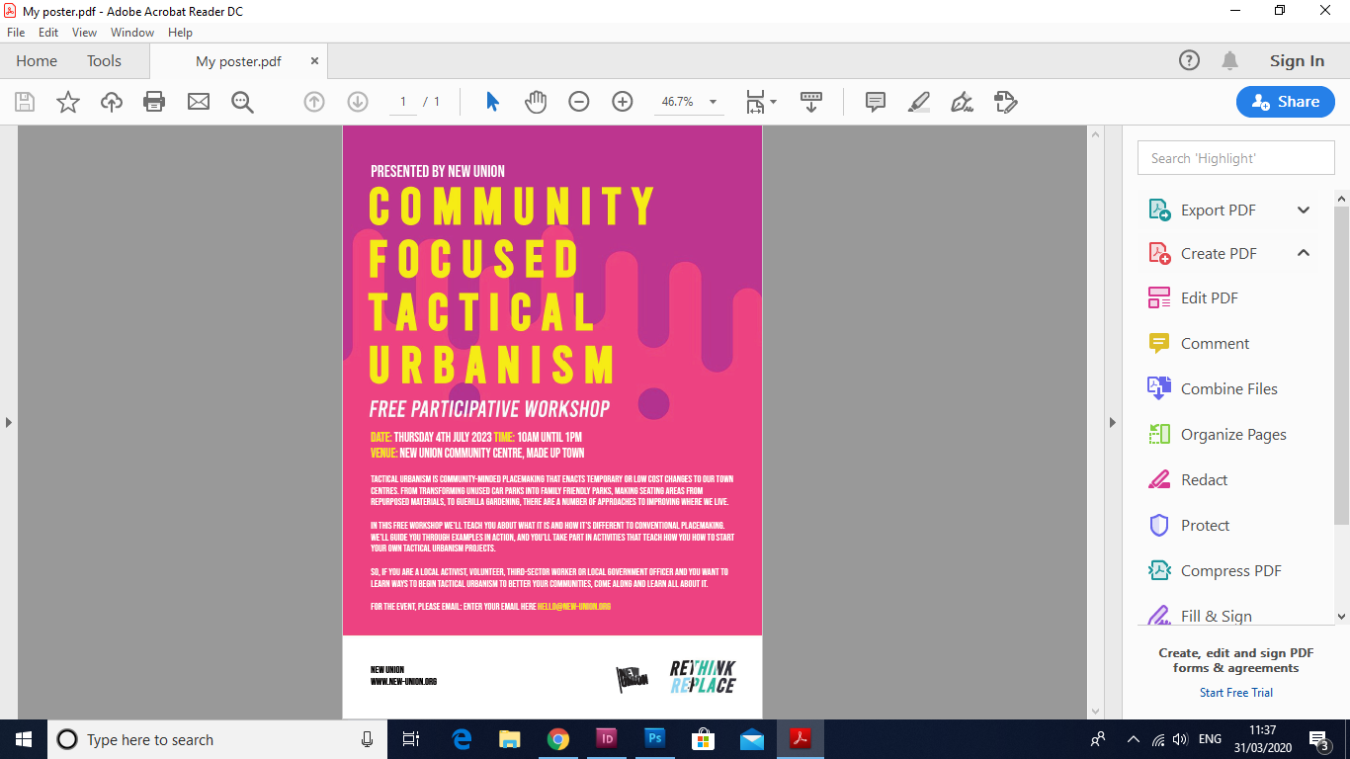

That is it, your poster is ready to be printed out or sent via your relevant newsletters.