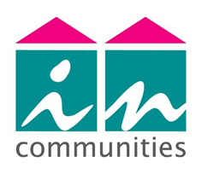

**CUSTOMER VOICE STRATEGY**

**2019-2024**

**The purpose of this strategy is to ensure we listen to and apply the Customer Voice to all our activity by gathering customer insight, ensuring involvement in services has impact, enabling our staff to respond to customers effectively, and that our Board has assurance and oversight that customers and customer demand are shaping our services.**

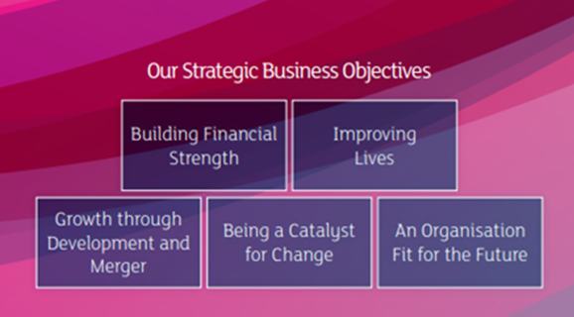  
In 2019 our Board reviewed the Incommunities Strategic Plan. Our vision ‘Improving Lives Incommunities’ remains the same and the plan set out our route for Improving Lives to 2040 to be achieved via our five Strategic Business Objectives.

This strategy is an action within the strategic plan under the theme ‘Improving Lives’ – our Board set out their commitment to: **Strengthen the approach to the customer voice, listening and communicating our story.** This Customer Voice Strategy also supports a number of other priorities across a range of strategic plan objectives and themes.

***Figure 1***

|  |  |
| --- | --- |
| During the past two years – particularly informed by the Grenfell tragedy – there have been a number of reports and reviews undertaken within the sector and by Government relating to housing and tenant engagement. (see ***figure 1***).  We are not waiting for guidance or regulation in order to act and have undertaken a review of our approach to the customer voice. |  |

We have identified three principal areas of focus. These are set out in ***figure 2*** below – the project purpose diagram’.

***Figure 2***

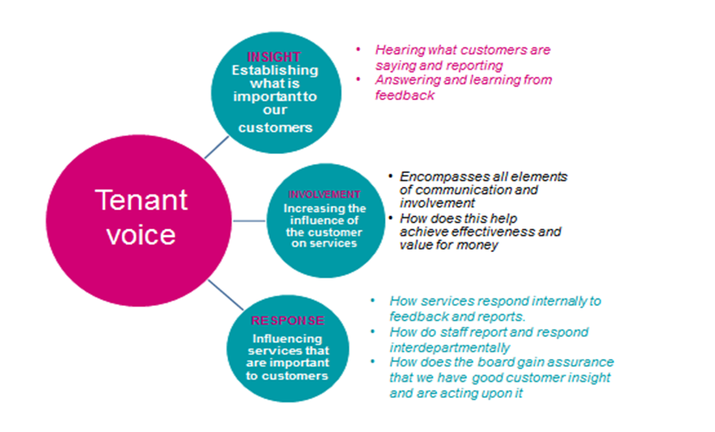

**Customer Voice**

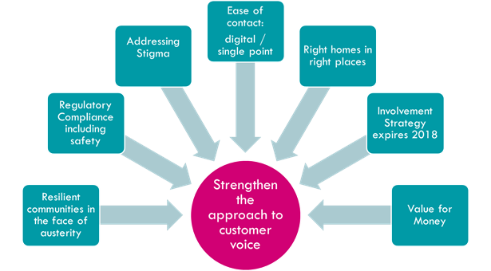**Our commitment to strengthen our ability to respond to the customer voice is driven by a number of factors:**

|  |  |  |
| --- | --- | --- |
| This Strategy builds on our previous work on customer scrutiny and involvement. We  recognised in the light of the Board’s objectives our strategy needed to go beyond  traditional involvement and engagement by:   * encompassing the customer voice in its wider sense through analysing and taking account of everyday engagement with our services (transactional engagement) * utilising this to inform our service improvement * using this to complement our existing scrutiny structures.   **In more detail, these driving factors are:** | |  |
| **Resilient communities** | We recognise that our customers and communities face a number of challenges arising from shifting economic conditions and changes in social priorities and public services. We have a Community Resilience Strategy in place and have adopted an approach of supporting community resilience via supporting tenants into employment and working with a network of community partners. We recognise that we need to act on the  concerns of communities and individuals who live there. | |
| **Regulatory compliance (including building safety)** | The regulator expects us to have mechanisms in place for tenant scrutiny and  involvement – whilst we meet the current regulatory standards in terms of structures and activity we intend to go beyond this by enhancing our use and application of transactional data to support service improvement. We also need to respond to the emerging recommendations of the Hackitt review on building safety. | |
| **Addressing stigma** | Campaigns, including ‘See the Person’, and the Social Housing Green Paper identified  that social housing tenants face stigma and stereotyping from the public, media and landlords. Our approach is to work in partnership with communities to make them resilient places where people can thrive. | |
| **Ease of contact** | We need to ensure that our customers can contact us using a variety of methods that are efficient, convenient and easy to use, harnessing the latest technology while also responding to those who may encounter barriers to making contact. | |
| **Right homes in the right places** | The Customer Voice Strategy supports the objectives of our Asset Management Strategy by providing customer insight and local market intelligence. | |
| **Value for money** | We intend to offer customers a wider range of methods to report and track services, and improve the journey customer reports make once they reach the organisation. This and the application of customer insight will reduce costs and ensure our services are efficient and effective. | |

**Our Ambition to 2040**

|  |  |
| --- | --- |
|  | In 2019 the Board approved our Strategic Plan – Improving Lives: Ambition to 2040.  This strategy supports all of the themes and the diagram at ***Appendix 1*** shows how the strategic plan objectives link to the Customer Voice Strategy and the projects planned to support them. |

**Our Approach**

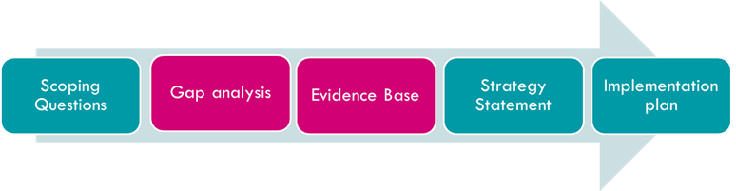

We carried out an analysis of our strengths, weaknesses, opportunities and threats in relation to our ability to hear and act upon the customer voice. From this**,** we conducted a gap analysis and gathered evidence across five themes to inform areas where we need to change, improve and plan for the future.

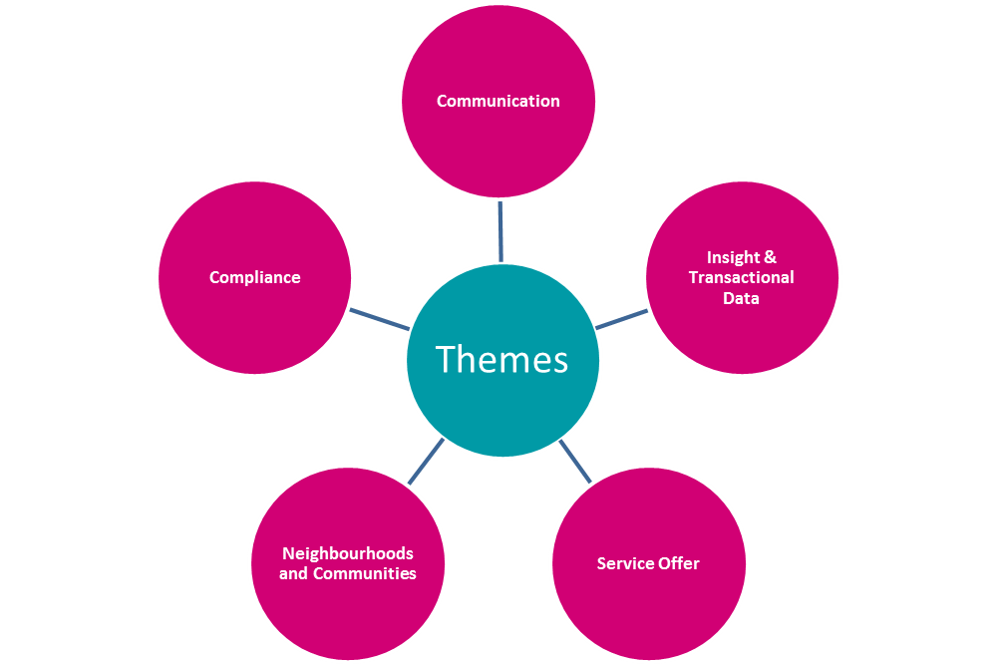

Some of the actions were determined from the results of self assessment using external benchmarks – for example the Tenant Participation Advisory Service National Tenant Engagement Standards and the Housing Quality Network Complaints Toolkit.

During 2018 our team of Customer Inspectors carried out a review of customer communication and their findings influence many of the actions in our implementation plan.

We also identified areas where:

* Change is already underway that could support the project purpose to better capture and act upon the customer voice.
* The activity we carry out is broadly effective and we intend to keep this approach (in these cases we can back up our assertions by self assessments carried out against standards, good practice, or evidence from feedback or external challenge.)

**Our Future State: How will we know we have achieved our objectives?**

* We will capture and act upon customer contact
* We will respond to and learn from feedback
* We will be able to evidence the influence of customers on service delivery
* We will be able to point to where the customer influence has delivered, improved effectiveness and/or value for money
* Our Board has assurance we have customer insight data and are acting  
  upon it
* Our staff are able to respond to feedback and reports from colleagues and customers and have the tools and technology they need to support them as part of an evidence-driven and agile culture – with requests for service taking shorter, straighter routes to resolution
* Improve the quality of our decision making
* Reduced demand on our Customer Service Centre
* Reduced social housing management cost per unit
* The incidence of ‘failure’ demand will fall across all customer facing services
* We will have a strategic approach to understanding and anticipating customer needs, drivers of satisfaction and identifying gaps across service areas
* We will increase the impact of the customer voice by using a variety of sources of data:
  + We will be able to provide objective data to inform decision-making and improve service delivery and VFM
  + We will evidence the use of insight data as a means to focus on shared outcomes, and monitor progress towards delivering outcomes
  + Insight data will be used to inform updates to the strategic plan, and assess its impact
  + We will use customer segmentation and insight to identify issues amongst different groups

**MEASUREMENT AND MONITORING**

**Measures**

Each action in our operational plan contains a success measure.

Examples of measures we will use to demonstrate progress with our Customer Voice strategic objectives are:

* Stays fixed
* Stays resolved
* Levels of value and failure
* Customer satisfaction (via our rolling survey) including with value for money of rent/service charge
* Social housing management cost per property

**Monitoring and Reporting**

* The Implementation Plan associated with the strategy will be owned by the relevant operational director and monitored via our operational   
  planning process
* The plan will be overseen by the Operations Committee with regular updates to the Community Trust Panel
* The impact on staff will be tested via targeted surveys to establish if they feel they have the resources and systems in place to effectively meet   
  customer demands
* The Board will receive an annual update on our findings from transactional data and the Customer Voice.
* Items relevant to building safety and the Hackitt Review recommendations will be considered by the Compliance Governance Group

**LINKS TO THE RISK REGISTER**

The Customer Voice Strategy is a contributing control against **Risk NS 5**: ‘*Failure to capture adequately the customers demand and deliver right first time’*

The Strategy also assists in mitigating against **Risk RS 39**: *‘Failure to have effective governance arrangements, clearly defined roles for each Board, effective communication to ensure financial viability and compliance with national standards’* by ensuring compliance with the Regulator For Social Housing’s Tenant Involvement and Empowerment Standard (in terms of the scrutiny process itself) and other consumer standards on service scrutiny activities, customer communication and complaints and anticipating future regulatory change. Many actions also contribute to compliance with the Neighbourhood Standard.

**LINKED STRATEGIES**

Incommunities Group Strategic Plan - Improving Lives to 2040

Incommunities Group Organisation Development Strategy 2018-22

Incommunities Community Resilience Strategy

Incommunities Group Asset Management & Development Strategy 2019-2029

ICT Strategy 2018

BACK PAGE

…………………………………………….

For more information about this strategy or about how you can get involved with Incommunities please contact

[involvement@incommunities.co.uk](mailto:involvement@incommunities.co.uk) or call 01274 254131

**Appendix 1:** Actions mapped to the Strategic Plan 