Agenda item

COMMITTEE REPORT
Report Title | Customer Insight Report | Date | 16th June 2020
Report To | Operations Committee | Confidential | No
Report From | Head of Sustainable Neighbourhoods | Contact | caroline.grosvenor@togetherhousing.co.uk

Executive Summary | This report provides an update on customer feedback and how we are using what customers tell us to improve services and address areas of low customer satisfaction.  We receive feedback from a variety of sources and last year developed a Customer Voice Group (CVG) to bring the data together to look at as a whole, rather than as individual sources.  The CVG has spent a lot of time analysing the data and identifying key themes. In this time the Resident Engagement Strategy and Consultation Policy have been reviewed, a rolling programme of consultation has been developed, an audit of Tenant Engagement and Involvement has taken place and several resident-led scrutiny projects have been completed. We have also carried out two STAR surveys and a text survey process following service transactions.  The main theme immediately coming out of our insight data is the need to improve information and communication to residents. Survey results tell us that the most important service to customers is repairs and maintenance, so getting information and communication right in this service area will have the biggest impact on satisfaction levels.  Feedback is also giving us indications of other areas we need to improve on but we are focussing on improving information and communication to customers as this will make the biggest difference to the customer experience.  This report provides an overview of our latest satisfaction data and feedback themes from customers. The report also provides a summary of the actions we are taking to address areas of concern and actions we have planned.  Further detail is available should anyone require it.
Recommendation | Operations Committee is asked to note the contents of this report.

- Background

  - Customer experience has emerged as the single most important aspect of achieving success for companies in all industries. What all businesses want to know is how well they are serving their customers, what they do well and should do more of, and what customers are less happy with so the business can focus on making improvements that will make a difference.

  - The Customer Voice Group was established in 2019 with the purpose of overseeing our engagement and feedback processes and analysing what customers tell us in a way that ties the inputs together and leads to insights which is vital to understand what the keys issues are for our tenants and residents.

  - The basis of customer insight is gathering intelligence and to do this requires collecting information from customers in multiple ways. We do this directly from surveys, scrutiny projects and engagement initiatives, and indirectly through social media and unsolicited channels and internally through complaints and compliments.

- Insight sources

We have several sources of customer feedback:
- STAR survey is a twice-yearly survey of around 1500 residents of all tenures carried out by an independent research company, the Leadership Factor. It is carried by telephone and asks about experiences and perceptions of our service
- Rant and Rave is a short text survey sent after individual customer transactions with us and is based on a rating score of 1 to 5
- Service specific surveys, mainly digital but sometimes telephone and postal asking for opinions on services usually to inform a service or policy review
- Scrutiny projects are carried out by a small number of resident scrutineers who look in-depth at a service area. They use their own experiences as a resident, they carry out mystery shopping and conduct their own surveys or conversations with a wider pool of residents as appropriate to the service area
- Performance monitoring groups like our Local Panels - who meet quarterly to review performance reports either company-wide for example customer services performance or more locally focussed like development programmes, and Environmental Services Resident Panels who also meet quarterly to review grounds maintenance and cleaning standards and receive feedback from our 70 local resident inspectors
- Resident engagement work – service or topic specific review days, local tenant and resident group meetings, estate walkabouts and scheme events
- Complaints and compliments
- Social media – we have two Facebook accounts, a company one and a resident engagement one. The resident engagement site has nearly 500 members and residents are free to post anything they like, whether it be advertising local charities or events, or more commonly comments on their experience of our service or queries on policy or procedures.

- Current satisfaction levels

Some of the feedback is more easily measured than others.

Table 1 – Key metrics - STAR
 | March 2018 | Sept 2018 | March 2019 | Sept 2019 | March 2020 | Targets 2019-20
Customer Satisfaction Index (CSI) | 76.4% | 76.5% | 78.9% | 79.5% | 79.1% | 80.4%
Net Promoter Score (NPS) | 36.8 | 40.0 | 42.2 | 46.5 | 47.9% | >40

  - Table 1 above shows the key metrics of Customer Satisfaction (CSI) and Net Promoter Score (NPS) taken from the STAR survey. We have seen an increase in CSI over the last 2 years but a slight dip in the last 6 months. We have seen an 11% gain in NPS over the last 2 years and a slight gain in our recent results.

  - The CSI is particularly difficult to shift as it is made up of several factors that are weighted according to importance. In the latest survey results we have seen a marginal increase in satisfaction among our customers in sheltered housing (1.2% up) but a decline in those in shared ownership (-4.2%) and leaseholders (-5.1%). In September 2019, the satisfaction of leaseholders and shared owners had significantly improved by 2.7% and 4.6% respectively so it’s disappointing to see this drop. Some of this may be around a decline in service charge satisfaction which can be synonymous with this tenure. For example, a typical quote from a leaseholder: “They just don't explain to you why they charge you service charges and I don't actually get any of that. For example, the grounds maintenance, I don't actually get any of that. Nothing happens from that so it is not benefiting me.”

  - NPS, however, comes from only one customer response (“how likely are you to recommend Together Housing?), which makes the score more likely to move and be volatile. It is worth noting that NPS is calculation that takes those who say they are very likely to recommend us (9 & 10 scores) minus those who score us only 0-6 (known as detractors). Those scoring us 7 or 8 are not counted. NPS is a widely used indicator, and although can be calculated in different ways, for example some companies include scores of 7 and 8 as positives, when the Leadership Factor use it to compare us with the rest of our sector and wider, we are comparing like for like.

Figure 1 – How we compare on Customer Satisfaction Index

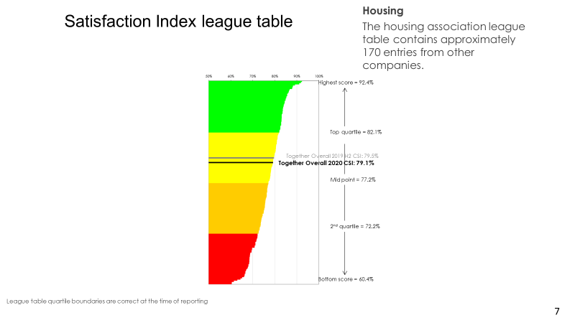
  - When compared with approximately 170 entries from other Housing Associations, the THA Customer Service Index (CSI) ranks us as mid second quartile performers, with the top performer at 92.4% against our 79.1% and the bottom score performer on 60.4%. Targets for 2020/21 have yet to be confirmed but to be a top quartile performer for Customer Satisfaction we need to reach 82.1% and above. Figure 2 shows how targets would relate to quartile performance.

Figure 2
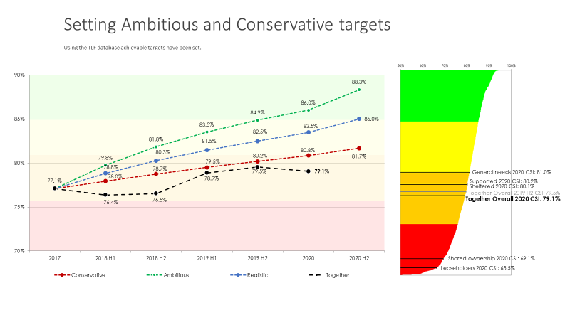

  - It is useful to see how we compare with other housing associations on key indicators of satisfaction and we compare favourably on many areas of service, even being in the best categories for value for money and trust.

Figure 3 - THA compared to other providers

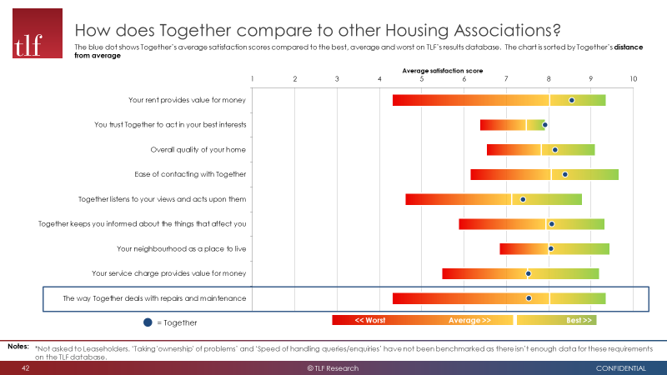

  - In 2019, we developed Customer Service Principles (CSP) using feedback residents were giving us in the STAR survey. We developed our CSP to reflect what customers said were the most important aspects of our customer service.

Figure 4 – Our Customer Service Principles

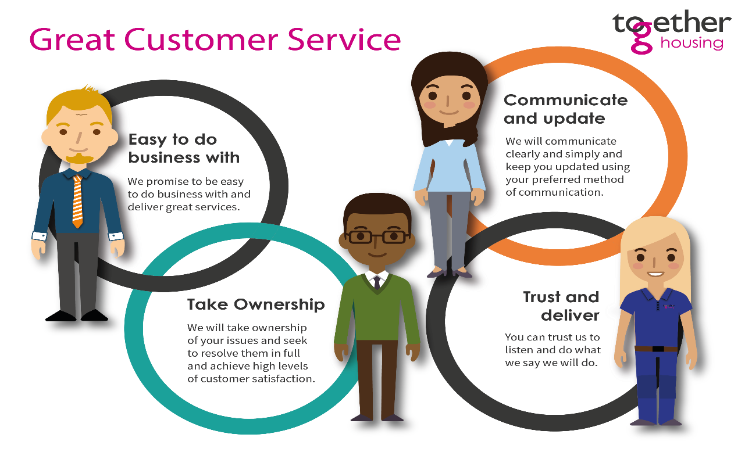

  - Throughout 2019 these principles have been included in customer mindset training delivered to all staff, they are promoted on our intranet and have been included in the draft Corporate Plan. Much of the feedback from customers, from all sources, continues to emphasize the importance of these principles and the impact they have on overall satisfaction.

  - Our current satisfaction for each of these principles is:

- Easy to do business with - our mean score out of 10 saw an increase from 8.3 September 2019 to 8.4 in March 2020 while,
- Staff taking ownership of any queries or requests – has stayed the same at 7.9
- Communicating and updating is static at 8.1 and
- Trusting THA to act in your best interests has also remained the same at 7.9.

The way we manage Repairs & Maintenance also has a significant impact on overall customer satisfaction. From September 2019 to March 2020 there was a decrease from 7.9 to 7.5 in “the way Together deals with repairs & maintenance”. 10% of residents score us in the detractor scores, that is 1 to 6 out of 10 for the way we handle repairs. This influences overall satisfaction levels by 16%.

Figure 5 shows the impact of the way we handle repairs on satisfaction levels.

Figure 5
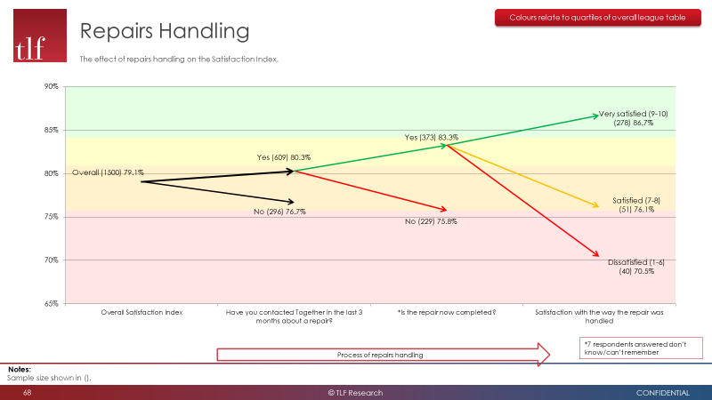

  - The “Smart Simplicity” programme, including such initiatives as the “Repairs Pledge”, bringing NSS in-house and introducing Opti-time for repairs reporting will hopefully increase customer satisfaction in this area. However and although it remains to be seen and is sector wide, the impact of Covid-19 and the cessation of our routine repairs service will undoubtedly be reflected in future satisfaction scores.

Figure 6 illustrates where we need to continue to focus in order to become a customer driven organisation. The areas to concentrate on are building trust, primarily through our repairs service, keeping customers informed, and listening and responding to what our customers have to say to us.

Figure 6 – where we need to focus our efforts to improve satisfaction

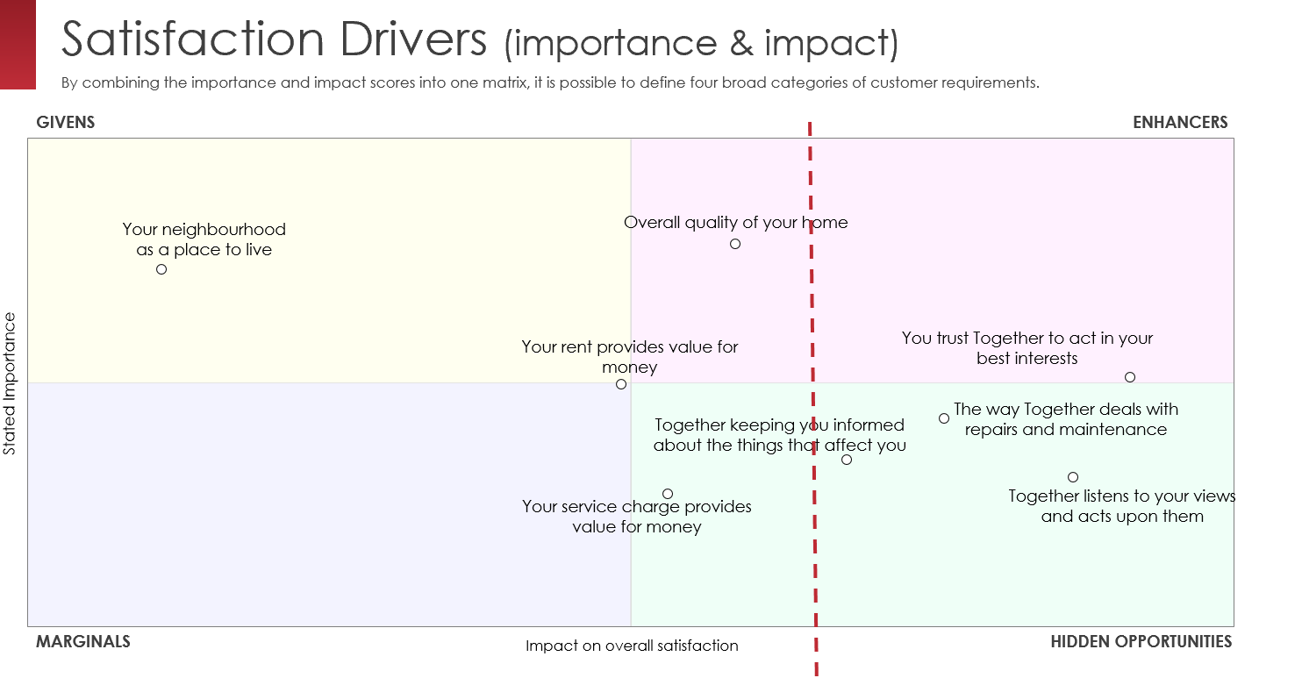

  - Rant and Rave responses provided a huge amount of feedback data on residents’ experience of our service. In 2019/20, we had almost 26,000 responses to our text surveys sent after key customer transactions with us.

Table 2 – key metrics – Rant and Rave

 | March 2018 | Sept 2018 | March 2019 | Sept 2019 | March 2020 | Targets 2019 - 20
Rant and Rave satisfaction | 4.56/5 | 4.54/5 | 4.62/5 | 4.65/5 | 4.62/5 | 4.65
Rant and Rave sentiment | 4.13/5 | 4.12/5 | 4.18/5 | 4.19/5 | 4.18/5 | -

  - Rant and Rave (R&R) surveys are short text surveys are sent to customers after they have received a service. In the main this will be a repair, booked by phone followed by a visit to customers’ properties. These surveys provide virtually “real time” feedback based around our service and cover key ‘touchpoints’ including the Customer Services team.

  - As well as customers’ giving a score (1-5) for the service they received, R&R also asks them “why” they gave THA that score (this is called “sentiment).” This is a free-format comment and gives us additional context around the score. “Sentiment” is as important as the score itself as it gives us key information as to our performance, and valuable feedback in terms of how we can improve. The “sentiment” score is usually lower than the CSAT score as it is words rather than figures and therefore subject to an algorithm.

  - We monitor each service area results on a monthly basis and due to the volume of responses (x) and sentiment giving us reasons for satisfaction we can analyse this to understand drivers of satisfaction and help to inform our improvement plans. A good example of this has been the work on understanding our new home condition (i.e. re-let standards). The most frequent feedback was dissatisfaction with cleanliness, decorating and outstanding minor repairs. We have put focus on getting all repairs done prior to new tenants moving in (rather than doing them after they have moved in) and increased our decoration to include floor coverings in kitchens and bathrooms and given staff discretion for more painting works as and when required. Whilst rant and rave scores for new home condition is still low, it has improved from April 2019 to March 2020.

Area of service | Satisfaction out of 5 |  | Sentiment score out of 5
 | April 2019 | March 2020 | April 2019 | March 2020
Customer services | 4.61 | 4.61 | 4.22 | 4.22
Gas servicing | 4.85 | 4.84 | 4.29 | 4.32
Sign ups | 4.73 | 4.86 | 4.49 | 4.57
New home condition | 4.08 | 4.14 | 3.73 | 3.51
Repairs service | 4.58 | 4.55 | 4.10 | 4.07
Planned improvements | 4.21 | 4.21 | 4.62 | 3.77

- Complaints

  - Complaints form an important element of our customer insight, understanding why residents are complaining and how we can learn from this. Our Resolution Team was created to oversee our management of complaints and we have seen improvements in this. We had 2,000 complaints in 2019/20, down from the 2,258 we had last year.

  - The Resolution Team now oversee the first level ‘Get It Sorted’ issues and monitor them to ensure they don’t go overdue. Overdue cases reduced from over 55% to an average of 26%. Complaints prone to going overdue were repairs and multi-service issues where residents report several complaints across service areas. In particular we have had a high volume of complaints about repairs in Y&H, the Northern Shared Services area and hopefully bringing this in house will go some way to improve the service provided.

  - Through intervention and support from the Resolution Team, those complaints that are escalated have reduced with only 2.3% going to Stage 1 and only 0.3% to Stage 2. Prior to the Resolution Team being formed, complaints going overdue our target was a significant issue. Through 2018, up to 50% were going beyond the policy timeframe, this year this is down to 26% and although this continues to need further improvement many of the complaints going overdue are often complex.

  - There were also 144 enquiries from MP’s during the year, most were queries around allocations, anti-social behaviour and progress with repairs. Only 10 (7%) required further investigation.

Figure 7 - Complaints by service area

The main services resident complain about are:
- Repairs (1091 complaints) - time taking to complete work or carry out inspections, contractor performance, quality of work and damage
- Neighbourhoods (140) - service charges, disputing decisions and communication
- Gas (130) - multiple boiler failures, time taking to resolve boiler problems and length of time waiting for parts

A recurring theme within complaints is the lack of communication and information being provided to keep residents updated, for example: -

Problem | Solution
Residents ringing in multiple times to chase a repair and multiple tasks being created for same issue over a long period | Instead of raising another repair, create a complaint so the issue is escalated rather than being processed as a new request.  In the latest STAR survey  - the % of tenants ringing us more than once to report a repair is 31.9% (up from the last survey 22.5%)  - the % of tenants waiting for over 3 months for their repair to be completed is 48.2% but this is down from 55% in the last survey
Changed appointments for repairs not always being communicated | New process for updating and informing customers.
Delays in repair inspections and residents not given an appointment | The process has changed so the Customer Service Centre now book the inspection in directly, so the customer gets an appointment at first point of contact and time is saved for inspectors
Emergency Repair Service Standard – our policy or service offer frequently does not align with customer perceptions e.g. how quick we should deal with a repair – or if it is an emergency.  This links to our feedback from Star surveys about customers feeling listened to at point of service delivery. | We will be reviewing our service offer for repairs and will raise this to the Customer Voice Group to look at as an area of policy residents are unhappy about.
Responsibility for new and/or complex equipment not always clear leading to delays in sorting out issues when residents report them. This causes problems out of hours because the information on the property components aren’t available, so it is unclear who is responsible or what the problem is. | A ‘Defect and Warranties’ project group is looking at clarifying responsibilities and repair processes and improving information on our systems to better deal with customer issues when they are reported.
Contractors are not always performing to same levels as in-house staff leading to different resident experiences | A project group will be established to look at our monitoring of and ‘after sales care’ processes when using contractors, including our Out of Hours service.  In the latest STAR survey feedback, 88.7% of tenants said the contractor turned up when they said they would but out of the 15 cases where the appointment was not kept to, only one tenant said they were informed of delays.
Complex Sales process not clearly supporting customers | Improved documentation and guidance being provided to prospective buyers.
Gas failures shortly after service leading to resident frustrations | Boiler testing process reviewed and improved self-help information on the website.
Gas – customers not in for appointments | We now send a text sent the day before and when on the trade’s person is on their way.
Gas – Multiple visits needed to solve problems leading to resident frustrations | We have seen a reduced in the re-visits for gas repairs due to better training and creating a team WhatsApp group enabling information (and sometimes parts) to be more quickly actioned and real-time learning shared.
Some residents who don’t have contents insurance complain that we won’t pay for damage we are not liable for. | We ask all new tenants to sign a form to acknowledge we have explained (and encouraged) the benefits of having home contents insurance. We promote the insurance company we have a partnership with offering competitive cover.

- Scrutiny and Resident Engagement

  - Our last scrutiny report on ‘Customer Access to Services concluded that whilst we are ‘easy to do business with’ for the majority of our customers, in communications terms, “it is often the failure to either return a call or keep a customer updated about changes or progress with their issues that leads to a drop in satisfaction.”

  - As far as taking ownership is concerned, the Report emphasises the need for face to face meetings with customers when issues are more complex. In addition, managing customer expectations clearly has an impact on satisfaction, and in certain situations customers can feel they’re not sure of the next steps, or what action they need to take. This was a failing across the business rather than one particular service area and as with feedback in the STAR survey and complaints, improving communication is a key piece of insight from our customers.

  - In terms of resident engagement activity, we have seen a 215% increase in numbers of residents engaged by the Resident Engagement team, from 1,539 up to 4,849 over the last year. As a percentage of our customer base, this is a rise from 4.05% to 12.7%. The increase is mainly due to the way we use digital channels to reach many more resident in particular our Resident Facebook Group and Virtual Voice which now has 2,350 members, with a range of ages represented & 9% BAME representation.

As with the other feedback routes, communication has been a key theme coming out of service specific engagement projects for example:-

- Planned improvements – a face to face project, and feedback was that information and correspondence sent to residents about and during their improvement work was unclear and lacked details customers felt they needed. A revised suite of letters was developed and used in an improvement scheme in Halifax; residents on that scheme reported 89% satisfaction with information and communication. In addition short videos are being produced that can be used to explain what it’s like to have the work done.
- Homeownership – a face to face focus group to seek feedback on information available to leaseholders. Shared owners wanted more information on lease extensions and the process for selling their homes. In response more information has been added to our website and a quarterly e-newsletter for leaseholders has been introduced.
- Survey of non-English speaking tenants – this formed part of the Customer Access to Services scrutiny project and was a face to face and telephone survey to seek feedback on how accessible our information is to non-English speaking residents. Residents reported they often struggle to communicate with us and everyday issues are going unreported, particularly in relation to anti-social behaviour. The ASB team is designing a leaflet which explains the ASB process, reporting hate crime, and this will be available in our main community languages. We are also scoping a project that will involve using a Harnessing Diversity Grant to help fund ESOL classes in the Calderdale area to start with, in conjunction with community partners; if successful we will replicate this in other areas of non-English speaking residents.
- Digital sign up process – a digital and postal survey of all new tenants asking for feedback on our digital tenancy sign up processes and information. Digital sign ups were introduced in early 2019 and we wanted to understand the customer experience of this. 64% of new tenants had accessed information on our website and 100% of them thought the website was easy to navigate however new tenants were not reading our Empty Homes Standard and focussing more on the sample tenancy agreement. 84% of new tenants were happy with the digital processes. Of those who were not digitally engaged, they wanted to receive more information in the post. Only 67% of new tenants knew who their neighbourhood officer was. We are developing videos to provide easier access to information for applicants and new tenants. We are ensuring that on digital tenants still receive the same about as information in the post, as those who can access on-line information.

Our resident engagement Facebook site is a useful barometer of resident feedback, often on very personal experiences and complaints, but nevertheless contributes to our understanding on customer sentiment and satisfaction levels. A common theme is residents not being kept informed about their query and dissatisfaction with the speed of responses.

Figure 8 - Satisfaction by segment

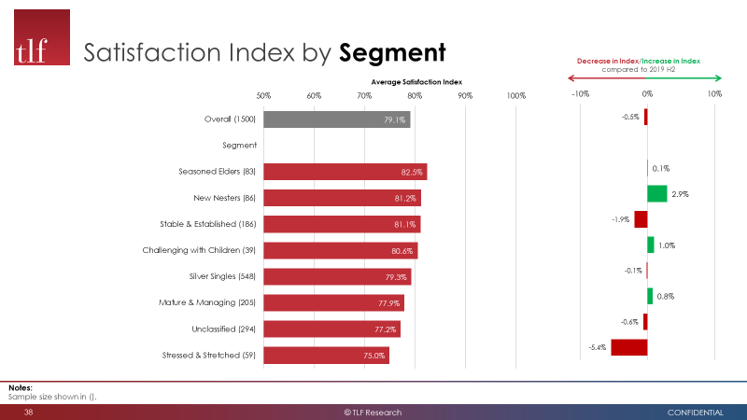

  - The figure above shows where we have had increases and decreases in satisfaction by different customer groups. Older customers often exhibit greater satisfaction than younger people, but interestingly new nesters satisfaction has improved the most and along with challenging with children.

Figure 9

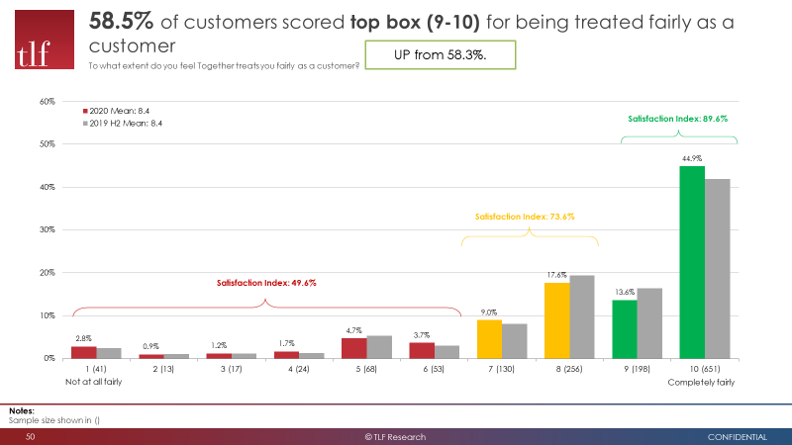

The % of tenants saying they are treated fairly has marginally increased and nearly half of respondents giving us a score of 10 for fairness.
- Equality and Diversity

  - Our latest STAR survey provides us with data on our BAME residents and highlights some differences in satisfaction for many service areas. Figure 10 and 11 provide an overview of satisfaction on key indicators. The difference in satisfaction needs to be explored in more detail and the data further dissected to understand if there are differences within this group in terms in customer segments, or age, or disability.

Figure 10

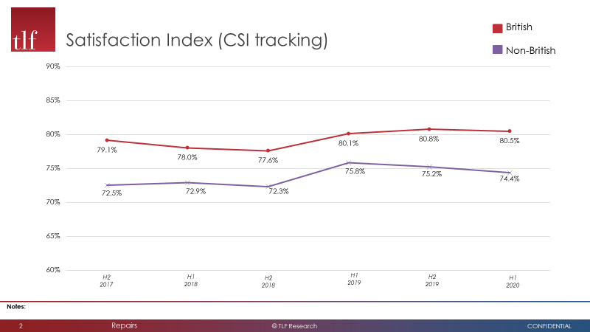

Figure 11
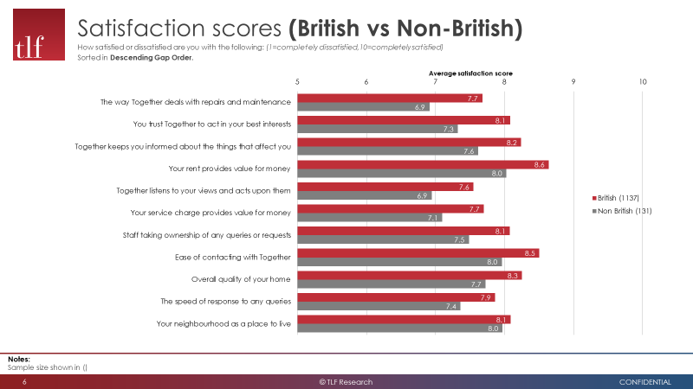

- Priorities for improvement

  - The CVG has spent time bringing our feedback inputs together so we can understand what we need to focus on and agree actions that will have the biggest impact on satisfaction. We were clear that we wanted to concentrate on a few key actions to start with rather than a long action plan that can dilute staff attention.

  - The main and initial theme coming out of the feedback data is the need to improve information to, and communication with, our customers and in particular for repairs and maintenance because this is by far the most frequent transaction (STAR stated 67.3% of recent contact was about repairs) and most important service to customers. Figure 5 (extract below) showed earlier that if we concentrate on these areas they are the most likely drivers of improving satisfaction.

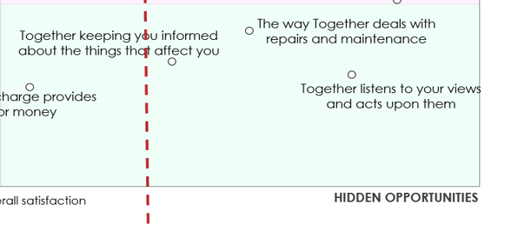

  - In terms of driving up satisfaction, these ‘hidden’ opportunities as well as trust are key. They are captured best within our Customer Service Principles.

  - To emphasize the importance of listening to and improving the customer experience, we want to link it to Customer Service Principles. If we can raise the profile and visibility of the CSP’s, building on the rollout that took place in staff training last year, and emphasize the importance of these core principles and the effect that getting them right has on satisfaction, staff should have this at the forefront of their mind in everything they do. So an immediate priority is to: -

- Increase visibility of the Customer Service Principles and embed this in everything we do

A second priority is to manage customer enquiries better, more quickly and without as much handoff or customers having to chase up for updates.

- Improve the data we hold and improve the way we manage this data, so customers get a better experience when they contact us

The figure below shows how these relate to the principles as well as capturing other actions that are already underway to address improving communication to customers.

Customer service principles | - Include the CSP in the Corporate Plan to provide a Golden Thread  - To improve visibility of the CSP’s via more frequent internal campaigns and communications  - Raise the importance to staff by creating a link to individual objectives and performance targets  - Use the CSP in our Covid-19 business recovery activity
- Improve the quality of data we hold on customers (census planned for autumn 2020)
- Improve the management of customer data (new client data processes are being rolled out June 2020)
- Develop our customer app and portal (development of this has started)
- Improve information on, and look of our website (work has started and a tender for the website front end is underway)
- Improve our allocation system (project due to complete in September) so it is easy for applicants to find a home
- Improve information and communication for non-English speaking customers

- Improve the repairs experience through smart simplicity processes (already underway) and Opti-time for making and changing repairs appointments (is in development)
- Data cleansing project to improve the structure and quality of data held so it is accurate and helps staff manage customer enquiries (started)
- Improvements in technology so staff out in neighbourhoods have better access to information and can deal with customer requests
- A Repairs Pledge for all repairs teams
- Weekly Get it Sorted reports (i.e. requests from customers) are sent to managers to monitor staff are taking action and to identify anything that goes overdue

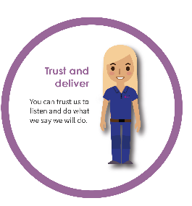 | - Improve right first time service so residents don’t have to make repeat contact  - Monthly performance reports and meetings with Heads of Service are taking place  - Service Standards simplified and publicised, first reports on performance due in August 2020

  - The CVG will monitor progress against this activity and the effect they have on satisfaction levels. The CVG will try to identify and overcome any barriers but will escalate issues where needed. The CVG will ensure this is communicated internally to staff and externally to customers.

Other themes coming out of our customer insight data are:

- Improve how we are feeding back to customers to show how we have listened and taken account of their feedback. Both improving the visibility of the Customer Voice internally and externally
- Improving the information we provide, including standards of service, to customers so they know what to expect, and publicise how we are performing
- Understanding the difference for BAME data, as well as other protected characteristics
- Ensuring contractors provide a better service especially when dealing with repairs
- Better accessibility to our neighbourhood officer service

  - The CVG is currently developing an action plan to capture these themes, to record actions taken to improve services and to track the impact on satisfaction scores.

- Financial Implications

  - There are no new specific financial implications arising from this report. However poor customer satisfaction can reduce income, increase our costs and restrict growth.

- Risk Assessment

  - Improving customer satisfaction is essential if the business is to continue to achieve its aims of high performance and growth. The table below taken from the risk register (Feb 2019) reflects the strategic risk of dissatisfaction with the services we provide. No additional risks have been identified and the risk assessment remains unchanged.

Strategic Risk | Sub Risk Description | Initial Risk Grade | Residual Risk Grade | Risk Tolerance | Impact on risk / assurance levels arising from this report
Reputational and social Impact | 4.1 Dissatisfaction with services such that it significantly impacts on business delivery and success | 12 | 6 | 1. Net Promoter score Target >40: actual = 47.9  2. Tenancy turnover Target <9%: actual = 8.7%  3. Overall CSI  Target 90%: actual = 79.1% | The initial risk is unchanged.  Management actions in response to customer feedback will help to reduce risk by improving customer satisfaction and NPS

- Covid-19

  - The Coronavirus has an impact on our customers and some of key services were suspended for a time and are just being re-mobilised. Communication has been sent to residents to explain the changes and more messages are planned a part of our business recovery. Undoubtedly this will affect satisfaction levels, especially if our recovery is not managed well. During the initial lockdown period we embarked on a telephone project to contact all our vulnerable and older residents around 15,000 people. Anecdotal feedback on this project, and many residents are still receiving a weekly check-in, has been overwhelmingly positive from both our customers and staff. We have sent out a survey to residents to ask for their perceptions of our service and communication since the March when lockdown was implemented. The survey has been sent out digitally, and already we have had over 3,000 responses (2,000 in the first 48 hours) and we are conducting a telephone survey to 500 non-digitally engaged residents. Early indications are the feedback is positive but thorough analysis is required and we are aiming to have results available by July.

The next STAR survey will start on 1 July and results will be available later this year.

- Conclusion

  - Customer satisfaction and customer expectations continues to be priority for us. We have made progress in many areas and have identified further actions that are required to improve the customer’s experience. The data we have on satisfaction from a variety of sources is significant, and is now being turned into insight, communicated back into the business so it can be used in the way services are delivered and improved.

  - We have seen an improvement on several indicators, including Net Promoter Score despite a slight dip in the overall Customer Satisfaction Index. However we still have areas of lower satisfaction and areas of concern.

  - Sustaining and continuing growth in customer satisfaction will be delivered only by acting on insight, reviewing changes in feedback and customer expectations and translating these into action. At the core of delivering what customers want are our Customer Service Principles and we must bring these to life and embed them into everything we do.

  - The Customer Voice Group is still developing and will continue to have a lead role in delivering actions to improve the satisfaction, involvement and engagement of customers.

