The Charter for Social Housing Residents
The Social Housing White Paper
This was released by the Ministry of Housing, Communities and Local Government (MHCLG) on 17th November 2020.
The White Paper is borne out of discussions with residents of Grenfell Tower, who said they felt like their complaints were not dealt with, and that they were rarely treated with dignity in respect.
The White Paper ultimately outlines a new seven-point Charter for Social Housing Residents, which will apply throughout England. The new strategy is to be implemented because often tenant expectations on safety, transparency and complaints are not met, despite social housing accounting for 4 million homes.
It echoes many of the commitments in the Housing Association sector Together with Tenants charter, particularly around tenant voice, relationships, accountability, quality, and complaints, and Together with Tenants is referenced positively in several places.

The seven commitments to tenants in the Charter, and the policy proposals to enforce these, are:
- To be safe in your home.
The government wants to out tenants back at the heart of building safety.
The Government will:
- legislate to strengthen the Regulator of Social Housing’s (RSH) consumer regulation objectives “to explicitly include safety”
- legislate to ensure social landlords identify a “nominated person” responsible for ensuring compliance with health and safety regulations
- the RSH will prepare a Memorandum of Understanding with the Health and Safety Executive (HSE) to ensure effective information sharing with the newly-formed Building Safety Regulator (BSR)
- launch a consultation on requiring smoke alarms in social housing and release new expectations for carbon monoxide alarms
- consult on new measures to ensure residents are protected from poor electrical safety, and
- keep working with the Social Sector (Building Safety) Engagement Best Practice Group and BSR to ensure residents voices are heard.

- To know how your landlord is performing.
The government wants to reconnect landlords and communities and ensure transparency and accountability
The Government will:
- create a set of tenant satisfaction measures (through the RSH) for landlords, based on tenants’ biggest concerns
- implement a new access to information scheme (in line with the Freedom of Information Act) for social housing tenants of both housing associations and privately-registered providers
- ensure landlords provide a clear breakdown of income and how they are spending it, including salaries of executives to be published alongside the tenant satisfaction measures, reporting on these annually, and
- require that landlords identify a senior person responsible for ensuring they comply with the RSH consumer standards.
See the box at the end for the draft tenant satisfaction and financial measures

- To have your complaints dealt with promptly and fairly.
Tenants have said that complaints can be difficult to make and take too long.
The Government will:
- remove the designated person filter
- expand the Housing Ombudsman Service by 2022 and halve decisions times
- require social landlords to comply with the Complaint Handling Code
- ensure landlords self-assess against the Housing Ombudsman’s (HOS) Complaint Handling Code by the end of December 2020;
- make sure tenants know how to raise complaints, and build confidence through a communications campaign;
- legislate for clear co-operation between the HOS and the RSH to hold failing landlords to account more effectively; and
- publicise the details of cases determined and published by the HOS
- run an awareness campaign of tenant rights.

- To be treated fairly and with respect, backed by a strong consumer regulator for tenants.
The government feels economic regulation has bene successful and consumer regulation does not go far enough to ensure delivery on the Charter.
The Government will:
- “transform” the RSH’s consumer regulation role so it monitors and proactively drives compliance with improved consumer standards;
- remove the ‘serious detriment test’ for the largest landlords (1,000+ homes) and replace it with regular inspections every four years;
- change the RSH’s objectives so they cover safety and transparency, and ensure consumer standards are updated in line with the new objectives;
- allow the RSH to publish a Code of Practice for landlords on consumer standards;
- strengthen the RSH’s enforcement powers – remove the cap on fines and introduce performance plans for landlords failing to comply
- introduce new powers for social landlords to arrange emergency repairs and gain access
- Cease TMO and ALMO contracts if they hinder RSH in the delivery of their powers
- review right to manage guidance
- strengthen the regulators powers to regulate private registered providers
- hold local authorities (LAs) to account as landlords, to the same scale as HAs and privately-registered providers); and
- empower the RSH to set up an Advisory Committee, giving independent advice on discharging their functions

- To have your voice heard by your landlord.
Government feels performance is inconsistent, with examples of tenants feeling patronised, ignores and treated with disrespect.
The Government will:
- ensure the RSH requires landlords to seek out best practice and consider how they can continually improve the way they engage with their tenants;
- deliver an all-new opportunities and empowerment programme for social housing residents to support more effective engagement and give residents tools to hold their landlord to account; and
- review training for residents – a new opportunities and empowerment programme for all residents to access
- commit to ongoing ministerial engagement to listen to tenants ensure high standards of customer service.
- review professional training and development to ensure residents receive a high standard of customer service

- To have a good quality home and neighbourhood to live in.
Tenants have reported feeling let down by poor neighbourhood management, upkeep of buildings and quality of shared spaces.
During lockdown, tenants struggled to find green spaces and had to deal with loneliness, isolation and ASB.
The Government will
- review the ‘Decent Homes Standard’ with an emphasis on decarbonisation and energy efficiency of homes, and improving communal and green spaces
- review professionalism and capacity of staff in dealing with mental health needs and encourage best practice sharing
- ensure tenants know who is responsible for action on anti-social behaviour, and who they can get support from and signposting;
- ensure landlords have a policy on tackling domestic abuse, and
- consider evidence to ensure housing is allocated “in the fairest way possible”, with the best outcome for communities in mind.

- To be supported to take your first step to ownership.
The government wishes to increase the supply of new and beautiful social homes and to ensure as many tenants as possible can buy a home:
The Government will:
- invest £11.5 billion to build up to 180,000 affordable homes, around half of which will be affordable ownership;
- introduce a new, fairer and more accessible Shared Ownership model;
- implement a new Right to Shared Ownership for tenants “who live in new grant funded homes for rent”;
- emphasise “beautiful” design through a new National Design Guide; introduce a new Affordable Homes Guarantee Scheme;
- and encourage LAs to take advantage of the removal of their cap on borrowing by building more council homes.

Draft tenant satisfaction and financial measures (see also 2 above)
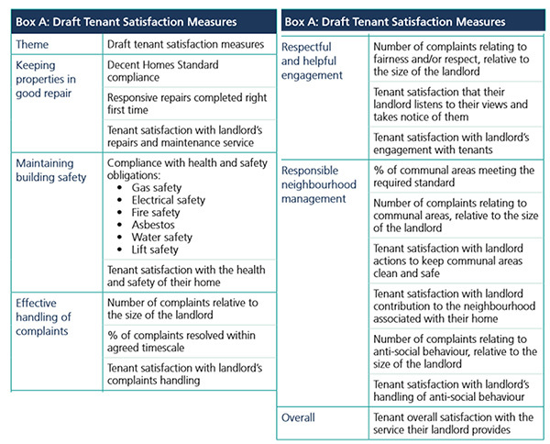
Draft financial measures include:
- CEO (or equivalent) salary, relative to size of landlord
- Executive remuneration, relative to size of landlord
- Management costs relative to size of landlord
Yvonne
yvonne@tenantadvisor.net www.tenantadvisor.net
@yvonne_hello
@yvonnehousing T
el: 07867974659

